Instructions for Reimbursement of
Graduate Student Senate Professional Development Funding

Below you will find instructions on how to create and save an expense report in ChromeRiver for the Professional Development funding that was approved for you by Graduate Student Senate.

All travel to be reimbursed by university funds must adhere to the University Travel Expense Policy. This document can be found on the General Counsel’s website, and a direct link to the document can be found here: https://www.bgsu.edu/content/dam/BGSU/general-counsel/documents/University-Travel-Expense.pdf. GSS also has additional guidelines which can be found on their Funding for Professional Development website.

Effective Spring 2023, there is a university expectation for conference/event attendees to utilize established traditional lodging (hotels or motels) in lieu of vacation rental facilities (AirBNB/VRBO, etc.) The expectation is established in an interest of safety for university employees and students as hotels are required to be inspected, uphold a level of fire code relevant to the location, appropriate insurance coverage, and are typically closer to the event venue.

If the attendee chooses to proceed with reserving a vacation rental, the following steps must occur prior to booking for consideration of reimbursement of a vacation rental accommodation:
Submit to gssawards@bgsu.edu with a subject line of “FPD LODGING COMPARISON” for review:
- Documented comparison of the costs for hotel(s) affiliated with or close to the event venue specific to the dates of your stay vs vacation rental
- Document travel expense to/from the event site and the vacation rental (taxi, bus, uber, lyft, rental, parking) from vendors local to the event site.
These expenses will be considered part of the vacation rental accommodation cost. This is on the presumption hotels will have conference transportation and/or within walking distance
The comparisons will be reviewed and a response will be provided within five business days from gssawards@bgsu.edu

If the FPD awardee booked a vacation rental, or attended the event using a vacation rental as lodging prior to February 28 2023, please submit the above information to gssawards@bgsu.edu, including the date the vacation rental was booked. (i.e. booking confirmation email). We will respond with an estimated amount eligible for reimbursement. Please do so prior to initiating your Chrome River expense report in case the eligible amount provided by gssawards@bgsu.edu prompts you to submit alternative expenses for reimbursement. We will also be able to tell you if there are submission errors that could delay approval or payment.

All documentation above and the response email from gssawards@bgsu.edu must be part of the receipt attachments for the Chrome River reimbursement request IF vacation rental is the chosen accommodation by the event attendee.
It should be noted that the lesser of the comparisons will be the level of expense eligible for reimbursement.

Reserving accommodations at a hotel does not require a review by gssawards@bgsu.edu prior to booking and will be reimbursed following university policy and expectations.

Please create your expense report as soon as possible after the date of the event, preferably within one month. We cannot accept an expense report before the event occurs.

How to Claim Your Reimbursement

If you have received funding from multiple sources, your department may prefer that one expense report be created reflecting all funding sources.
- Speak to your department prior to initiating the reimbursement process.
- For those of you who have not received additional funding or whose departments request separate expense reports, please continue to follow the instructions below.

Access Chrome River by clicking the Employee tab in MyBGSU (Chrome River is located in the left navigation under Misc Services).
- If you do not have access to ChromeRiver, it is likely because you are not currently employed as a graduate assistant at BGSU. If you do not have access, please reach out to your academic department administrative support and they can assist you by creating a ChromeRiver single pay on your behalf.

- Add Alexia Coffman as a delegate to your Chrome River account (see Step One below)

Create an expense report by following Steps Two and Three below.
- The expense report total should not exceed the amount for which you were approved.
- If you were given multiple awards (e.g., traveling to two different conferences), please complete separate expense reports for each.
- The GSS Allocation/Department Budget number is 119000SBCF. When you start typing this into the box for an expense item, it will begin to populate.
  - The Program Code depends on the semester in which you received your award. Enter 8010 for Spring, 8020 for Summer, and 8030 for Fall.

When uploading receipts, please also include a copy of your GSS FPD award letter and registration confirmation (if applicable).
  - Receipts must also show that you paid for the expense.
  - If another party paid for the expense, you must have documentation which includes a copy of the receipt from the billing party (organization) and a statement from the person who paid, verifying that they received compensation from you.

- When your expense report is completed, please SAVE/CLOSE it, but DO NOT submit it.
  - Then email GSSawards@bgsu.edu to let the Graduate College know it is ready for review. They will review the report and submit for processing.

Step 1: Add New Delegates

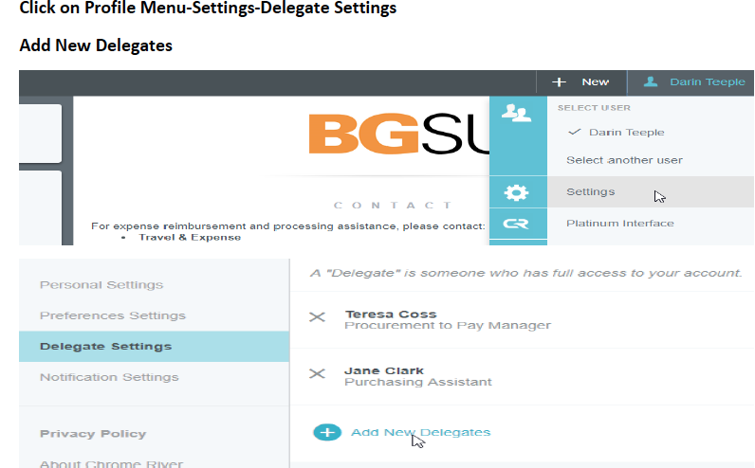
**Please enter Alexia Coffman as a delegate**

Step 2: Create Expense Report

Click on +Create to create a new expense report
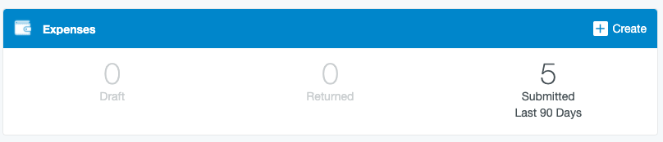

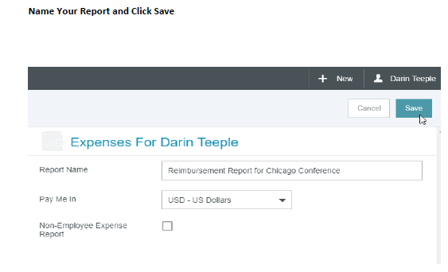
Please name your report as follows: Last Name, First Name- Dates of Travel -or- Organization Name

Step 3: Enter Expenses and Add Receipts

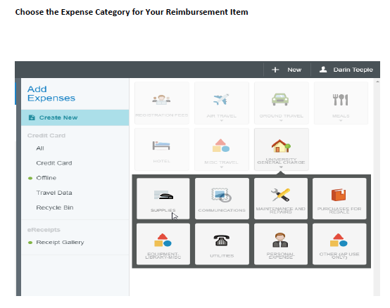
The next step is to enter your expenses. The following directions explain how to enter Registration Fee, Air Travel, Ground Travel, Hotel, and Misc Travel.
- Please only include those expenses that you will be reimbursed for and please only enter the amount for which you were approved (e.g., if you were approved for $100, but your conference registration was $200, please only enter a total of $100 in the expense items and include a note that states you were approved to be reimbursed $100).
- For memberships and professional organizations, the expense item will be coded as: University General Communications Institutional Memberships.

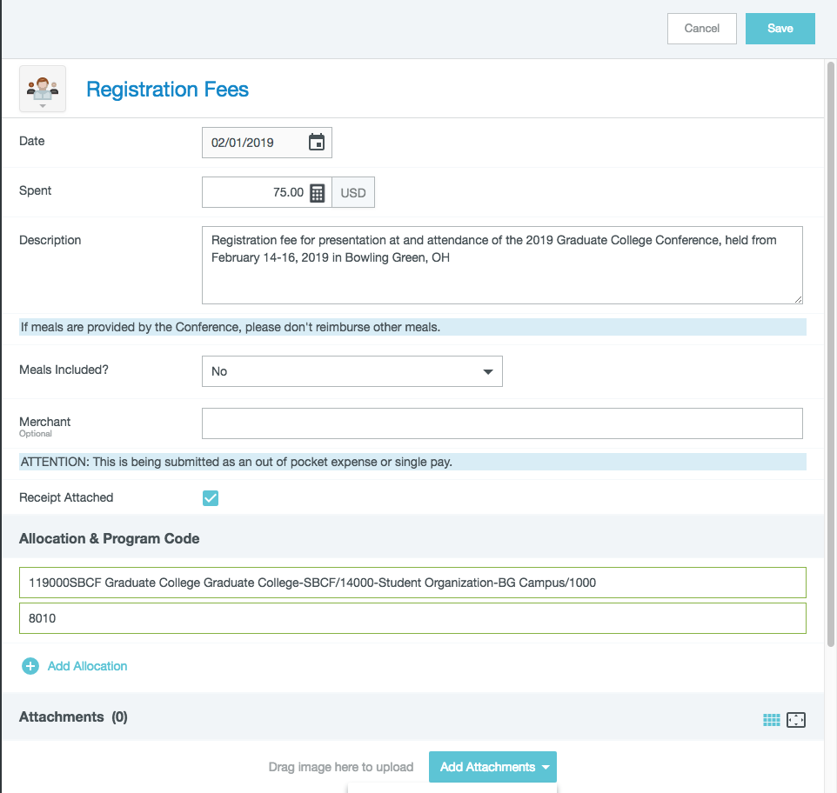
For Registration Fee reimbursement, please complete the fields as follows:
Date: Purchase Date (Please do not use conference date or today’s date)
Spent: Reimbursable Amount (This will not always be the total amount paid)
Description: Detailed information including the type of expense (registration fee), name of event (full conference name), dates of event and location of event
Meals Included: As appropriate
Merchant: Please leave this field blank
Receipt Attached: Please check this box
Allocation & Program Code: The GSS Allocation/Department Budget number is 119000SBCF. When you start typing this into the box, it will begin to populate. The Program Code depends on the semester in which you received your award. Enter 8010 for Spring, 8020 for Summer, and 8030 for Fall.
Attachments: You can either drag and drop a PDF or JPEG of your receipt here or choose Add Attachment to upload. **Conference agenda/program links or copies-with dates-must be attached.

Click Save and move on.

For Airfare reimbursement, please complete the fields as follows:
Date: Date of flight (Please do not use conference date or today’s date)
Spent: Reimbursable Amount (This will not always be the total amount paid)
Description: Detailed information including :
- the type of expense (airfare),
- name of event (full conference name),
- dates of event and
- location of event
Class: Only Economy is reimbursable per University policy
Merchant: Please leave this field blank
Receipt Attached: Please check this box
Allocation & Program Code: The GSS Allocation/Department Budget number is 119000SBCF. When you start typing this into the box, it will begin to populate. The Program Code depends on the semester in which you received your award. Enter 8010 for Spring, 8020 for Summer, and 8030 for Fall.
Attachments: You can either drag and drop a PDF or JPEG of your receipt here, or choose Add Attachment to upload. **Receipts showing payment in full, payment type and owner of payment type should be included.

Click Save and move on.

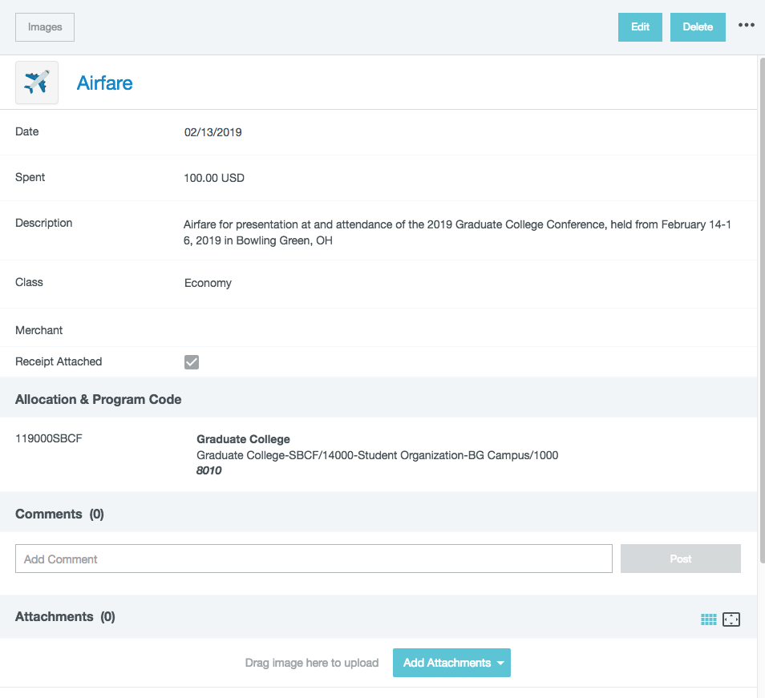

Ground Travel Reimbursement- Options #1, #2, and #3

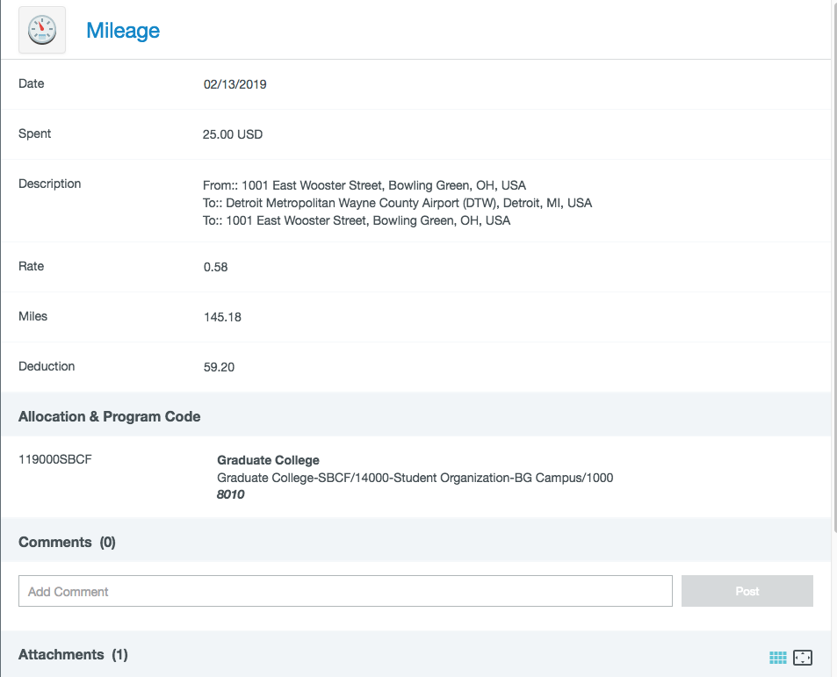
Option #1: Mileage- this option can be used if you drove a personal vehicle to an airport or your final destination.
Date: Travel Date (Please do not use conference date or today’s date)
Spent: This will be grayed out and will autofill when mileage is calculated
Description: This will autofill with your travel route, please add: purpose of expense (conference attendance), name, dates and location of event
Miles: Calculate via embedded link (Car icon), once complete, Miles, Description and Spent will autofill
Deduction: If necessary, please deduct the appropriate amount to ensure you do not go over your award.
Allocation & Program Code: The GSS Allocation/Department Budget number is 119000SBCF. When you start typing this into the box, it will begin to populate. The Program Code depends on the semester in which you received your award. Enter 8010 for Spring, 8020 for Summer, and 8030 for Fall.
Attachments: N/A- automatically done

Click Save and move on.

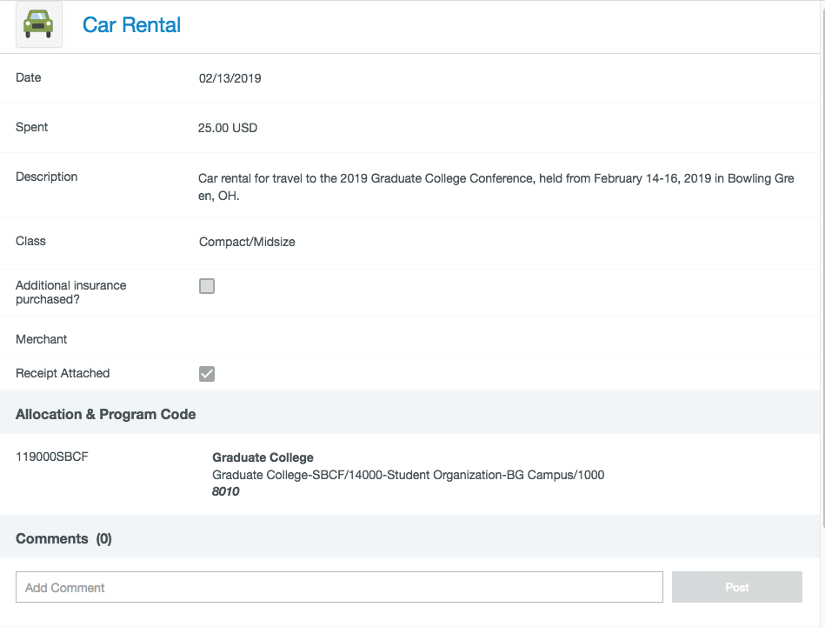
Option #2: Car Rental- this option can be used if you drove a rental car to an airport or your final destination.
Date: Travel Date (Please do not use conference date or today’s date)
Spent: Reimbursable Amount (This will not always be the total amount paid)
Description: Detailed information including the type of expense (car rental), name of event (full conference name), dates of event and location of event
Class: Only Compact/Midsize is reimbursable per University policy
Deduction: If necessary, please deduct the appropriate amount to ensure you do not go over your award.
Additional Insurance Purchased?: You should never do this. Instead, use Enterprise’s BGSU account # XZ38UO9, the rates are better and insurance is included.
Merchant: Please leave this field blank
Receipt Attached: Please check this box
Allocation & Program Code: The GSS Allocation/Department Budget number is 119000SBCF. When you start typing this into the box, it will begin to populate. The Program Code depends on the semester in which you received your award. Enter 8010 for Spring, 8020 for Summer, and 8030 for Fall.
Attachments: You can either drag and drop a PDF or JPEG of your receipt here, or choose Add Attachment to upload

Click Save and move on.

Option #3: Fuel- this option can be used in lieu of mileage if you drove your personal vehicle to an airport or your final destination. You cannot request mileage and fuel reimbursement
Date: Travel Date (Please do not use conference date or today’s date)
Spent: Reimbursable Amount (This will not always be the total amount paid)
Description: Detailed information including the type of expense (car rental), name of event (full conference name), dates of event and location of event
Merchant: Please leave this field blank
Receipt Attached: Please check this box
Allocation & Program Code: The GSS Allocation/Department Budget number is 119000SBCF. When you start typing this into the box, it will begin to populate. The Program Code depends on the semester in which you received your award. Enter 8010 for Spring, 8020 for Summer, and 8030 for Fall.
Attachments: You can either drag and drop a PDF or JPEG of your receipt here, or choose Add Attachment to upload

Click Save and move on.

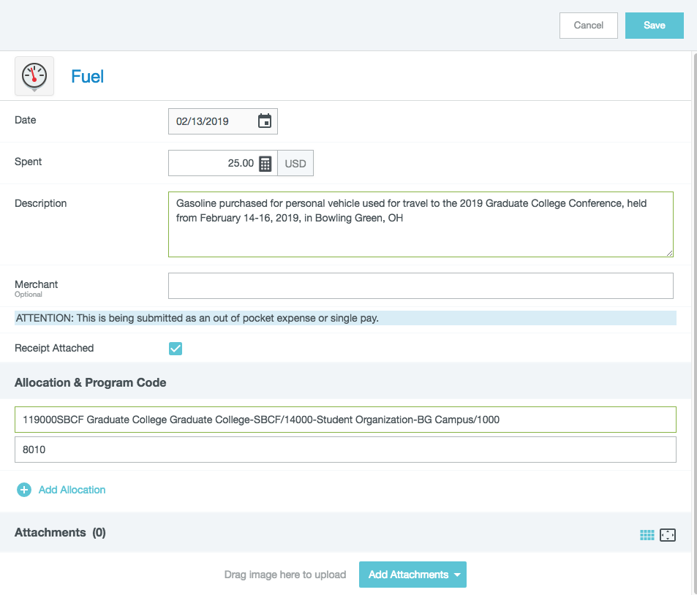
Step #1
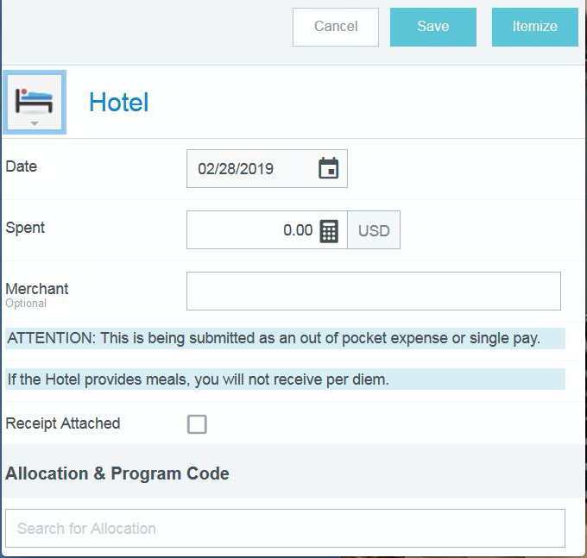
For Hotel reimbursement, there are 3 steps, please proceed as follows:
Step #1
Date: Date you began your stay (Please do not use your conference date or today’s date)
Spent: Reimbursable Amount (This will not always be the total amount paid)
Merchant: Please leave this field blank
Receipt Attached: Please check this box
Allocation & Program Code: The GSS Allocation/Department Budget number is 119000SBCF. When you start typing this into the box, it will begin to populate. The Program Code depends on the semester in which you received your award. Enter 8010 for Spring, 8020 for Summer, and 8030 for Fall.

Step #2
Click “Itemize” in the top right corner, and a new screen will come up with itemization choices. “Room Charge” cover the cost of the room and all associated taxes. This should always be your first choice.

Step #3
Date: Should auto populate
Spent: Enter the amount as appropriate
Description: Detailed information including the type of expense (lodging), name of event (full conference name), dates of event and location of event
Merchant: Please leave this field blank
Receipt Attached: Please check this box
Allocation & Program Code: The GSS Allocation/Department Budget number is 119000SBCF. When you start typing this into the box, it will begin to populate. The Program Code depends on the semester in which you received your award. Enter 8010 for Spring, 8020 for Summer, and 8030 for Fall.
Attachments: You can either drag and drop a PDF or JPEG of your receipt here, or choose Add Attachment to upload. **Receipts showing payment in full, payment type and owner of payment type should be included.

Click Save and move on.

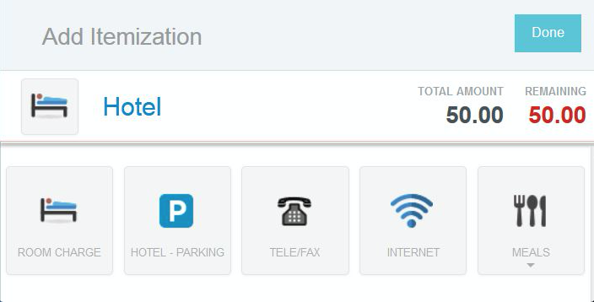
Step #2
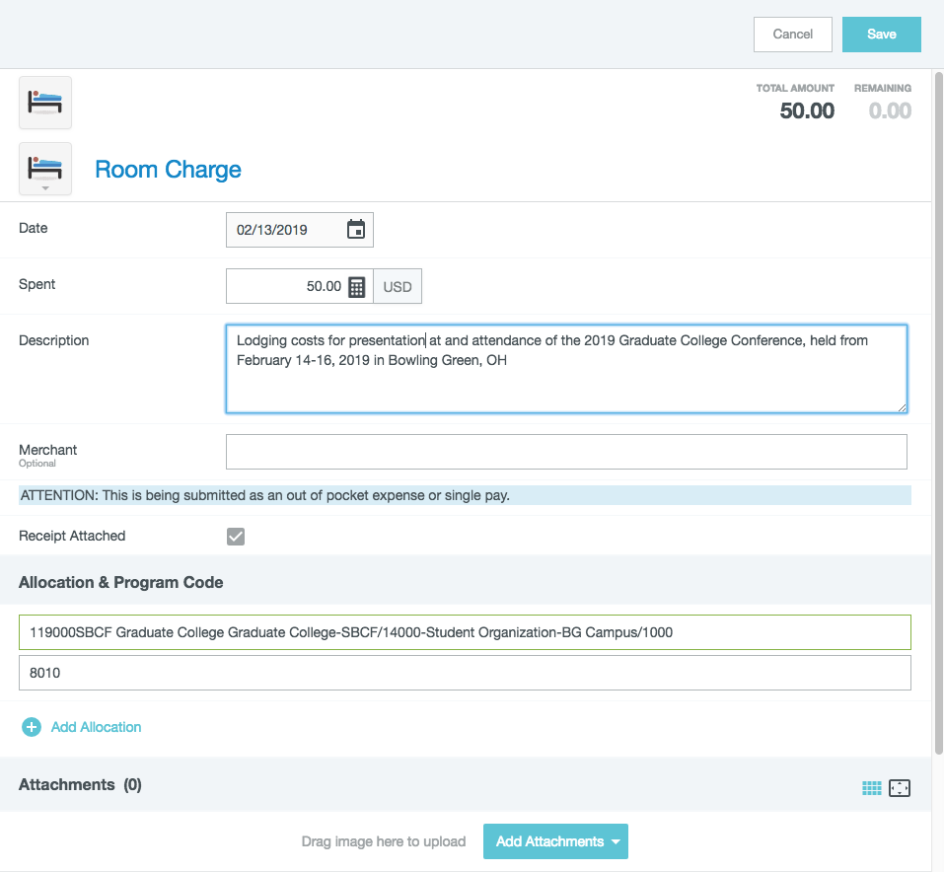
Step #3

IMPORTANT REMINDERS:
- All expense reports must include a PDF of the original GSS FPD award letter among the receipts
- If your award was for conference expenses, a copy of or link to the agenda/program must be included among the receipts.
- If you are travelling, you are required to register your trip with the Office of the Dean of Students. This includes domestic and international travel. Register your trip here: https://www.bgsu.edu/dean-of-students/student-travel-policy.html. Remember to attach your confirmation in Chrome River.
- A reservation confirmation is not considered proof of payment unless it specifically states, “PAID IN FULL” with your name and payment information attached.
- If someone else paid the expense and you reimbursed them, you will need to include proof of payment from the payer as well as proof that you reimbursed them (PayPal or Venmo receipt or letter of confirmation)

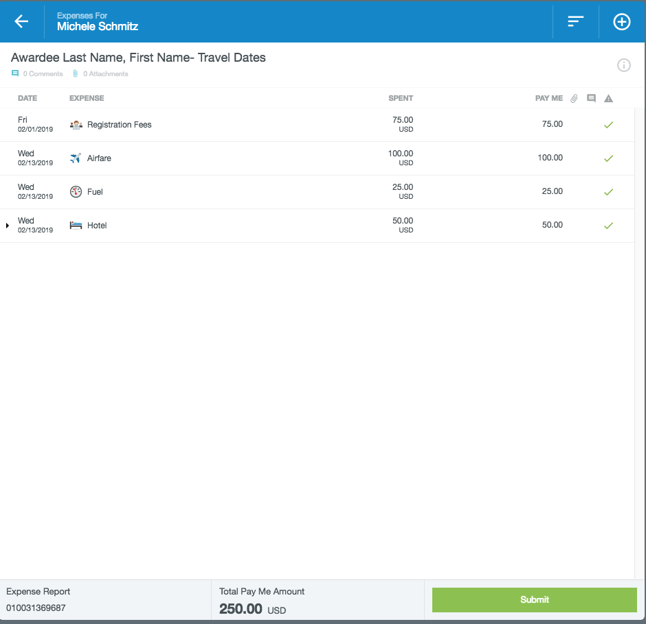

Once you have entered and saved each line item for reimbursement, the report should look like the example above, with the “Total Pay Me Amount” not exceeding the amount of your award.

DO NOT SUBMIT!!

Please exit the application and email gssawards@bgsu.edu to let them know that there is an expense report to be reviewed.

