Academic Honesty Executive Summary
This project was a student-led assessment of students at Bowling Green State University. It was conducted by a team of four students identified as Student Learning Analysts (SLAs) as part of the Office of Academic Assessment. The SLAs designed a focus group protocol and a survey exploring students' awareness and knowledge of the Academic Honesty Policy.
Focus Group Results
There were four focus groups facilitated by the SLAs with a total of 28 participants from varying class standings and majors. Audio recorders were used to ensure that all information was properly documented. These recordings were transcribed and analyzed. Transcriptions were open coded and then focus coded into themes by the SLAs. All codes were analyzed and narrowed to seven main themes with subthemes, listed below.

1. Awareness: Participants discussed how they were made aware of the Academic Honesty Policy over their academic career.
- Previous Knowledge: Participants spoke about how they were made aware of the Academic Honesty policy.
- Consequences: Students talked about how academic dishonesty affects students who violate the policy.
One participant discussed that students should be aware of the consequences because they can affect future educational studies: Another consequence to consider is even if students don’t get expelled or anything like that, if they get a mark on their transcripts, what’s it going to look like for graduate school. (T2, L267- 268)

2. Reasons for Academic Dishonesty: Participants discussed their understanding for the reasons students participate in academic dishonesty.
- Academic Pressure: Participants discussed importance of grades and GPA at the university level.
- Type of Class: Students may cheat in classes that they do not perceive as important for their major.
- Unprepared: Students may not feel prepared for a class exam or assignment.
- Time Management: Not managing time properly may lead to academic dishonesty.
- Easy to Cheat: Participants suggested it is the easy way out and no one gets caught.
- Social Pressure: Students identified pressure that friends and outside influences can create.
This student mentioned the need to succeed in order to gain the approval of their parents: A lot of students have a lot of pressure on them to succeed in school um, so, if they ever think that they might not do so well on an exam they might want to cheat rather than take the bad grade and risk um losing scholarships or losing parent’s approval. (T3, L179-181)

3. Technology: Participants discussed various technological components in relation to Academic Honesty and dishonesty.
- Negative: Technology can cause information to be distributed faster and enable academic dishonesty.
- Positive: Technology can prohibit students from violating the policy.
Another student relayed ways in which technology could help identify violations to the Academic Honesty Policy: ...I think also it makes it a lot easier to catch people because everything is searchable. You can look up like a specific phrase or things ... There’s [sic] always so many ways. There is [sic] always ways of checking like time stamping and you can reverse search phrases or even whole sentences. Also, you... have a whole slew of papers coming in – especially if you’re doing online turn ins. You can do stuff like that... (T4, L318-323).

4. Levels: Participants discussed that there were levels of academic dishonesty that would categorize some of the violations.
- Socially Acceptable: Students are willing to help one another on assignments because it is common to help other students.
- Severity: Certain violations are worse than others.
One participant believed that all academic dishonesty is severe, but says that nobody is punished for committing the violation: I mean obviously they’re really serious. I think that a lot of people sort of like commit academic dishonesty thinking they won't get caught and then when it does or if it does happen then it's like 'Yeah I really shouldn’t have done that' like you sort of do it in the hope that it doesn’t happen like it’s never going to happen. I don’t know if that is unrealistic or not because I don’t actually know anyone who has gotten charged with academic dishonesty. (T4, L385-389)

5. Responsibility: Participants discussed who they believed was responsible for student success in Academic Honesty.
- Students: Participants expressed their recognition of students' participation in academic dishonesty.
- Faculty: Professors often do not enforce the Academic Honesty Policy themselves.
- Institution: Students specified what the rules should be university-wide and in classes.
One participant pointed out that students should be academically responsible because they are paying for their education: I feel like college is a choice, it’s an investment, you’re putting a lot of money into this. So why not use that investment and invest in your knowledge? Because wisdom is a powerful thing especially in society. (T3, L536-537)
6. Prevention: Participants discussed and gave suggestions for ways that the University could help prevent academic dishonesty.
- Faculty: Students discussed how faculty can prevent academic dishonesty in their courses.
- Institution: Participants described ways they thought the University could be decreasing academic dishonesty.
- Consistency: Participants were confused by the inconsistencies in the policy between classes or professors.
One participant stated that students are often unaware of what is considered academic dishonesty because of the inconsistency between classes: ‘Cause again it’s like different professors are going to see different things as academic dishonesty. One professor might be like 'Oh yeah the homework is online, so you might as well hang out with your friends and do it' but another professor might find out about that and like report you or something, so you never know. (T4, L455-458)

7. Value of Education: Students discussed the importance of completing honest work and their desire to learn.
- Future: Participants related Academic Honesty and dishonesty to future careers, education, and their lives.
- Importance of Learning: Students believed that learning is essential in their lives.
One student recognized the importance of learning and the value that an education can have for individuals when they are academically honest: It kind of brings to question what the students are here for. ‘Cause like if our entire purpose for being in college was to learn then we wouldn’t commit academic dishonesty because we would want to learn the subjects and we wouldn’t be like ah if I do this then we don’t have to go through the work... I’m pretty sure not many of the students see it like that. I think most students see college less as 'I’m here to learn than I’m here to graduate and get a degree.' That’s where the divide comes in like the root reason why people cheat is because they don’t really value learning the topic they just want the grade. (T4, L401-407)
Survey Results
To further explore the data from the focus groups, the SLAs created a survey about Academic Honesty. The questions and their response options on the survey emerged from the data discovered in the focus groups. There was a total of 191 responses to the survey. The survey was conducted with tablet devices by the SLAs at various locations on the campus of BGSU.
When surveyed, 92% of students said they were aware of BGSU's Academic Honesty Policy, with 46% of participants indicating that they were aware of the policy because of course syllabi. Students identified the top type of academic dishonesty violation they believed was committed most often. Based on survey results, plagiarism (42%) and cheating (33%) were chosen the most.
Within the survey, students were given three scenarios and asked to rank how serious they believed the scenarios to be. The scenario they identified as the most serious was Scenario 2 where 76% indicated that copying a few sentences from an online source without citation was serious/very serious. For Scenario 1, 69% indicated that sharing questions or answers from an exam with another student was serious/very serious. Scenario 3 had the fewest students indicating the situation was serious with 40% of students saying that taking an online exam with another student was serious/very serious.
After attaining a better understanding of reasons why students participate in academic dishonesty from the focus groups, the SLAs developed a similar question for the survey. The highest proportion of student responses (48%) indicated academic pressure as a reason why students participate in academic
dishonesty.
One survey question was asked to gain knowledge on how the University can help students learn more about the Academic Honesty Policy. Class discussion was chosen most often, with 34% of students indicating that it would help them learn more about the policy. Another question asked students what they believe causes the most confusion regarding the Academic Honesty Policy. In response to this question, 45% of students said that a lack of understanding how to properly cite caused the most confusion.
For more information about this assessment project, please contact Dr. Jessica M. Turos at the BGSU Office of Academic Assessment at jmturos@bgsu.edu.

Academic Honesty
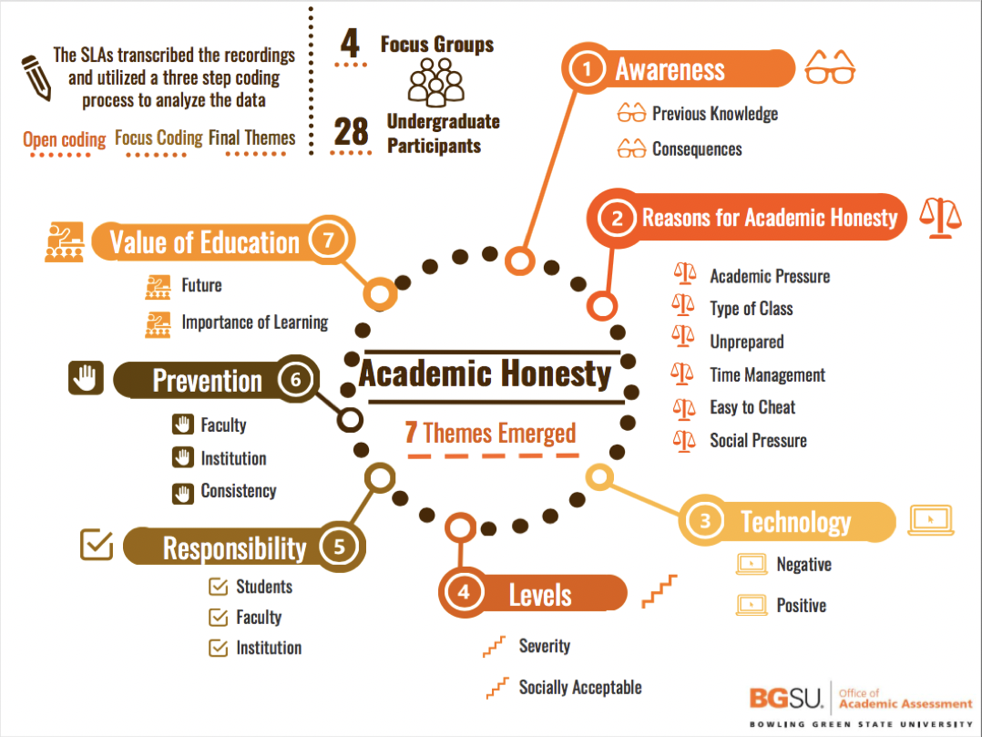

Academic Honesty Survey Results
