College Life in A Pandemic: Executive Summary
This project was a student-led assessment of Bowling Green State University (BGSU) undergraduate students. It was conducted by a team of undergraduate students identified as Student Learning Analysts (SLAs) from the Office of Academic Assessment. The SLAs designed a focus group protocol to gain insight on BGSU student experiences outside of the classroom during the COVID-19 pandemic. There were 6 focus groups facilitated by the SLAs, with a total of 35 participants from varying class standings and majors from five different colleges. Out of the 35 participants, 60% identified as female (n=21), 37% of the participants identified as male (n=13), and 3% identified as nonbinary (n=1). From the race/ethnicity information participants provided, 71% self-reported their race/ethnicity as White (n=25), 14% as African American/Black (n=5), 3% as Chicano/a/e (n=1), 3% Hispanic (n=1), 3% Latino (n=1), 3% as Slavic (n=1), and 3% as White and Black (n=1). Cisco WebEx was used as the online meeting platform, and the focus groups were recorded to ensure that all information was properly documented. These recordings were then transcribed and analyzed. The SLAs used a three-step coding process, which involved open coding, focus coding, and theme identification. Throughout these discussions, five themes with their corresponding subthemes emerged and are highlighted below.

Well-Being – Students discussed things that impacted their general emotions, happiness, and/or comfort.
  - Mental health – Students noted the ways in which their mental health changed including increased loneliness, anxiety, and self-care
  - Physical health – Participants discussed the ways in which their physical health changed, such as lack of physical activity, changes in physical health, and maintaining physical health.
  - Coping Mechanisms – Students talked about strategies, steps. or hobbies they developed, such as staying physically active, going outside, time management strategies, self-care, and maintaining a normal life, to deal with living in a COVID-19 world.
  - Mindset – Participants discussed the way they think about things and how it benefited them or changed their outlook. Some mindsets discussed include taking responsibility, having discipline, a sense of accomplishment, having an open mind, accepting that they cannot control the situation, and changing their perception of college.

One student spoke about how they tried to change their mindset by focusing more on themself: I feel like... this semester… COVID and everything kind of like, forced me to look at… all the bad habits I've like had. And now I'm just… kind of working on… and forcing, like, positive habits… I'm not hard on myself because it's just like, these times are crazy… It just makes me have like, more self-realization about… things I do and like what I want with my life. (T5, L312-315)

Living Situation – Students discussed how their housing (i.e., where they live) impacted their college experience.
- On Campus – Students talked about how they were positively, negatively, or not impacted while living in BGSU residence halls.
- Off Campus in BG – Students discussed how they were positively impacted while living off campus in the Bowling Green area and how it was different from on campus.
- At Home with Family – Participants noted how their family circumstances and living situations affected their college experience.

One participant explained that the constant changes in the residence hall rules made living on campus feel unsteady: …I live on campus, so I would describe it as, like, unstable. I guess, so like, one moment the rules are like that and the other moment they either add something or take something away. Like recently we have been granted… permission to have a guest in their rooms, which is great. ‘cause it wasn't allowed in the beginning of the semester but it's still kind of like, um, shifting all the time and changing and you can never really, like, get comfortable and get used to it because something might change, like, the next week. (T4, L28-33)

Involvement – Students discussed participating or not participating in things outside of classes.
  - Campus Organizations – Students discussed their engagement and experiences with student organizations and the impact of the virtual environment.
  - Work/Internships – Students talked about their experience with work and/or internships during the pandemic and how these experiences helped students stay involved, but also created some issues.
  - Volunteering – Students talked about successes and challenges to engaging in volunteer work during pandemic times, including access to involvement opportunities.

One participant elaborated on how people felt burnt out from Zoom and online meetings, which affected the engagement of the organization: ...Involvement is definitely a lot different. I think a lot of the groups have cut down on meeting times…because some people are just not motivated to keep up involvement, so involvement has gone down in those ways… A lot of things you just can't do very well over Zoom since a lot of people quit. So, a lot of things are just the bare minimum, and people aren't having as much fulfillment from the things they used to… (T3, L175-179)

Connections – Students talked about the interactions they had with other people and feeling part of something.
  - Social Media – Participants noted how social media impacted or fostered making connections by helping them keep in touch with others, make new friends, or communicate with classmates.
  - New Connections – Students discussed how they can or cannot make connections or interact with others during COVID-19.
  - Quality – Students discussed their levels of interaction with others (i.e., surface level or deep).
  - Support – Students discussed people (e.g., family, friends, professors, advisors, and RAs) that facilitated connections and interactions to improve their college experience.

One student discussed their struggles in making connections: I was just going to say that I honestly feel like I haven't really had any connections to other students, or I haven't really been able to. I feel like this has been the most, like, isolated in my life and… as friends would come back to BG, like I assumed that they would and a lot of them haven’t. Um, so the only resources I have to possibly make connections doing COVID was through clubs, which I've tried, but since it's all virtually, you don't really get the one-on-one. So, I don't really feel like there's been a really good way to connect with others. (T6, L114-119)

Challenges/Barriers – Students talk about things that inhibited a good experience or made a situation more difficult or become inconvenient.
  - Motivation – Students talked about how during fall 2020, their motivation was reduced as compared to previous semesters because of current situations.
  - Technology – Participants discussed how technology, including social media, hardware, and virtual ways of connecting, became a barrier to the “normal” college experience and was not always beneficial.
  - Uncertainty – Students spoke about the difficulty they had adapting to these new situations, the lack of knowing what is ahead, and the constantly changing social environment.

One student discussed that the challenge they faced was adjusting to various things simultaneously:
...I mean, overall, it's definitely been a challenge to, um, adjust to going to school every single day and being in-person to having to, like, share a house with five other people, and trying to figure out how we do online classes... at the same time. And, like, what if the Wi-Fi shuts down? So all these little obstacles that you've never really had to deal with, um, are definitely going to be an issue, and they have been an issue, so it's all about overcoming those little things in the way. (T6, L325-330)

Infographic
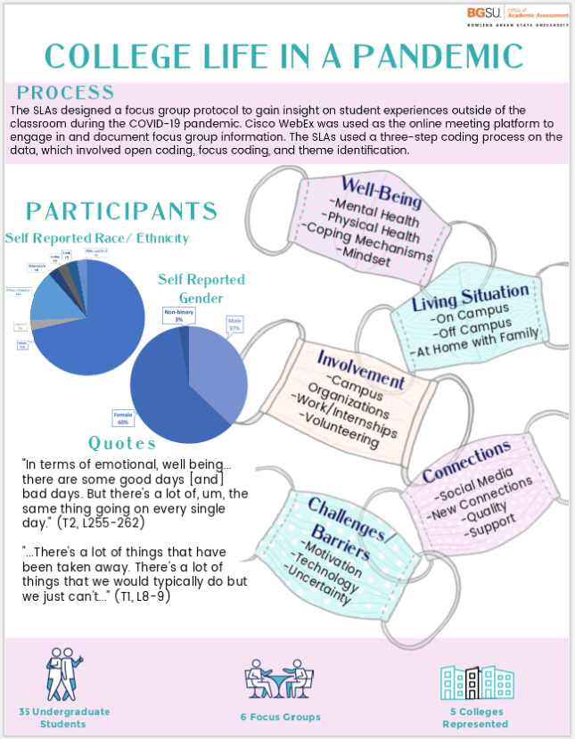

Word Cloud

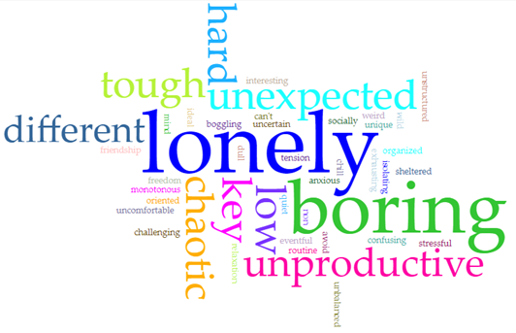
This word cloud illustrates student responses to: “What are some words or phrases you would use to describe your life outside of the classroom during the pandemic this semester?”

