LOGGING IN TO HERO
There are two methods for logging in to Sidewalk Hero to complete adoptions.

METHOD ONE: Log in to your MyBGSU account. In the orange row across the top choose, ‘EMPLOYEE’, then select ‘BOOKSTORE’ from the dropdown box. In the left-hand column under Faculty Adoptions, select ‘All Campuses’
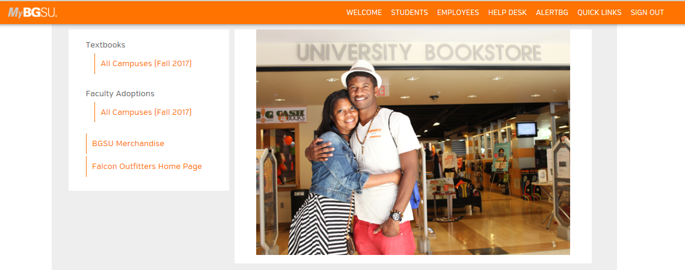

METHOD TWO: You may also access the Hero program through the Falcon Outfitters website. https://www.bgsu.edu/bookstore/ From the left-hand column, choose ‘Textbooks’.
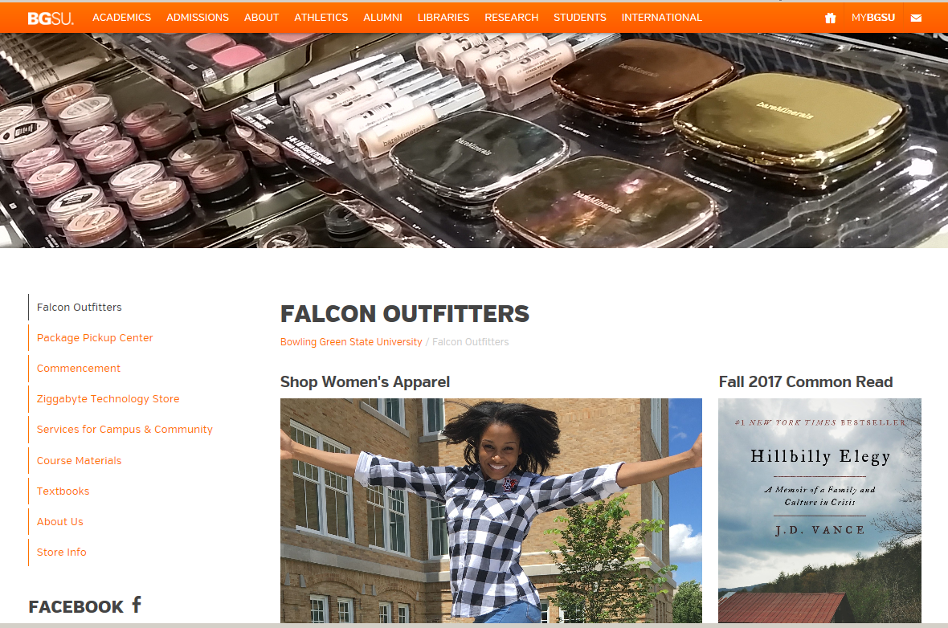

From this page, select ‘VIEW YOUR BOOKLIST NOW’ and you will be redirected to the Hero sign in page.
