2017-2018 BRANCH DUES FORM
Dues Year: July 1, 2017 to June 30, 2018

Be part of a professional organization dedicated to making positive societal change for women and girls

MEMBER INFORMATION: Please print clearly or type and fill in all spaces.
Date:
Name:
Street Address:
City/State/Zip:
Phone (h) (w)
E-Mail:
Fax:
Highest degree earned: Year:
College/University: State:
Current Occupation:
Annual Regular membership DUES for National Association, State, and BG Branch: $70
Others are Grad Student ($39.81), Student Affiliate ($20), Life (MBL) ($21), Dual ($10)

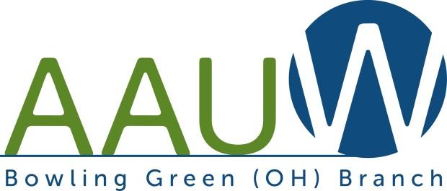
Amount of dues: $

Amount donated for each:
Local Scholarship
Tech Trek Camp
Total Amount Donated: $
Total Amount of Check: $
Make check payable to: AAUW BG Branch
Mail this form and your check to:

Linda Koehler, Treasurer
562 S. Ridge Drive
Perrysburg, OH 43551

NOTE: A portion of your AAUW dues may be deductible as a charitable contribution within the limits of IRS tax code, i.e. $46. Some members may be able to deduct dues as ordinary and necessary business expenses.

