Stan works at the Christmas Ornament Packing Plant. He uses boxes sent by a box company. The boxes are shaped as rectangular prisms. He fills those boxes fill with ornaments. Each ornament is packed in an individual cube. Typically, a box measures 4’ x 3’ x 3’. The cube with the ornament in it is 1’ x 1’ x 1’.

- How many ornament cubes fit into one box?

- During the busiest time of year, the box company sends a different size box. This shipment’s boxes are $3\frac{2}{3}$ ft x $2 \frac{5}{6 }$ft x $3\frac{1}{2}$ft. How many ornament cubes fit into one of these new boxes?

- A nearby company packs fake wedding rings in small cubes. What must the size of the small cube be, such that it fills the boxes without any wasted space?
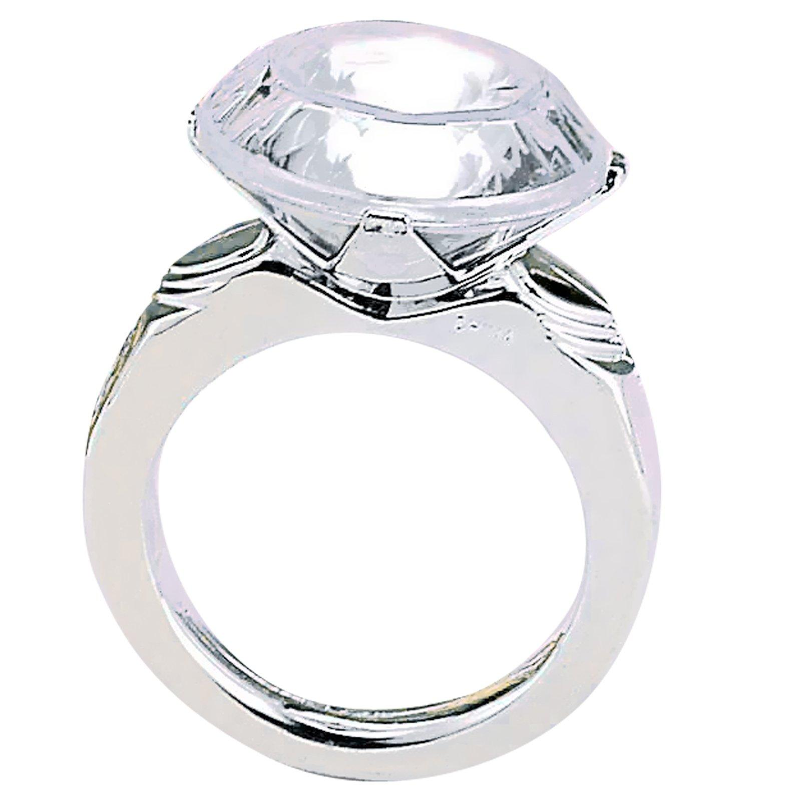

- Make a scale figure (drawing) of the new box such that the centimeter cubes represent a ring box.

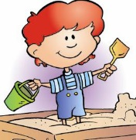
- On the other side of the ring plant is a toy store that sells sand by the box. Mr. Sandman usually uses the same size box as Stan, (4’ x 3’ x 3’) and has an abundance of extra boxes. He sells the sand for $7 per box. Stan offers to exchange the boxes measuring $3\frac{2}{3}$ ft x $2 \frac{5}{6 }$ft x $3\frac{1}{2}$ft with Mr. Sandman. If Mr. Sandman wants to keep the price per box at $7, should he exchange some boxes with Stan? Why or why not?

- How can we relate the number of ring boxes to the amount of sand that can be put into the new box?

- Can we generalize a way to find the volume of a rectangular prism with fractional side lengths?

