It is PARTY TIME! You can celebrate whatever you want, but you must have a standard party hat. The hat must be a right cone without a base. You know the kind…
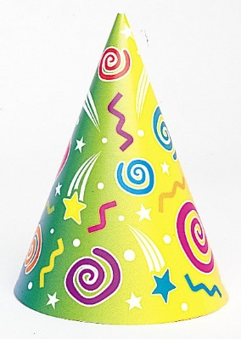
As a large group, you must decide the following:
- The hat must be ______ inches tall.

- The circumference of the opening must be _______ inches.

Now, make your hat!

Pat the Partier wants to decorate the party hat. In order to obtain the proper hat decorations, he needs to find the surface area of the hat. Find the surface area of his hat.

Later in the evening, Pat the Partier decides to use his hat as a cup. How many ounces of soda can Pat the Partier put in his cup?

