Suppose you bought a snazzy new pedometer. You walked from home to school then to the post office, and finally to BW3. You want to take the shortest routes possible. How far will your pedometer say you’ve walked?

Map of Busy Town

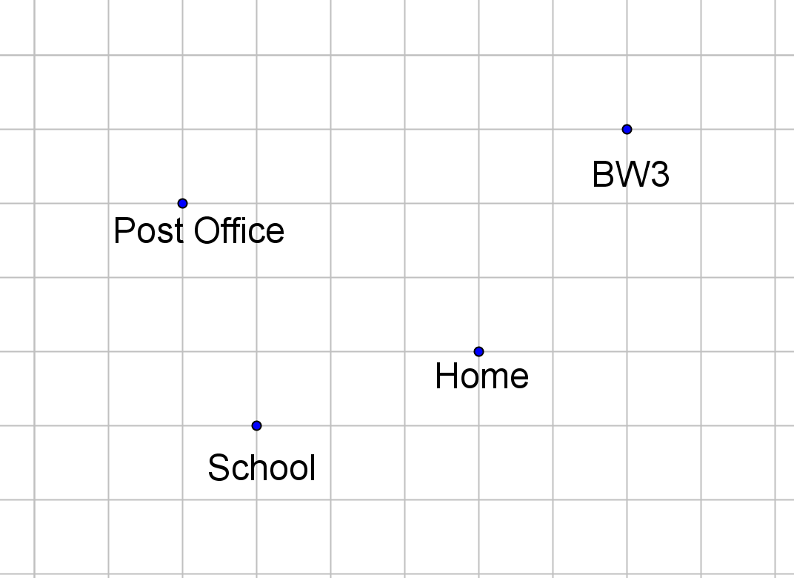
Grid lines are one mile apart, but do NOT represent roads – only distance.

Find the distance between (3,1) and (-2, -4). How would you explain this to your students?

