Rolling Two Dice
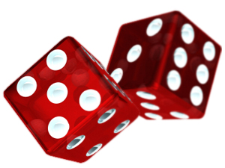

We have looked at the random experiment of rolling two dice and considered the probability of rolling a prime sum and the probability of rolling a two-digit product.

One of your lesson study groups did a Dice Differences lesson. (Would one of you please share a summary of the lesson? ) What may students learn from this lesson? How does this lesson relate to The Wink Game and Rolling Two Dice activities that we have done?

What are some other questions that we might ask about the results of rolling two dice?

What can students learn about number and operations by exploring some of these questions?

