***Rolling Two Dice***

*(adapted from Bright, Thomas, Tarr, & Frierson, 2003)*

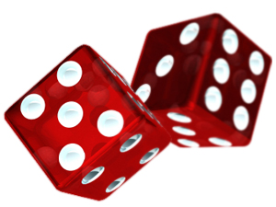**When rolling two dice (or rolling one die twice), about how often would you expect**

**to get a prime sum? Would you estimate the probability of rolling a prime sum to**

**be close to zero, close to ½, or close to one? Why?**

**When rolling two dice (or rolling one die two times), about how often would you expect to get a two-digit product? Would you estimate the probability of rolling a two-digit product to be close to zero, close to ½, or close to one? Why?**

**Roll two dice 20 times and record the following information in the table below: whether or not the sum is prime, the ratio of “number of prime sums” to “cumulative number of rolls”, whether or not the product is a two-digit number, and the ratio of “number of two-digit products” to “cumulative number of rolls”. Then graph your data on the next page.**

|  |  |  |  |  |
| --- | --- | --- | --- | --- |
| ***Roll*** | ***Prime sum?*** | ***Prime sums : number of rolls*** | ***2-digit product?*** | ***2-digit products : number of rolls*** |
| 1 |  |  |  |  |
| 2 |  |  |  |  |
| 3 |  |  |  |  |
| 4 |  |  |  |  |
| 5 |  |  |  |  |
| 6 |  |  |  |  |
| 7 |  |  |  |  |
| 8 |  |  |  |  |
| 9 |  |  |  |  |
| 10 |  |  |  |  |
| 11 |  |  |  |  |
| 12 |  |  |  |  |
| 13 |  |  |  |  |
| 14 |  |  |  |  |
| 15 |  |  |  |  |
| 16 |  |  |  |  |
| 17 |  |  |  |  |
| 18 |  |  |  |  |
| 19 |  |  |  |  |
| 20 |  |  |  |  |





**Consider the following questions:**

* **What patterns do you see in the graphs? What do these patterns tell you?**
* **Based on the results of your simulation, estimate the probability of rolling a prime sum and the probability of rolling a two-digit product when rolling two dice. How did you make these estimates?**

**With the others at your table, use an organized list, table, and/or tree diagram to find the probabilities of the events “rolling a prime sum” and “rolling a two-digit product”.**

**How do these probabilities compare to the observed frequencies in the simulation**?