Olympic Event 1: Each letter represents a whole number 1-9. Determine as many solutions as possible such that the sum within each colored ring is the same. In other words A + B = B + C + D = D + E + F = F + G + H = H + I.
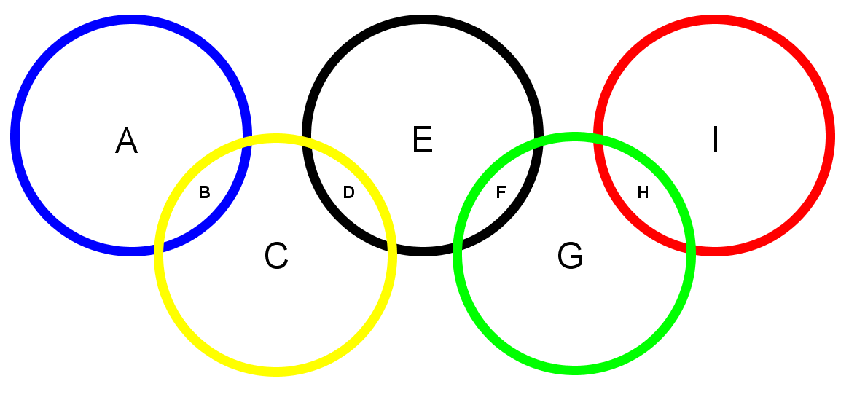
Source: https://www.rain.org/~mkummel/stumpers/22sep00a.html

