The Geometry of Number (Multiplication)

- Discovering and finding other ways to do 13 X 17 = ___________

- 12 X 20 = _________________

- Determine an efficient way to determine the number the dots and show how you would group dots to make it efficient.
Connect Dot Arrays to Multiplication with Base Ten Blocks

Re-present the previous problems using Base 10 blocks or Base 10 block drawings.

Connecting it to the Standard Algorithm
For problem 3, draw comparisons between the partial products and Standard Algorithm. Explain below.

Algebra: Extending Multiplicative Representation

For the following dot arrays someone covered up part of the arrays with a piece of paper. Find the number of missing dots by at least 2 different methods and explain how you can know how many dots long X and Y are:
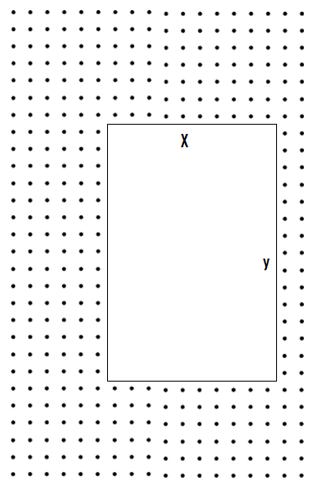

Algebra: Unknowns in representing multiplication and juxtaposition.

In the following situations some of the dots of an array have been covered up. How many dots are there? Represent the solutions as best you can with a multiplicative expression and state any assumptions you must make. Challenge: Try to represent it in more than 1 way.
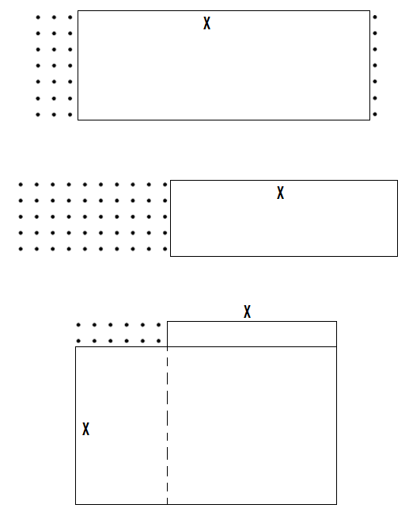

Multiplication Algorithm’s Factor * Factor = Product

Partial Products Algorithm Standard Algorithm Equal Ratio’s

47 47 28
x 2 x 2 x 5

43 43
x 32 x 32

Is there any connection to Algebra and Expressions in the Partial Products and Standard Algorithms?

Lattice Multiplication
a) 47 x 2 = ? b) 43 x 32 = ? c) 423 x 52

