Sum of Interior Angles of a Polygon

Colton, MaKenna, and Austin are trying to figure out the sum of the interior angle measures in an n-gon, but first they want to find the sum of the interior angles in a quadrilateral and a pentagon. They then hope to use these answers to find a pattern that will aid them in finding a formula that can be used to find the sum of the interior angles in any n-gon.

Colton says that he knows the sum of the interior angles of a triangle is 180°. MaKenna and Austin agree. They decide to each break the quadrilateral into triangles (see below).
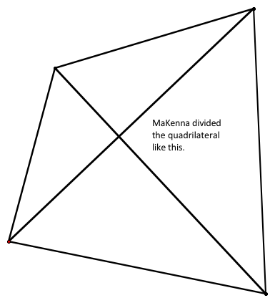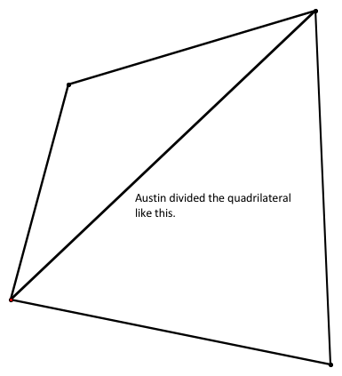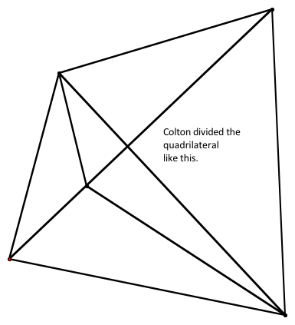
Here are the students’ findings:

MaKenna said that she has four triangles, and 4(180) = 720, so a quadrilateral has 720°.

Austin said that he has two triangles, and 2(180) = 360, so a quadrilateral has 360°.

Colton said that he has six triangles, and 6(180) = 1080, so a quadrilateral has 1080°.

Who is right? Why? Can you use more than one students’ mentality? How?

Hmmm… Ok, so here is what each student did for a pentagon.

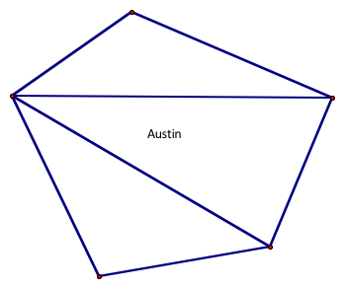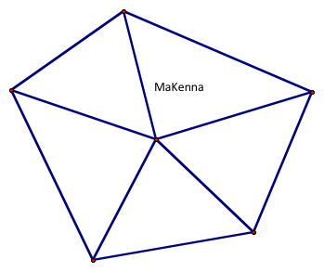
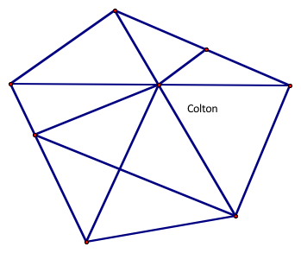
Austin has decided that he is going to start at one vertex and fan out the segments to all the other vertices in his pentagon, giving him _____ triangles, thus ________total degrees.

MaKenna has decided to put a point somewhere in the interior of the pentagon and connect that point to each of the vertices in the pentagon (kind of like the spokes of a wheel), giving her ____ triangles, thus ____ total degrees.

Colton just made triangles. He has ______ triangles, thus _____total degrees.

None of these methods is necessarily wrong, but we know that a pentagon has only one sum of angle measures and here we have three. What is wrong? What is right? Is it fair to say that while Colton isn’t necessarily wrong, his method is haphazard enough that it is difficult to find a pattern? What do we need to do to be able to use Austin or MaKenna’s method? Anything? Why?

We will assume that Austin and MaKenna’s ways are “better”, only because we can perhaps find a pattern that will lead us to a formula that makes sense for any n-gon. Haphazardness isn’t wrong, but finding a pattern will be impossible. Use Austin and MaKenna’s methods to fill out the chart below.

Austin’s Method (Fan Out) | MaKenna’s Method (Spokes of a Wheel)
# of sides # of triangles Sum of degrees  3 (triangle)  4 (quadrilateral)  5 (pentagon)  6 (hexagon)  7 (heptagon)  8 (octagon  N (n-gon) | # of sides # of triangles Sum of degrees  3 (triangle)  4 (quadrilateral)  5 (pentagon)  6 (hexagon)  7 (heptagon)  8 (octagon  N (n-gon)

Explanation of formula: Explanation of formula:

Notes:

