Consider the following problem:
This is a bridge of length 2: 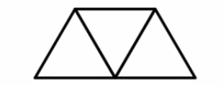

This is a bridge of length 3: 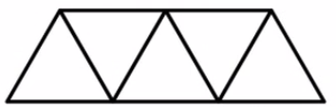

How many beams are in each bridge? _________ (length 2)

___________ (length 3)

How many beams are in a bridge of length 5? ________ How did you arrive at that result? [SHOW YOUR WORK OR DESCRIBE YOUR APPROACH BELOW. DISCUSS AT LEAST TWO DISTINCT WAYS.]

How many beams are in a bridge of length 10? _________ How did you arrive at that result? [SHOW YOUR WORK OR DESCRIBE YOUR APPROACH BELOW. DISCUSS AT LEAST TWO DISTINCT WAYS.]

Ms. Dixon asked students to generate expressions that connect the number of toothpicks and its length (n).
Robbie generated the expression 3 + 4(n - 1).
Taye generated the expression n + 2n + (n - 1).
Josephine generated the expression 3n + (n – 1).
Are any of these expressions correct? If not, justify with sufficient evidence that they are not correct. If so, (a) write an explanation that connects each term with a specific part of the figure and (b) describe how each expression is distinct from the others.

Hint: You might benefit from the visualization of the bridge to get you started. Feel free to draw upon it as needed.
