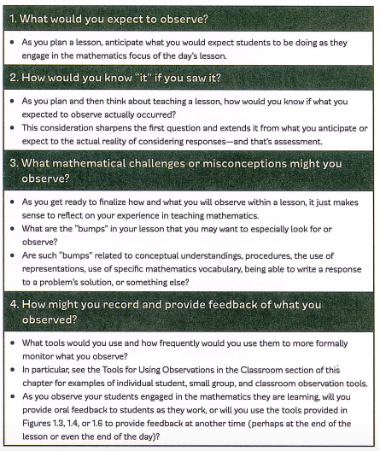

Fennell, F., Kobett, B., & Wray, J. (2017). *The formative 5: Everyday assessment techniques for every math classroom.* Thousand Oaks, CA: Corwin.

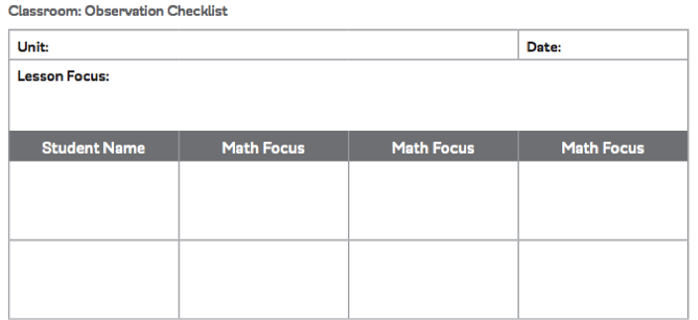

Fennell, F., Kobett, B., & Wray, J. (2017). *The formative 5: Everyday assessment techniques for every math classroom.* Thousand Oaks, CA: Corwin.

<https://resources.corwin.com/formative5/student-resources/observations>

