Lead in the Environment
Some Background Information
We know that lead has been mined and used by mankind for at least 6000 years. But its use was greatly increased during the industrial revolution.
The primary sources of lead in the environment today are from lead-based paints that were banned in the US in 1978 and combustion of leaded gasoline that was phased out in the US beginning in 1976 and eliminated from use in cars and trucks in 1986.
Children are more susceptible to lead poisoning than adults.
The Activity
In this activity you will be given three Tables with data related to lead in the environment and in children’s blood. Please use the data provided in the Tables to complete the tasks outlined below.
Table 1. Historical Comparisons of Blood Lead Levels (BLL) in 2 Years Old Children
Date | Location | Mean BLL (μg/dL)
Pre-industrial | US | 0.016
1970 | US | 15
1970 | Boston, MA | 20
2010 | US | 1.5
2010 | Boston, MA | 3
T1. How have blood lead levels (BLL) in children in the US changed from pre-industrial times to 2010.

T2. Why do you think these changes have occurred (what happened in the 1970s)?

T3.Why do you think there is a difference in the mean blood lead levels in children in Boston, MA compared to nation-wide?

Table 2. Elevated Blood Lead Levels in Children in Ohio Cities in 2020 and Age of Houses
City | % with elevated BLL | % of houses built before 1980
Akron | 2.0 % | 91 %
Bowling Green | 1.8 % | 53 %
Canton | 3.3 % | 89 %
Cincinnati | 2.6 % | 93 %
Cleveland | 9.7 % | 85 %
Columbus | 1.6 % | 58 %
Dayton | 2.0 % | 88 %
Perrysburg | 1.3 % | 39 %
Toledo | 5.8 % | 84 %
Youngstown | 5.8 % | 97 %
Zanesville | 3.1 % | 82 %
State-wide | 2.1 % | Median age = 52 years
T4. On the map on the next page, write the % of children with elevated lead levels and the % of houses built before 1980 for each of the cities.

T5. Do you see any correlation between the % of children with elevated lead levels and the % of houses built before 1980?

T6. What other factors do you think might affect the % of children with elevated lead levels in these cities (what are the different sources of lead in the environment)?

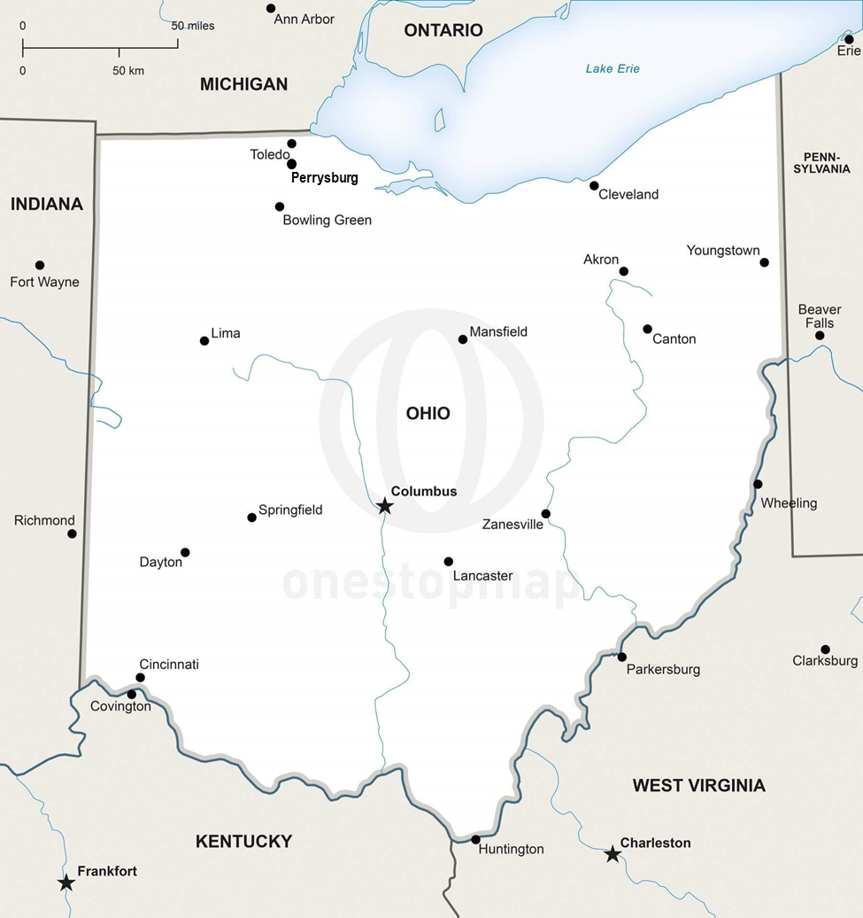

Table 3. CDC Action Levels for Blood Lead Levels in Children and mean value in US children
Date (year) |  | Action level (μg/dL) |  | Date (year) | Mean BLL in US Children (μg/dL)
1960 | 60
1973 | 40
1975 | 30 |  |  | 1978 | 15.2
1985 | 25 |  |  | 1990 | 3.6
1990 | 10 |  |  | 2000 | 1.9
2012 | 5 |  |  | 2012 | 0.8
2021 | 3.5 |  |  | 2018 | 0.6

T7. On the graph on the next page, please plot the action levels using circles (●) and the mean blood lead levels using squares (■) and draw a curve through each connecting the points.

T8. How have the action levels and mean blood lead levels in children in the US changed since 1960?

T9. What do you think caused these changes?
