Lead in Soils Around Your House
Some Background Information
What is Lead?
Lead is a naturally occurring element that has been used by humankind for more than 6000 years. It is one of the easiest metals to smelt and combined with its nonreactive nature, it has become one of the most widely used metals beginning with Roman times and with greatly expanded usage during the Industrial Revolution.
Heath Hazards of Lead
Unfortunately, lead has been shown to be highly toxic primarily affecting neurological functions by hindering the transmission of signals through neurocognitive pathways. As such, it damages the nervous system and causes damage to the brain, liver, and kidneys.

The risk of lead toxicity is greatest in children who tend to engage in hand to mouth ingestion of lead contaminated soils and dust. Also, children absorb 40% more lead into their blood than adults and they are in a critical brain development stage.
Elevated blood lead levels in children is known to cause slowed growth and development, learning and behavior problems, lower IQ, and decreased ability to pay attention and maintain self-control.
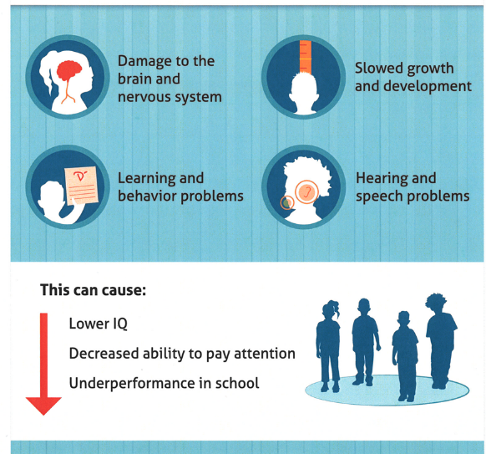 https://www.chesco.org/ImageRepository/
Document?documentID=52053
Sources of Lead in the Environment
There are numerous sources of lead in the environment but the primary sources in modern times are from historical uses of lead-based paint, leaded gasoline, and lead pipe and solder.
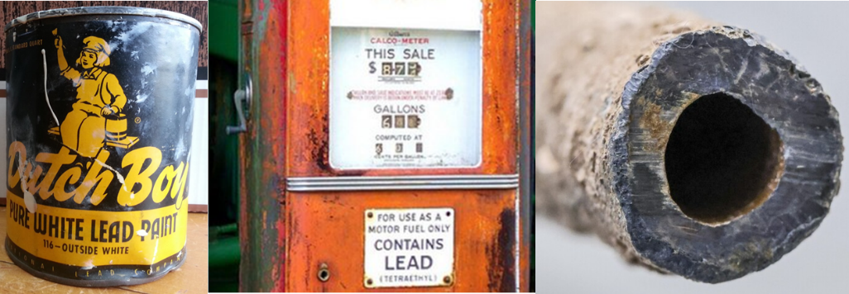
Lead Pathways to People
- Direct ingestion of contaminated soils
  - Hand to mouth especially young children
  - Contaminated soil adhered to produce (poorly washed)
- Inhalation of dust/fine particulates
  - Dust in the environment (working in garden)
  - Dust tracked into dwelling spaces (home and work)
  - Tobacco smoke
- Water and Food consumption
  - Water contaminated from pipes/solder
  - Lead in food grown in/on contaminated soils (plants and animals)
Distribution of Lead in Soils
There are four general location types of interest for evaluating lead in soils:
- General areas where children play like backyards, schoolyards and play grounds.
- Next to current or pre-existing buildings in so-called drip zones.
- Near busy roadways.
- In residential and community gardens.
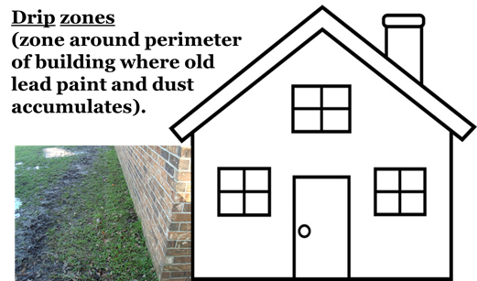
Soils Action Levels
Action levels refer to lead concentrations above which adverse health effects are probable.
- The median background concentration of lead in US agricultural soils is 11 ppm and ranges from 9 to 39 ppm in Ohio soils.
- The USEPA action level for lead in soils in children’s play areas is 400 ppm.
- The USEPA action level for lead in garden soils is 100 ppm.
- Soil lead action levels are 80 ppm in California, 100 ppm in Minnesota, and 250 ppm in Wisconsin.
The Activity
Following the instructions outlined below, you are to collect soil samples from around your house to determine their lead content. Plastic sample baggies and spoons are provided with the permission form. You are to bring your soil samples into class along with the signed permission form. You will be instructed on how to use the field portable Xray fluorescence spectrometer (FP-XRF powerpoint) and will analyze your own soil samples for lead and other heavy metals as part of the next session. The results for the class will be compiled and presented at the final session.
Soil Sampling Instructions
Choosing a Location
The most important step in soil sampling is collecting the appropriate sample.
NOTE: Always get the property owners permission before you collect your samples.
Sampling General Areas
- Lead has low solubility and mobility in soils, as such, in undisturbed soil the greatest concentration of lead is most often found in the top ~2 inches (5 cm).
- Always use clean tools and containers.
- Clear away any mulch, plants, or grass at the surface and dig down ~2 inches (5 cm) into the soil.
- Scoop 5-6 spoonfuls of soil into a clean baggie labeled with your name, the location (address) where the sample was collected, and the type of soil sample (backyard).
- Seal the baggie and then WASH YOUR HANDS.
- Bring the soil you collected to your teacher along with your permission slip signed by your parents or guardian.
Sampling Drip Zone
- The greatest source of lead in residential soils is from past use of lead-based paints that accumulate near the base of buildings from weathering or removing old paint in preparation for a new coat of paint. Lead-based paints were banned in 1978.
- You should collect samples from undisturbed locations that are ~2 feet away from a building (house, garage, barn, etc) follow similar procedure as outlined above.
Sampling near Busy Roadways
- Lead in fine soot produced from the combustion of leaded gasoline in cars and trucks is the second greatest source of lead in residential soils. Leaded gasoline was banned in 1996.
- You should collect samples 20-30 feet away from the roadway (away from any road construction materials) following similar procedure as outlined above. You should note the distance from the roadway.
Sampling Gardens
- Through typical gardening practices of tilling, weeding, and harvesting, lead can be transported throughout garden soils. As such, when sampling gardens you will want to take a series of samples at different depths.
- Begin by collecting a sample at the surface.
- Then dig down ~6 inches (~15 cm) and collect an intermediate depth sample, and then to ~12 inches (~30 cm) to collect a sample at root depth.
- Be certain to label the garden samples with their respective depths.
Labeling Baggies
You should label your bags with
- Your name
- The address where the sample was collected
- The type of sample (backyard, drip zone, near street, or garden with depth)
Also, you should note on the baggies or a slip of paper placed inside the baggie, any other comments/observations you have for the samples like, very wet, very hard, rocks, construction/demolition debris, thick leaf litter, etc.
It would also be useful if you can include information on the age of nearby buildings and whether they are painted or brick.

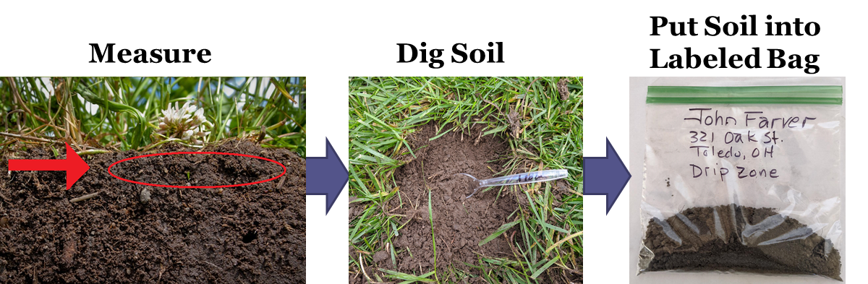
Then
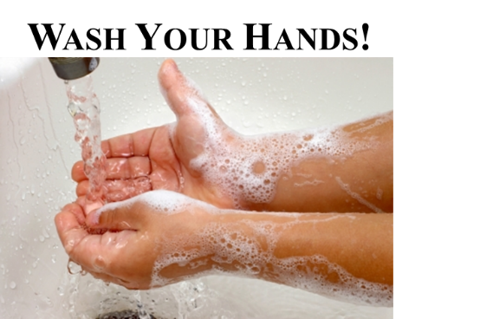

For general information regarding Lead Hazards to Children please visit the Center for Disease Control and Prevention website:
https://www.cdc.gov/nceh/lead/default.htm

