Lead in an Abandoned Lot Project

Dear Earth Scientists,

The city of Toledo, OH is interested in redeveloping this abandoned housing lot. They are hoping to put in community gardens, a moderate-sized playground, and a parking lot. The city is aware there used to be a house on the lot built in the 1920s. However, in the city building fire last year all records of old buildings were destroyed. The city is aware of the impacts of lead on humans, and therefore they are hiring us to figure out where the best location for the parking lot, playground, and gardens is. They only have the budget to test 6 samples, so you will need to determine the best locations to test. I’ve attached an outline of the steps I would follow for this task.
Please report back to me with a sketch of the probable house location and your suggestion of where to place the gardens, playground, and parking lot. Please include where the samples were taken and how much lead was found in them.

Good luck,
Your Boss

Recommended outline of steps:

- Talk to neighbors and see what they remember.
  - Find the envelope labeled “neighbor statements” each person gets to choose one card. That card has the statement from the neighbor they talked to.

- Walk around the property and see if you can find any evidence of a building.
  - Find the envelope labeled “evidence,” each person gets to choose one card. That is the evidence you noticed when walking around the property.

- Discuss with other investigators (your group) to see what they have found.
  - As a group, share and discuss what you find. Note any important clues on the records sheet.

- As a group, determine 6 sites to test.
  - Use the information you gathered to determine which 6 sites you would like to sample. The sites are labeled on the attached map. Note which sites you would like to sample on the records sheet.

- Check-in with the boss.
  - Get your sample site approved by a teacher and acquire the test results.

- As a group, determine where the playground, gardens, and parking lot should go.
  - Use the cards with set dimensions and move them around the lot as needed to make sure all spaces are safe for the public.
  - Background screening level (normally found in soil) is about 14 ppm.
  - USEPA suggests levels be below 100 ppm in gardens and below 400 ppm in areas where children play.

- Record recommendations on the records sheet and turn them in to the boss.
  - Your boss just got an email with more information! Let’s see what it says!

Toledo, OH Site 14 Development Outline

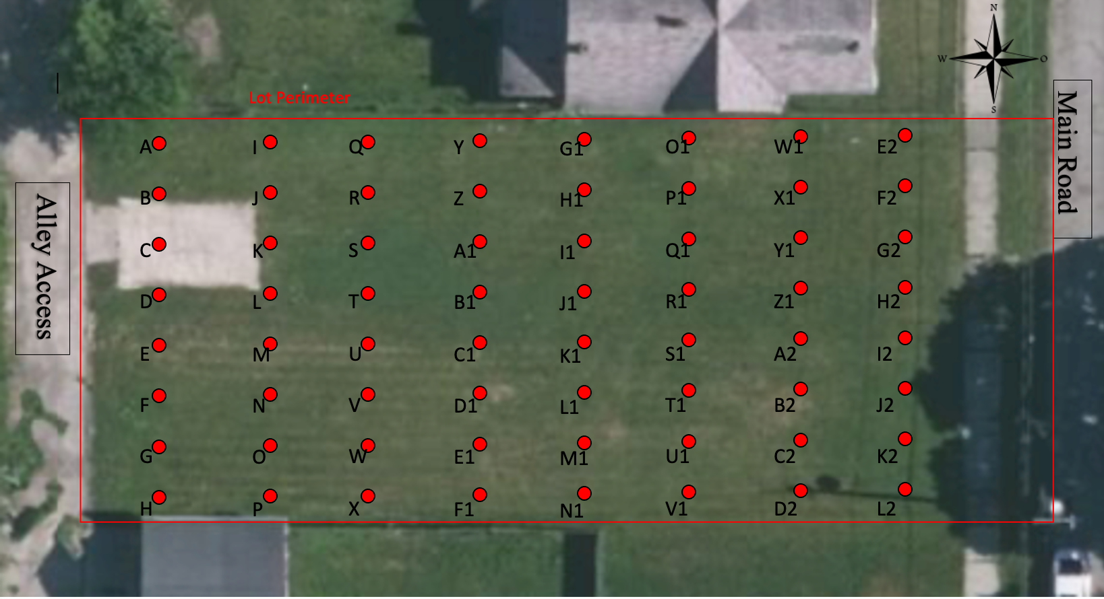

Data Report Sheet:
Researcher Names: ____________________________________________________________ ____________________________________________________________________________
Study Site: ___________________________________________________________________
Date: _____/_____/_____

Information Gathered from Neighbors:

Information Gathered from Evidence:

Study Sites chosen to test
Site ID | PPM Lead

- Record these test results on the map. Try your best to outline where a house may have stood. Do you think there was a shed on the land too? If so, try to outline that as well.

- The Environmental Protection Agency suggests less than 100 ppm of lead in garden soils and less than 400 ppm in areas where children play. Using this information, the results from your samples, and knowledge gathered from neighbors and evidence, use the garden, playground, and parking lot pieces to try to determine where they should go.

When your group is happy with the locations, outline the templates on your map (make sure to label them) and check in with your boss

Neighbor Statement:  - “I believe there was a house in the Northeast Corner of the property.” | Neighbor Statement:  - “I believe there was a house in the Northeast Corner of the property.”
Neighbor Statement:  - “I don’t remember any house there, but there was a shed in the Northwest corner when I moved in. The shed did not look very old” | Neighbor Statement:  - “I don’t remember any house there, but there was a shed in the Northwest corner when I moved in. The shed did not look very old”
Neighbor Statement:  - “There was most definitely a house there, it was falling apart and near the other house to the North! I can’t believe it didn’t take that one down with it!” | Neighbor Statement:  - “There was most definitely a house there, it was falling apart and near the other house to the North! I can’t believe it didn’t take that one down with it!”
Neighbor Statement:  - “The house was similar in length to the one to the North. | Neighbor Statement:  - “The house was similar in length to the one to the North.
Neighbor Statement:  - “I moved here recently. I don’t ever remember a house there. Sorry.” | Neighbor Statement:  - “I moved here recently. I don’t ever remember a house there. Sorry.”

Neighbor Statement:  - “I recall an old house in the Northeast part of the lot. It was about the same size as the other house. There was also a shed in the Northwest corner. It wasn’t very large and did not seem old.” | Neighbor Statement:  - “I recall an old house in the Northeast part of the lot. It was about the same size as the other house. There was also a shed in the Northwest corner. It wasn’t very large and did not seem old.”
Evidence:  - You found a piece of concrete near point W1. | Evidence:  - You found a piece of concrete near point W1.
Evidence:  - You have found an old wooden board near point R1. | Evidence:  - You have found an old wooden board near point R1.
Evidence:  - You have found flakes of paint and other debris near point J1. | Evidence:  - You have found flakes of paint and other debris near point J1.
Evidence:  - You couldn’t find any new evidence on your walk around the property. | Evidence:  - You couldn’t find any new evidence on your walk around the property.

Evidence:  - You found old building materials and debris near point Q1. | Evidence:  - You found old building materials and debris near point Q1.
Evidence:  - You found a pile of bricks at point K. | Evidence:  - You found a pile of bricks at point K.

Lead Concentration (ppm) from FP-XRF Analysis of Soils from Abandoned Lot
A  350 | I  55 | Q  100 | Y  250 | G1  1500 | O1  1346 | W1  1234 | E2  1239
B  200 | J  112 | R  32 | Z  72 | H1  1200 | P1  100 | X1  223 | F2  1420
C  150 | K  176 | S  26 | A1  55 | I1  2500 | Q1  300 | Y1  445 | G2  1100
D  13 | L  55 | T  17 | B1  91 | J1  1900 | R1  3100 | Z1  2500 | H2  1750
E  15 | M  16 | U  26 | C1  32 | K1  52 | S1  50 | A2  65 | I2  62
F  23 | N  12 | V  16 | D1  14 | L1  14 | T1  13 | B2  19 | J2  16
G  15 | O  14 | W  13 | E1  18 | M1  17 | U1  12 | C2  13 | K2  21
H  34 | P  23 | X  15 | F1  10 | N1  22 | V1  15 | D2  25 | L2  30
