Inspecting a House for Indoor Lead
Some Background Information
Lead poisoning remains a significant health concern especially for young children who engage in hand-to-mouth ingestion of dust/dirt. Lead dust in very small amounts (about the amount found in a sugar packet) is enough to poison a young child.
The primary sources of lead in the environment today are from lead-based paints that were banned in the US in 1978 and combustion of leaded gasoline that was phased out in the US beginning in 1976 and eliminated from use in cars and trucks in 1986.
Dust produced by grinding, sanding, flaking or peeling of lead-based paint inside the house or dust/dirt brought into the house on boots, cloths, toys, pets or food stuffs can result in lead contamination. Other potential sources of indoor lead include in water from lead pipes and solder and lead dust in outdoor air.
Sources of Indoor Lead
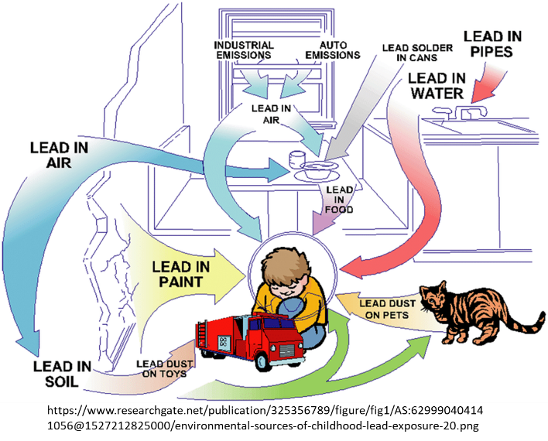
Areas that have a lot of traffic or movement are the main culprit. Windows and doors are potential areas for lead contamination concerns as they are opened and closed continuously and surfaces often rub against each other producing dust. Both window sills and frames can contain lead paint and chipping or peeling can occur, leading to contamination issues. Handrails or banisters are constantly being touched or grabbed, and if these surfaces have lead paint, they can become a source of contamination. Stairs are another problem area due to their high traffic levels and high wear.
Lead dust can accumulate in houses, especially on window sills and on floors. Rooms where children sleep or play are of particular concern due to longer/greater exposure to the lead dust.
The most common visual signs of paint wear include:
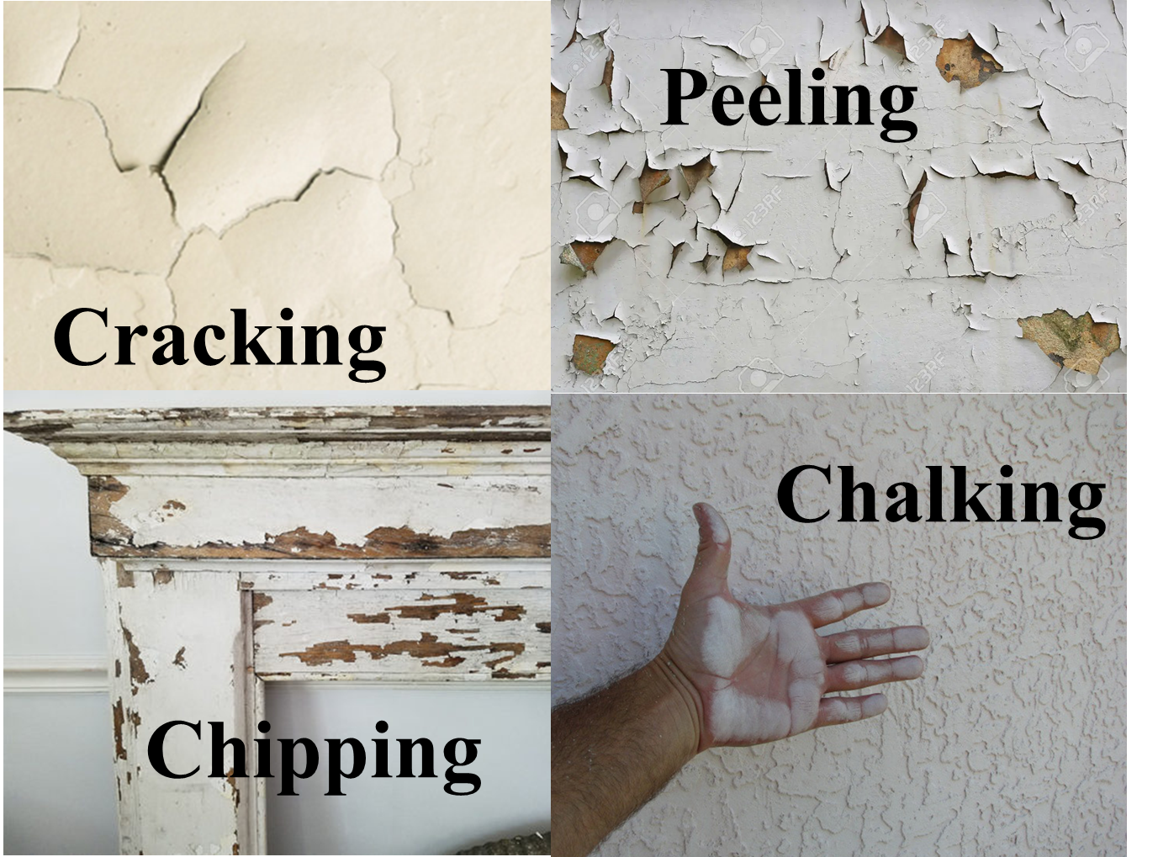
The Activity
Having heard that you were learning about lead in the environment at school, your neighbors asked if you would conduct a visual inspection of their house looking for potential lead contamination as they have two young children. Unfortunately, they are on a tight budget and can afford to analyze the lead content of only five samples.
You will be provided with pictures of 12 different locations in 6 different rooms and the stairway in the house. You should note:
- the house was built and originally painted in 1960
- the mudroom/backyard entry was renovated in 2000
- the master bedroom and the kitchen were renovated in 2010
Step 1. You are to inspect the pictures looking for signs of wear of the paint.
Step 2. Then consider the likelihood of lead hazard to children for each location and circle it on the table below.

Location | Likelihood of Lead Hazard to Children
Living Room Window Sill | Not likely | Likely | Very Likely
Living Room Floor | Not likely | Likely | Very Likely
Kitchen Window Sill | Not likely | Likely | Very Likely
Kitchen Door | Not likely | Likely | Very Likely
Master Bedroom Window Sill | Not likely | Likely | Very Likely
Master Bedroom Door | Not likely | Likely | Very Likely
Children’s Bedroom Window Sill | Not likely | Likely | Very Likely
Children’s Bedroom Door | Not likely | Likely | Very Likely
Bathroom Door Frame | Not likely | Likely | Very Likely
Bathroom Door | Not likely | Likely | Very Likely
Stairway | Not likely | Likely | Very Likely
Mudroom/Entryway | Not likely | Likely | Very Likely
Step 3. Identify the five locations that you would like to have analyzed for lead taking into account the age of the paint and the potential exposure to their children.
Step 4. In the spaces below, write the sample locations you think should be analyzed and in the boxes explain why you choose that sample location.
Sample location 1. ________________________
Explanation:

Sample location 2. ________________________
Explanation:

Sample location 3. ________________________
Explanation:

Sample location 4. ________________________
Explanation:

Sample location 5. ________________________
Explanation:

Step 5. Finally, discuss your selections with your group members explaining why you choose the five samples you did and see if they selected the same sample locations.
After discussing your selections with your group did you change any of them? If so, which ones and why?

For more information on house inspections for lead see:
http://www.hud.gov/offices/lead/training/visualassessment/h00101.htm
For more information on lead in the environment and its potential health effects see:
https://www.cdc.gov/nceh/lead/prevention/infographic-lead-in-environment.htm

