Chocolate Bar Task ∼ Cutting the Chocolate Bar

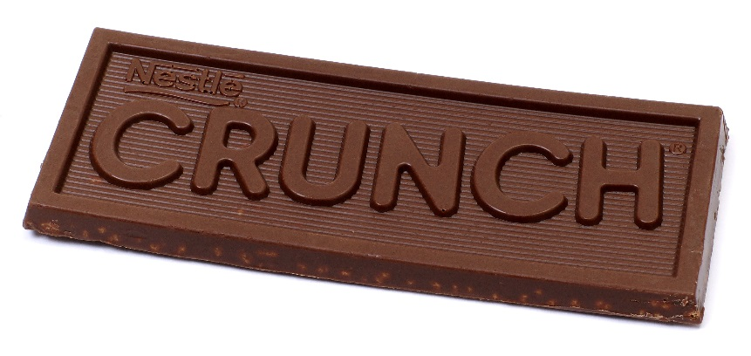
For this task, we will be cutting a chocolate bar into two pieces so that the length of one piece is a given fraction of the length of the whole chocolate bar. In order to do this, we will make one cut parallel to the short edges of the bar.

Save this part! ª/_{b} Eat this part!

1

Let’s practice first with a paper strip. Suppose your fraction is ⁵/₆. Where would you cut the paper strip so that the length of one piece is ⁵/₆ of the length of the whole strip? Do this individually first, and then discuss possible strategies with others at your table.

What strategies did you and your group use? What strategies might young students use?

When you receive your bag of supplies, take a fraction card and a chocolate bar. Accurately cut the chocolate bar so that the length of one piece represents your fraction of the length of the whole bar. Put that piece on a napkin along with your fraction card, and eat the other piece! (If there are extra fraction cards, work together to cut the remaining chocolate bars so that you will have a full set.)

What might you ask about the pieces of chocolate at your table?

Chocolate Bar Task ∼ Comparing the Pieces

Which piece of chocolate is the longest? Which is the shortest?

Arrange the pieces of chocolate in order from the shortest length to the longest length. List the order of the corresponding fractions below.

__________ __________ __________ __________ __________

Using what you know about fractions, does this order make sense? If not, what changes should be made?

Use reasoning to explain why each fraction is larger or smaller than another.

What are some common procedures that we teach for comparing fractions? Use the chocolate bar situation to explain why these work.

Student Reasoning about Comparing Fractions

Analyze each student’s reasoning. Is the student’s reasoning correct? If so, why does it work? If not, why is it incorrect and how would you address the student’s misconception?

1. Sam has a method for comparing fractions. He just looks at the numerator. Sam says the fraction with the larger numerator is bigger because it has more pieces.

2. Keisha says that fractions that use bigger numbers are greater than fractions that use smaller numbers.

3. Deshawn knows an easy way to compare two fractions with the same numerators. He just looks at the denominators. Deshawn says that the fraction with the larger denominator is the smaller fraction.

4. Ashley compares fractions by looking at the difference between the denominator and the numerator of each fraction. She says that the fraction with the larger difference is the smaller fraction because it is farther from the whole.

Adapted from Mathematics for Elementary Teachers, Beckmann, 2014

