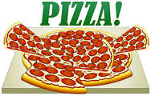 THE PIZZA COMPARISON TASK

Goal | To help students understand that a fraction tells us only about the relationship between the part and the whole, not about the size of the whole or the size of the parts. (Adapted from Van de Walle [2004, p.254].)
Task | Think carefully about the following question. Write a complete answer. You may use drawings, words, or numbers to explain your answer. Be sure to show all your work.  Jose ate ½ of a pizza.  Ella ate ½ of another pizza.  Jose said that he ate more pizza than Ella, but Ella said they both ate the same amount. Use words and pictures to show that Jose could be right.

