Leapfrog Fractions

These leaping frogs are playing a fraction game.
They leap from lily pad to lily pad adding up the fractions as they go.

They have just three lily pads each.

When they have counted up to one whole, and no more, they can reach the island in the center of the lake.

- Complete the lily pad fractions so that these five frogs can get to the island. Write your answers on the empty lily pads.
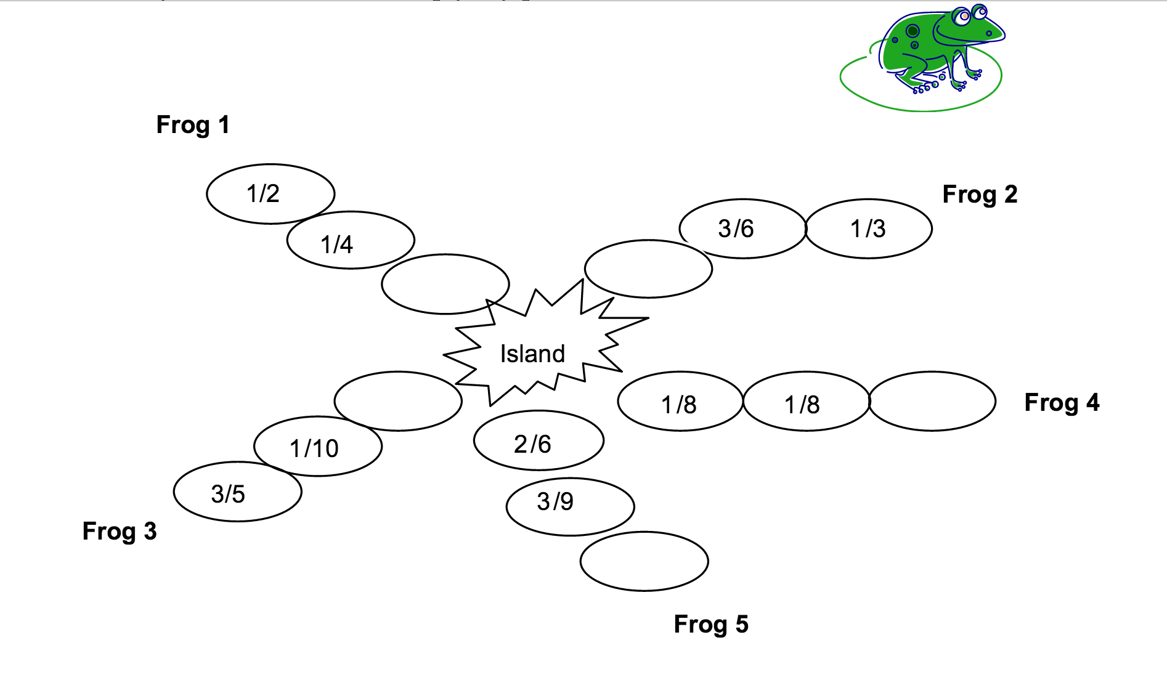
- Frog number 6 wants to join his friends on the island. His three lily pads are: ¼ + 1/5 + 10/20

Can he make it? Show how you figured this out.

