Leaves and Caterpillars Task
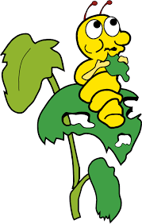
A fourth-grade class needs 5 leaves each day to feed its 2 caterpillars. How many leaves would the students need each day for 12 caterpillars?

