Letter Vessels – Part 2
The height of the pool of water in one of the vessels is measured and a graph of the height as a function of time is plotted (shown below).
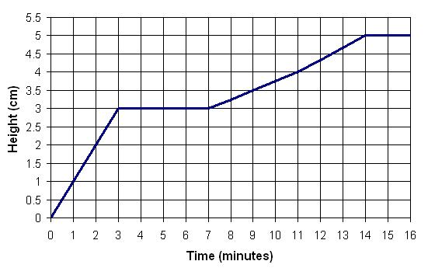
4. Which vessel was used to make this graph? Explain your reasoning with specific details from the graph and the vessel.

5. A very observant student notices that the given graph is actually slightly inaccurate: at certain points it is an over-measurement and at certain points it is an under-measurement. Where is this happening on the graph?

Adapted from Math Fillers, NRICH enriching mathematics. University of Cambridge. http://nrich.maths.org/6424

