Letter Vessels – Part 1
A series of vessels look like letters when viewed face-on. They are 1 cm thick, and the corners of the vessels have either whole or half cm values for their coordinates.
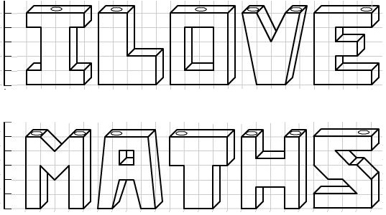

Water is poured slowly into each vessel through one of the holes at the top at a rate of 1 cubic centimeter per second.
1. Seven of these vessels take the same time to fill up. Which are they?

2. Which one takes the longest to fill?

3. Which vessel would fill up fastest?

