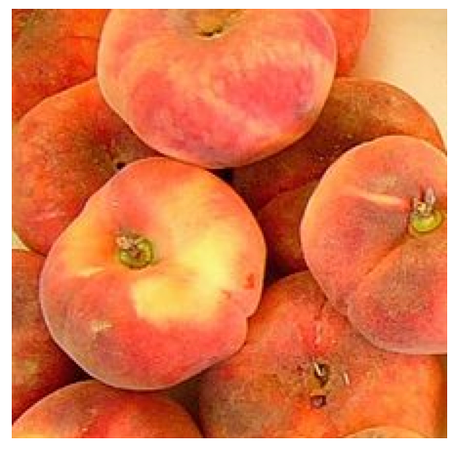

Peaches Today…Peaches Tomorrow

(i) A little monkey had 60 peaches.
On the first day he decided to keep 3/4 of his peaches.
He gave the rest away. Then he ate one.
On the second day he decided to keep 7/11 of his peaches.
He gave the rest away. Then he ate one.
On the third day he decided to keep 5/9 of his peaches.
He gave the rest away. Then he ate one.
On the fourth day he decided to keep 2/7 of his peaches.
He gave the rest away. Then he ate one.
On the fifth day he decided to keep 2/3 of his peaches.
He gave the rest away. Then he ate one.
How many did he have left at the end?

(ii) A little monkey had 75 peaches.
Each day, he kept a fraction of his peaches, gave the rest away, and then ate one.
These are the fractions he decided to keep:
1/2,1/4,3/4,3/5,5/6,11/15
In which order did he use the fractions so that he was left with just one peach at the end?

(iii) Peach Rationing
Whenever the monkey has peaches, he always keeps a fraction of them each day, gives the rest away, and then eats one.
I wonder how long he could make his peaches last for?
Here are his rules:
- Each fraction must be in its simplest form and must be less than 1.
- The denominator is never the same as the number of peaches left (for example, if there were 45 peaches left, he would not be allowed to keep 44/45 of them).
Can you start with fewer than 100 peaches and choose fractions so that there is at least one peach left after a week?

http://nrich.maths.org/

