*Understanding Fraction Division with Cookies*

(adapted from Gregg, Jeff, and Gregg, Dana Underwood. Measurement and fair-sharing

models for dividing fractions. *Mathematics Teaching in the Middle School*, 12(9): 490-496)

Serving size is not always a whole number. For example, on a package of cookies, a serving size could be 2 cookies, or it could be 1½ cookies.

For each of the following scenarios, you are given the size of a serving. Use this information to determine how many servings you have in the given amount of cookies. Then write a division number sentence.

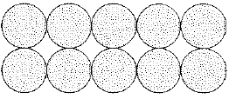

1. A serving is 5 cookies. How many servings

can I make from 10 cookies?

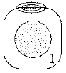

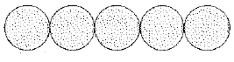2. A serving is 1 cookie. How many servings

can I make from 5 cookies?



3. A serving is ½ cookie. How many servings

can I make from 5 cookies?



4. A serving is ¼ cookie. How many servings

can I make from 5 cookies?

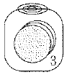

5. A serving is 3 cookies. How many servings

can I make from 5 cookies?

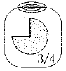

6. A serving is ¾ cookie. How many servings

can I make from 5 cookies?



7. A serving is 2/3 cookie. How many

servings can I make from 5 cookies?

8. A serving is ½ cookie. How many servings can I make from ¾ cookie?



9. A serving is ½ cookie. How many servings can I make from 3/8 cookie?



10. A serving is ½ cookie. How many servings can I make from 5/8 cookie?

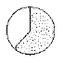

11. A serving is ¾ cookie. How many servings can I make from ½ cookie?



12. A serving is 5/8 cookie. How many servings can I make from ½ cookie?