HOW MUCH CHOCOLATE DO I GET?

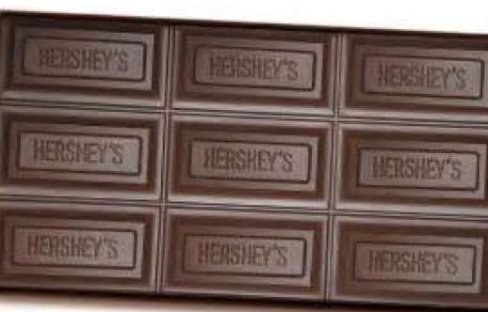

Sammy has a chocolate candy bar and 12 great friends. His candy bar has 9 pieces and Sammy wants to share his chocolate equally. How much of a candy bar will Sammy and each of his friends get if the chocolate is shared equally?

Show on the candy bar what Sammy and each friend will receive.

If Sammy wanted to make breaking up the candy bar easier how many friends should he share with?

