Problem Solving with Ratios, Proportion, and Percent

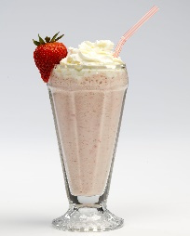
1) Chandra made a milkshake by mixing ¹/₂ cup of ice cream with ³/₄ cup of
milk. How many cups of ice cream and milk should Chandra use if she
wants to make the same milkshake with the following amounts:

(a) using 3 cups of ice cream

(b) to make 3 cups of milkshake

2) Russell was supposed to mix 3 tablespoons of weed killer concentrate with 1³/₄ cups of
water to make a weed killer. By accident, Russell put in an extra tablespoon of weed
killer concentrate. How much water should Russell add to his mixture to correct for his
mistake?

3) A restaurant server received a $7 tip on a meal he served. If this tip represents 20% of
the cost of the meal, then how much did the meal cost?

4) Skateboard Problems from Progressions for the Common Core State Standards in
Mathematics, 6-7, Ratios and Proportional Reasoning
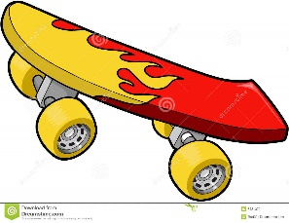
Skateboard Problem 1: After a 20% discount, the price of a SuperSick
skateboard is $140. What was the price before this discount?

Skateboard Problem 2: A SuperSick skateboard costs $140 now, but its price will go up by 20%. What will the new price be after the increase?

