Comparing Mixtures
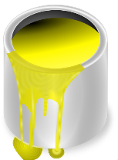
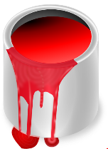
Abby’s orange paint is made by mixing 1 cup of red paint for every 3 cups of yellow paint. Zack’s orange paint is made by mixing 3 cups of red paint for every 5 cups of yellow paint. How do the shades of their orange paints compare?

