Logic Puzzles that Build
Spatial Reasoning

Extra Puzzles to Solve

Jeffrey Wanko

wankojj@miamioh.edu

Miami University

Oxford, OH

Presented at Black Swamp Math Teachers' Circle

July 29, 2015

Sashigane  - Divide the grid into L-shaped blocks.  - Cells with circles form a “bend” in the block  - The number in a circle shows the number of cells in its block. Circles without numbers allow the block to contain any number of cells  - Cells with arrows form one end of its block. The arrow points towards the “bend” in its block.  - The number of markings in a block may be 0, 1, 2 or 3. | Yosenabe  - Move all circles, vertically or horizontally, so they enter the gray areas.  - Show the movement of a circle by an arrow.  - The arrows do not bend, and do not cross other white circles or lines of other arrows.  - The number in a gray area must be equal to the total of the numbers of the circles that enter the area.  - Empty gray areas may have any sum total.  - At least one circle must enter a gray area.
Faibu Seruzu  - Divide the grid into pentominoes.  - Each number in the grid indicates the number of sides of the square around the number that are used.  - Each square of the grid must be included in exactly one pentomino piece; in other words, every grid square must be used but no pentominoes may overlap. | Habi-Loop  - Every square in the grid must contain either a black square, or a part of the closed loop.  - Lines can only be horizontal or vertical and cannot cross another line.  - Squares with a letter can be either part of the loop or blacked out.  - If a letter is blacked out all of the other squares with the same letter must be blacked out.  - Blacked out squares cannot be adjacent and only squares with letters can be blacked out.  - The direction of the loop coming in and going out of a square with a letter, must have the same direction for all of the other squares with the same letter.
Herugolf

- Move all circles vertically or horizontally, so they end at an “H” (Hole).
- Show the movement of a circle by an arrow.
- The number in the circle represents the maximum number of “strokes” to get to a hole.
- The first “stroke” must travel the length of the circled number.
- Each successive stroke, if used, must be reduced by 1. (Starting from a 4, the first movement must be 4 units, the second must be 3 and so on).
- Lines cannot stop in a grey cell or move off of the grid.
- Lines cannot cross.
Puzzle Rules
SASHIGANE
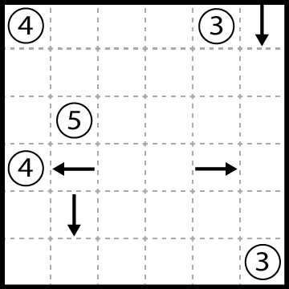 | 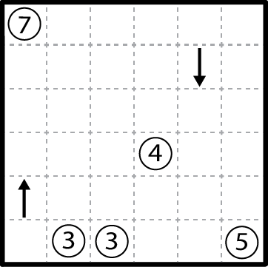
Sashigane Puzzle 1 | Sashigane Puzzle 2
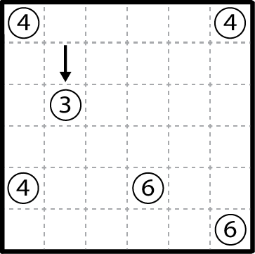 | 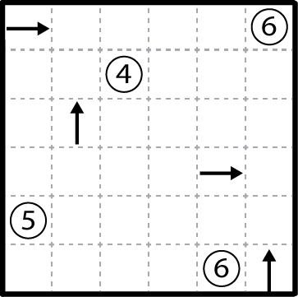
Sashigane Puzzle 3 | Sashigane Puzzle 4
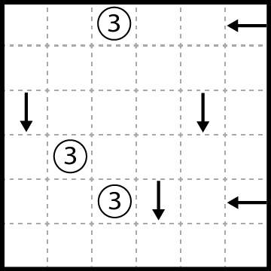 | 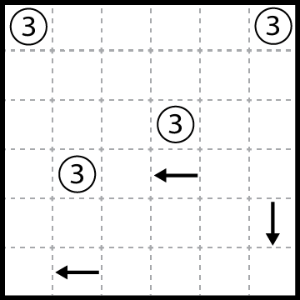
Sashigane Puzzle 5 | Sashigane Puzzle 6
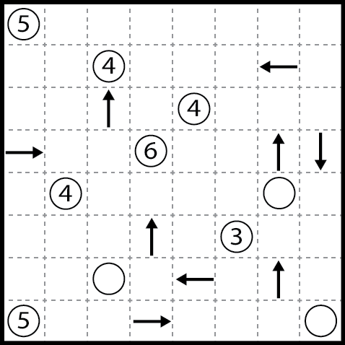 | 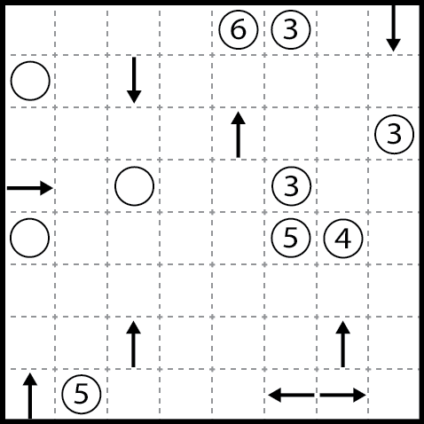
Sashigane Puzzle 7 | Sashigane Puzzle 8
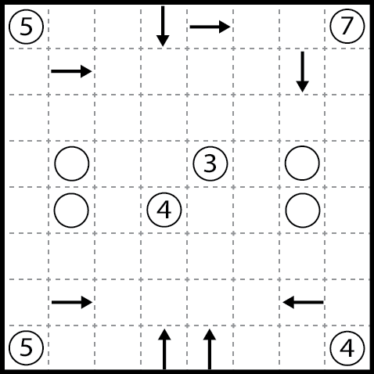 | 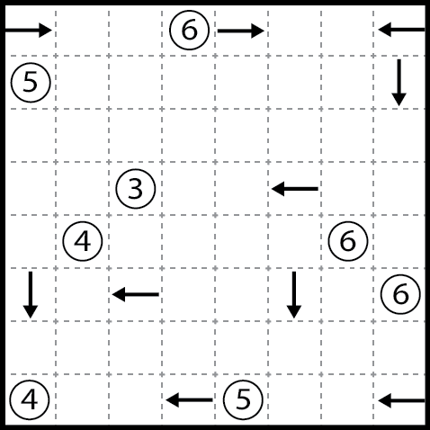
Sashigane Puzzle 9 | Sashigane Puzzle 10
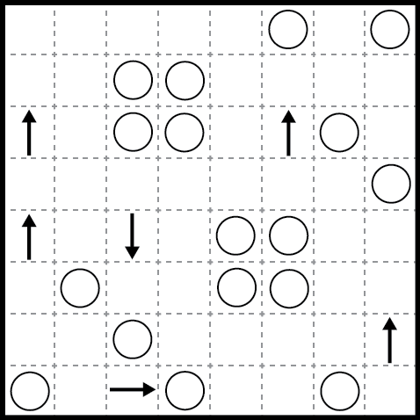 | 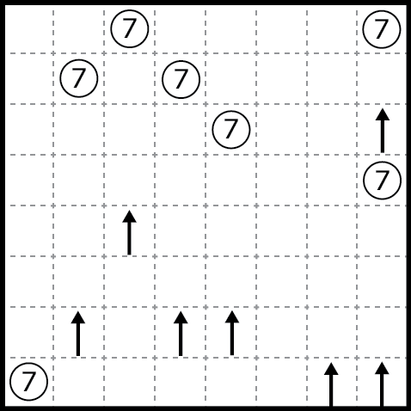
Sashigane Puzzle 11 | Sashigane Puzzle 12
YOSENABE
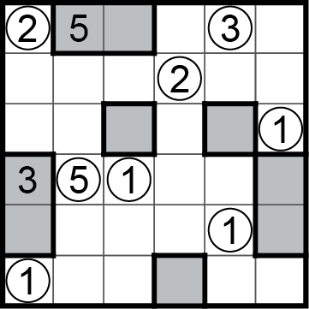 | 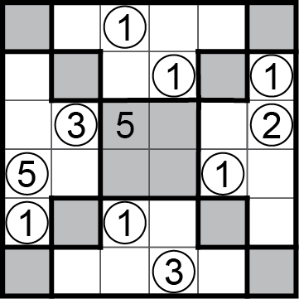
Yosenabe Puzzle 1 | Yosenabe Puzzle 2
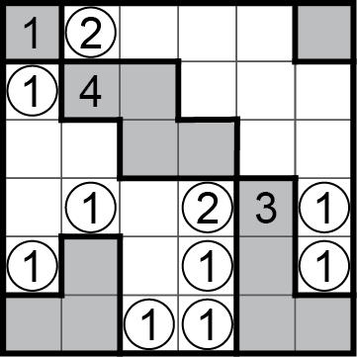 | 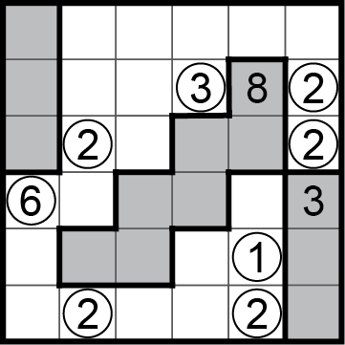
Yosenabe Puzzle 3 | Yosenabe Puzzle 4
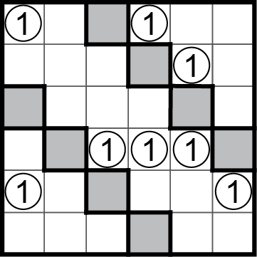 | 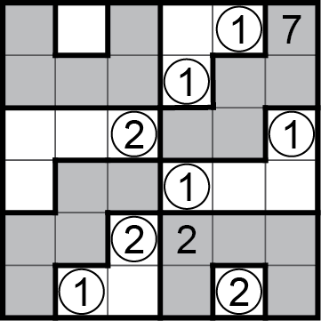
Yosenabe Puzzle 5 | Yosenabe Puzzle 6
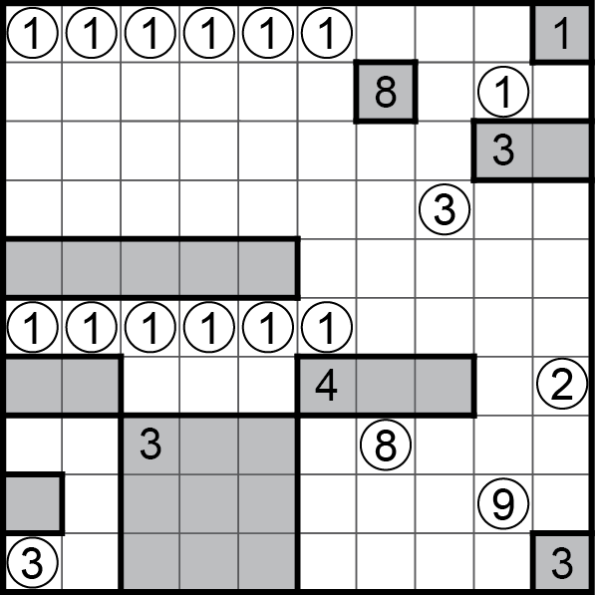 | 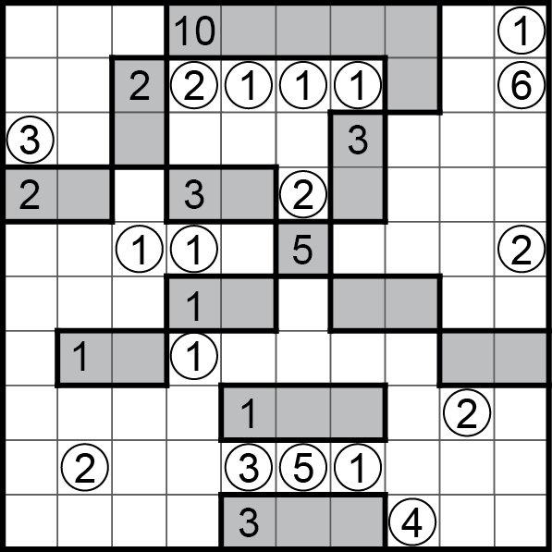
Yosenabe Puzzle 7 | Yosenabe Puzzle 8
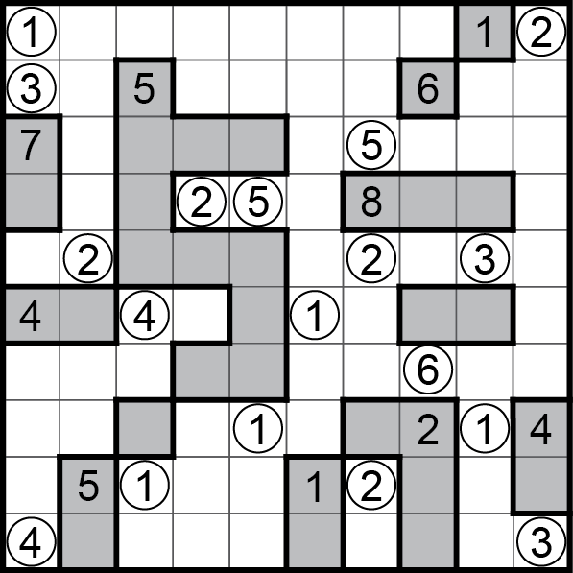 | 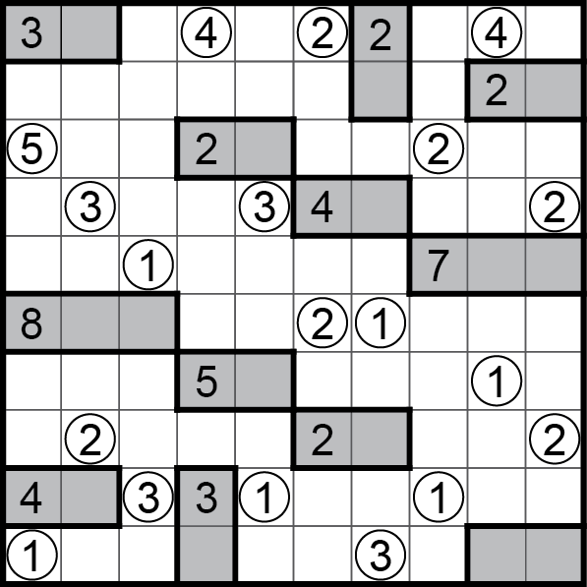
Yosenabe Puzzle 9 | Yosenabe Puzzle 10
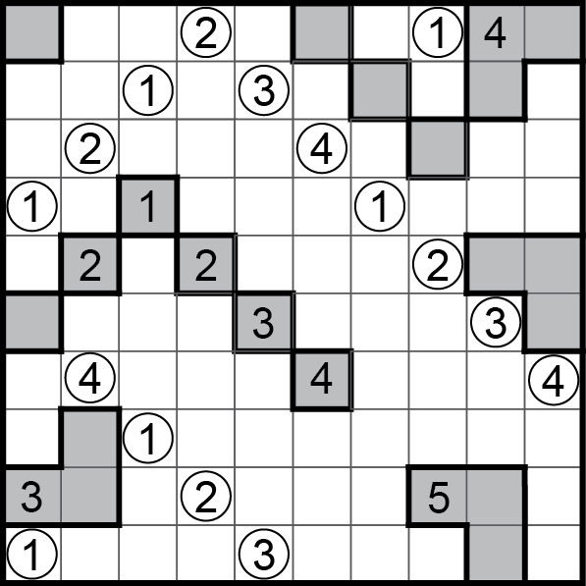 | 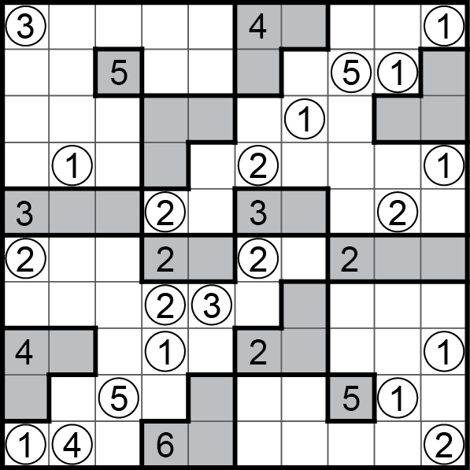
Yosenabe Puzzle 11 | Yosenabe Puzzle 12

FAIBU SERUZU
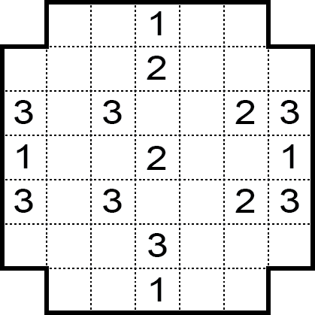 | 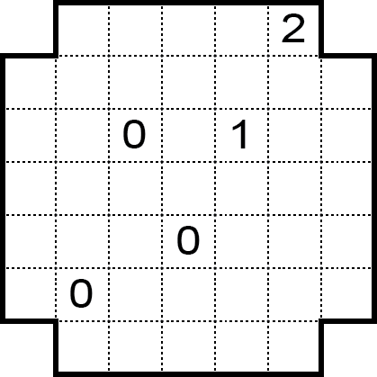
Faibu Seruzu Puzzle 1 | Faibu Seruzu Puzzle 2
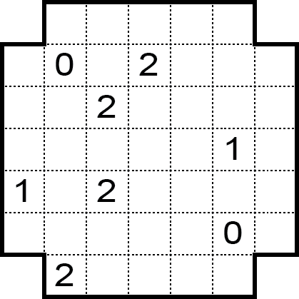 | 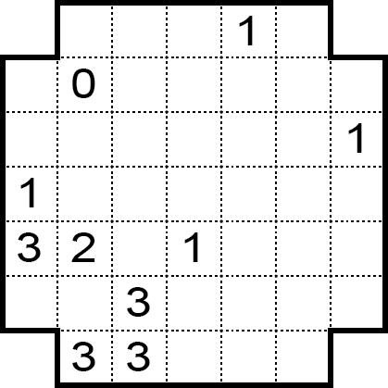
Faibu Seruzu Puzzle 3 | Faibu Seruzu Puzzle 4
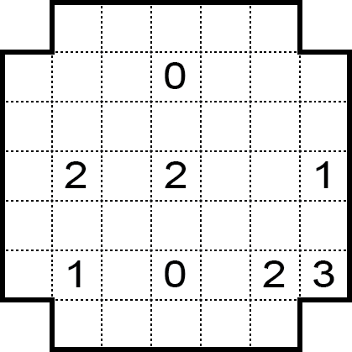 | 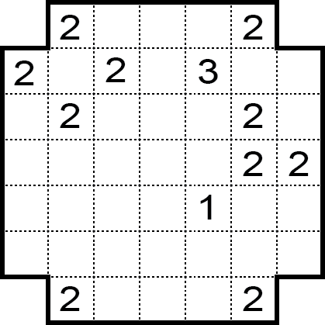
Faibu Seruzu Puzzle 5 | Faibu Seruzu Puzzle 6
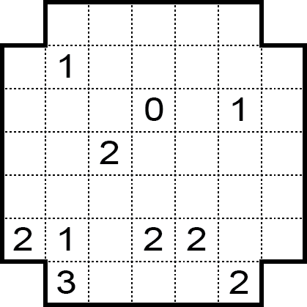 | 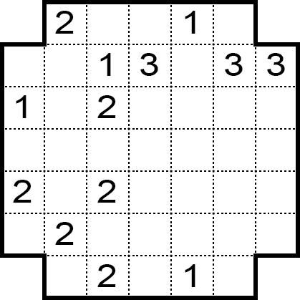
Faibu Seruzu Puzzle 7 | Faibu Seruzu Puzzle 8
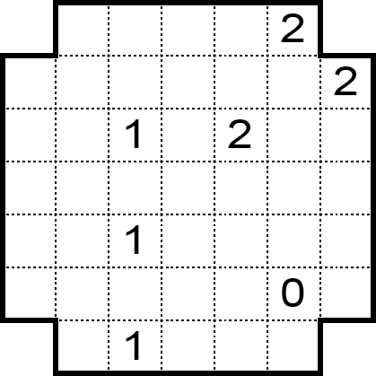 | 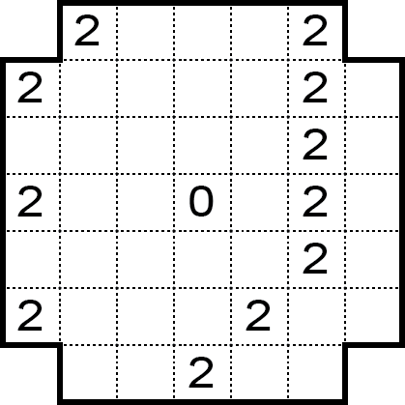
Faibu Seruzu Puzzle 9 | Faibu Seruzu Puzzle 10
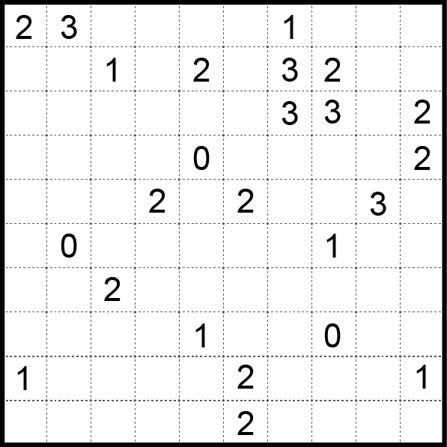 | 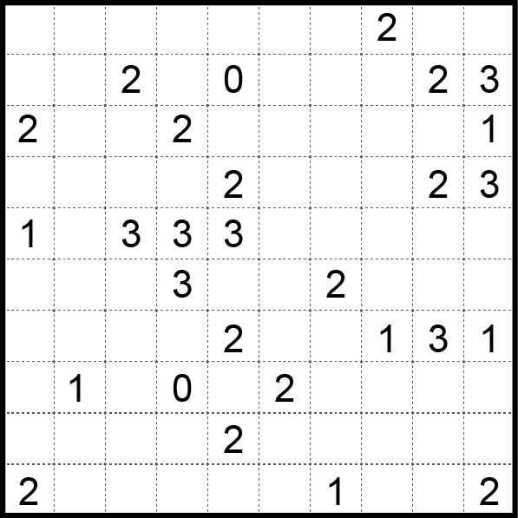
Faibu Seruzu Puzzle 11 | Faibu Seruzu Puzzle 12

HABI-LOOP
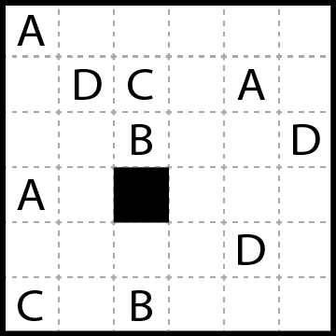 | 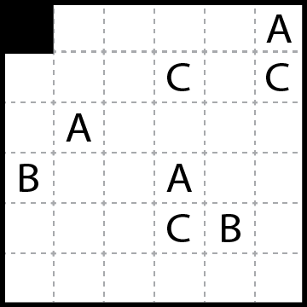
Habi-Loop Puzzle 1 | Habi-Loop Puzzle 2
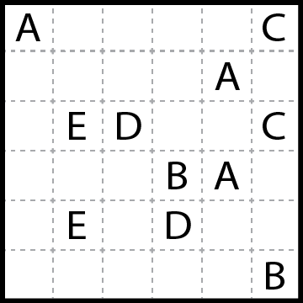 | 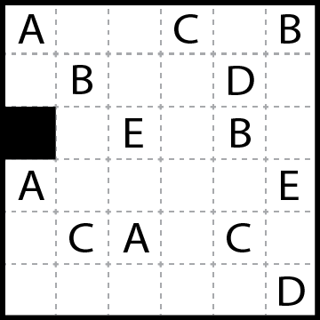
Habi-Loop Puzzle 3 | Habi-Loop Puzzle 4
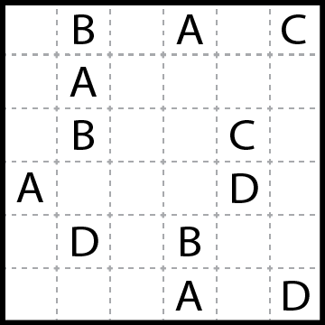 | 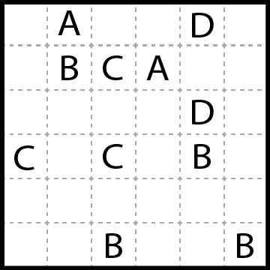
Habi-Loop Puzzle 5 | Habi-Loop Puzzle 6
`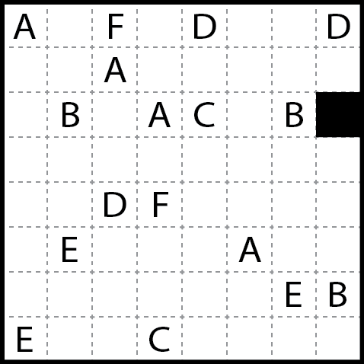 | 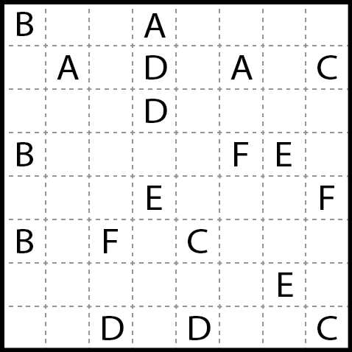
Habi-Loop Puzzle 7 | Habi-Loop Puzzle 8
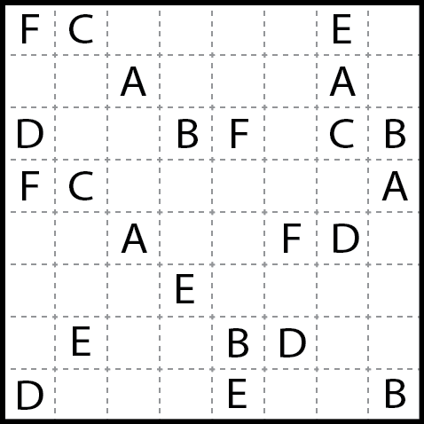 | 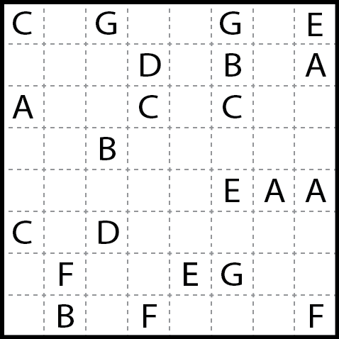
Habi-Loop Puzzle 9 | Habi-Loop Puzzle 10
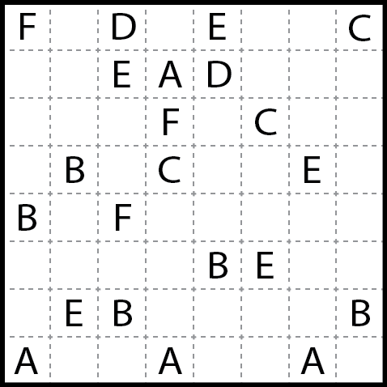 | 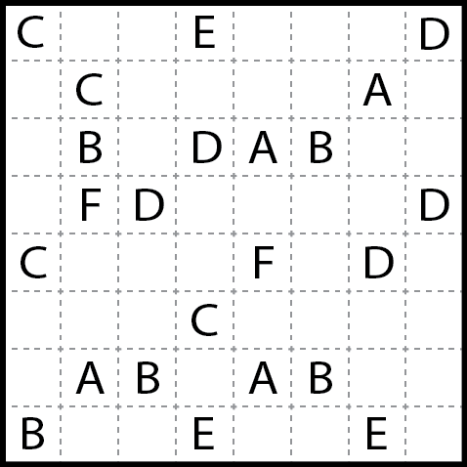
Habi-Loop Puzzle 11 | Habi-Loop Puzzle 12

HERUGOLF
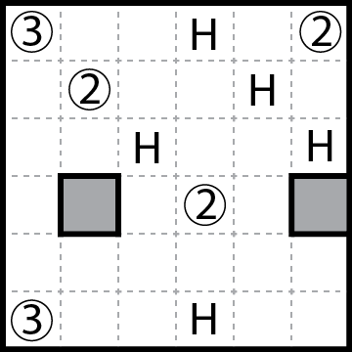 | 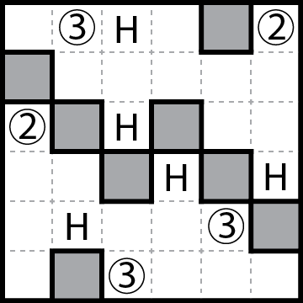
Herugolf Puzzle 1 | Herugolf Puzzle 2
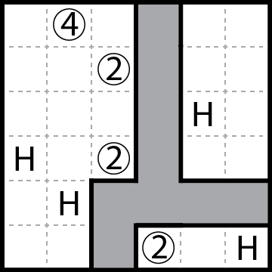 | 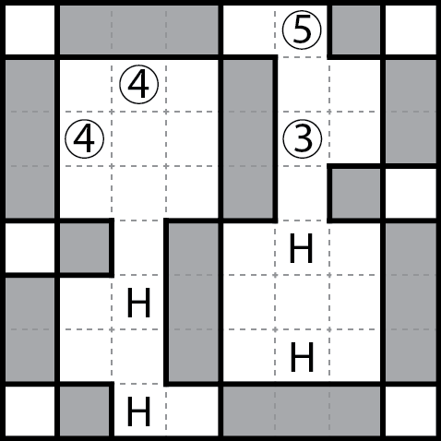
Herugolf Puzzle 3 | Herugolf Puzzle 4
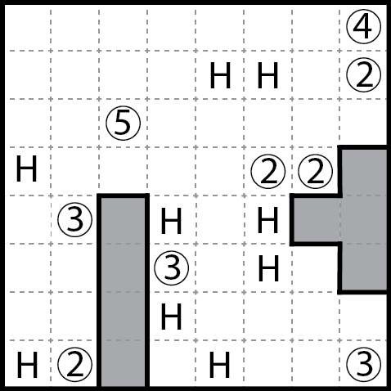 | 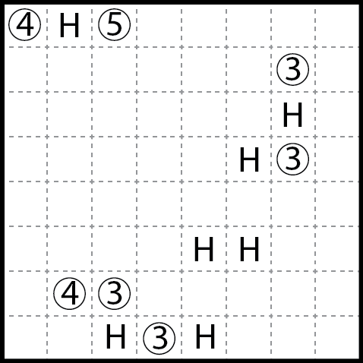
Herugolf Puzzle 5 | Herugolf Puzzle 6
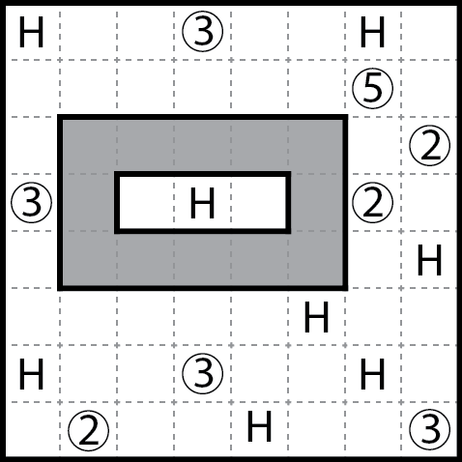 | 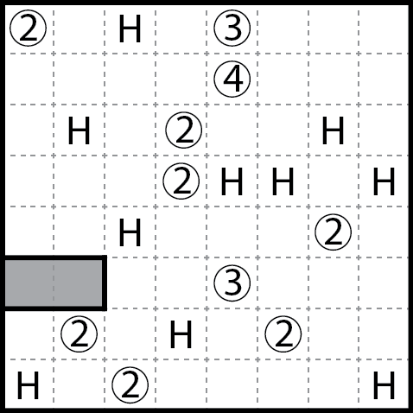
Herugolf Puzzle 7 | Herugolf Puzzle 8
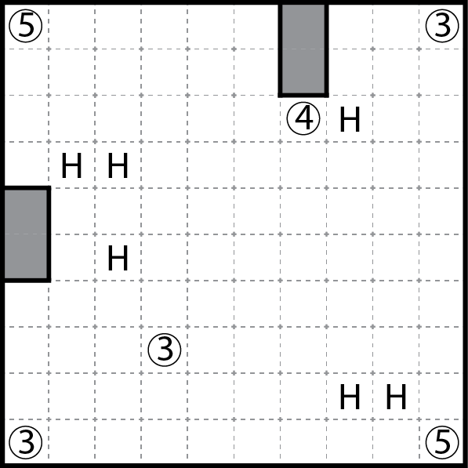 | 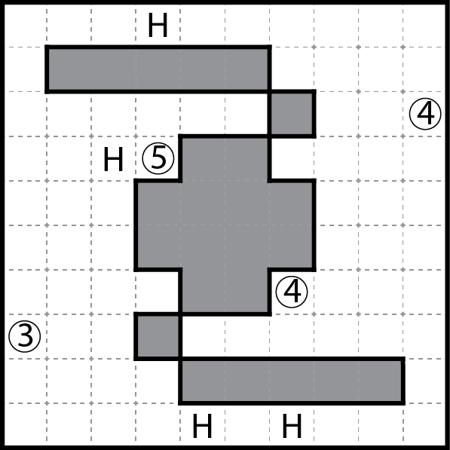
Herugolf Puzzle 9 | Herugolf Puzzle 10
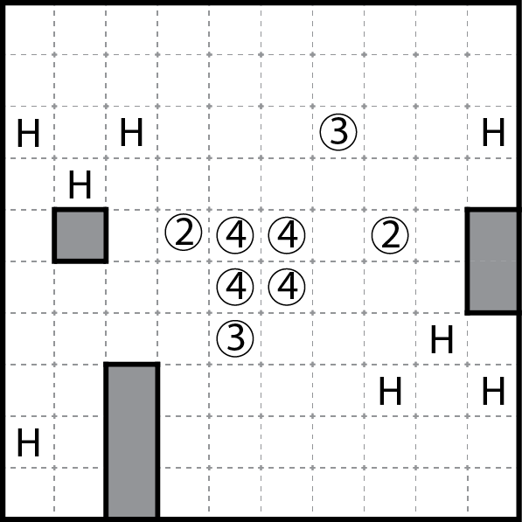 | 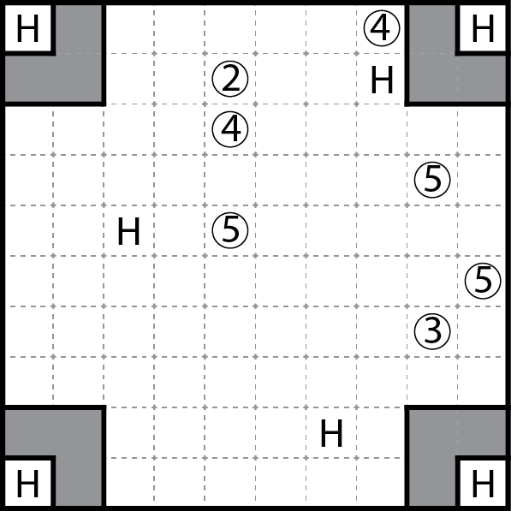
Herugolf Puzzle 11 | Herugolf Puzzle 12

SOLUTIONS

Sashigane

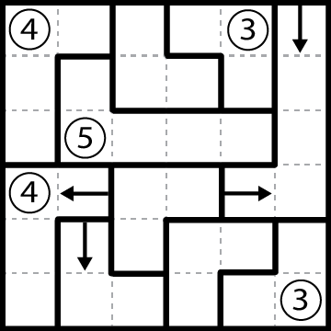 | 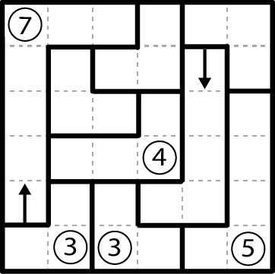 | 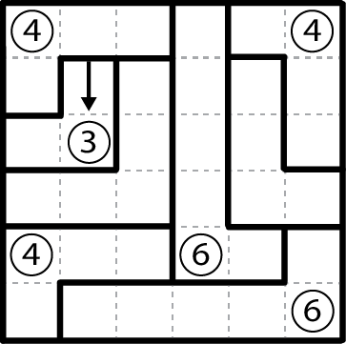
Puzzle 1 | Puzzle 2 | Puzzle 3

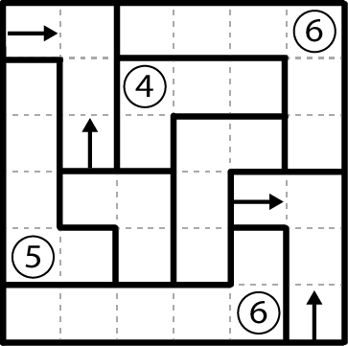 | 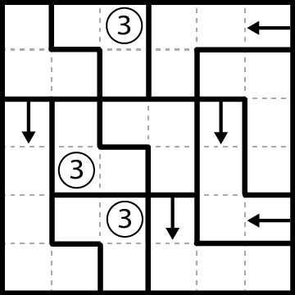 | 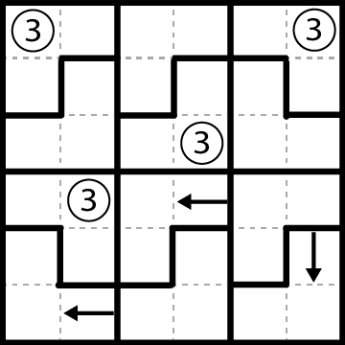
Puzzle 4 | Puzzle 5 | Puzzle 6

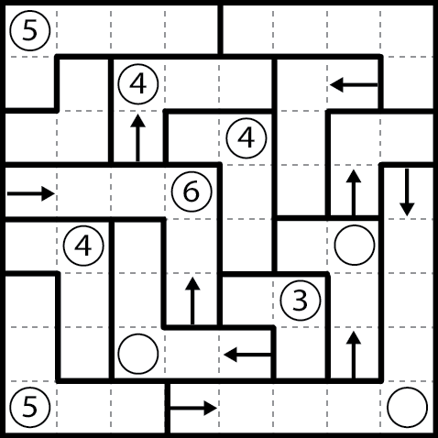 | 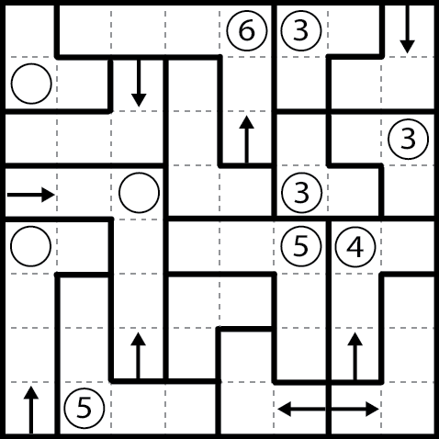 | 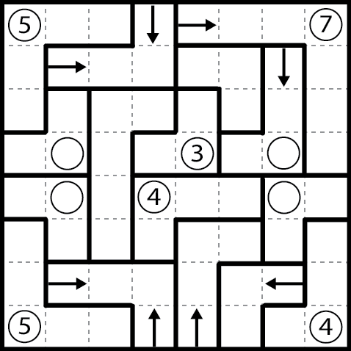
Puzzle 7 | Puzzle 8 | Puzzle 9

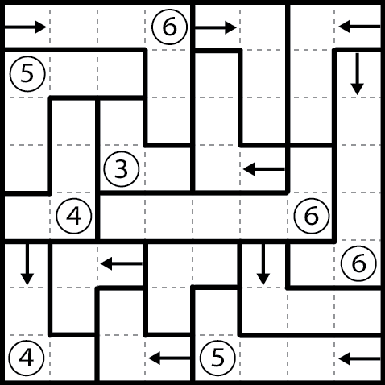 | 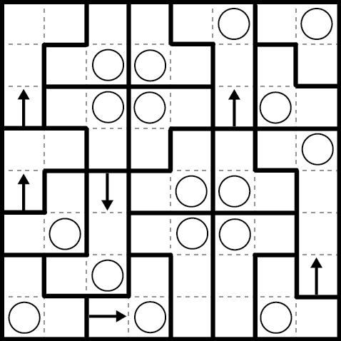 | 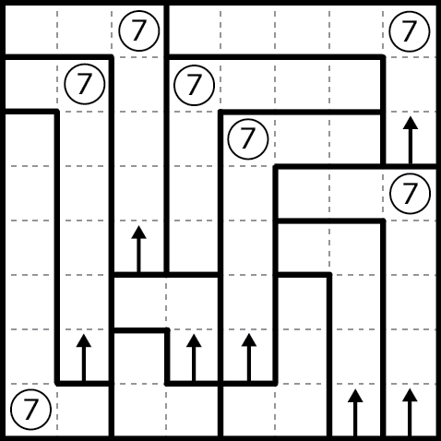
Puzzle 10 | Puzzle 11 | Puzzle 12

SOLUTIONS

Yosenabe

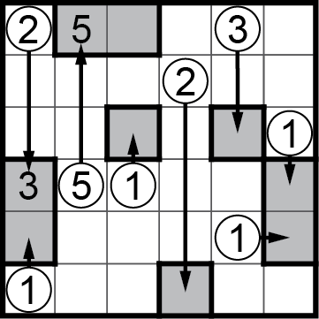 | 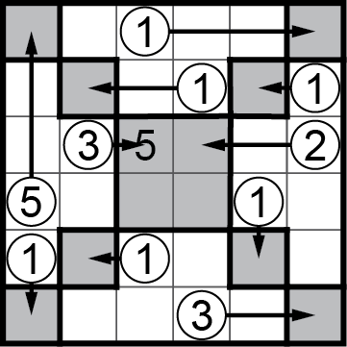 | 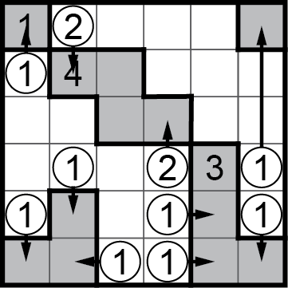
Puzzle 1 | Puzzle 2 | Puzzle 3

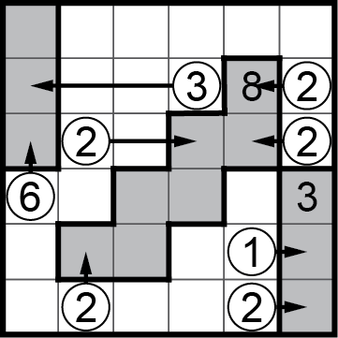 | 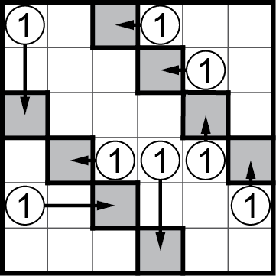 | 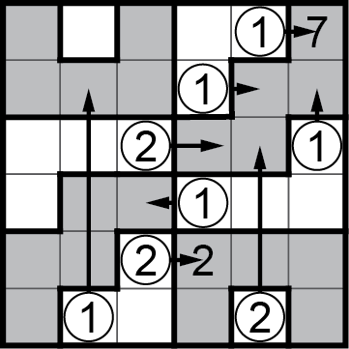
Puzzle 4 | Puzzle 5 | Puzzle 6

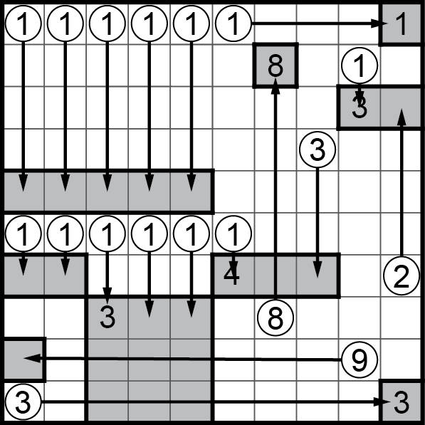 | 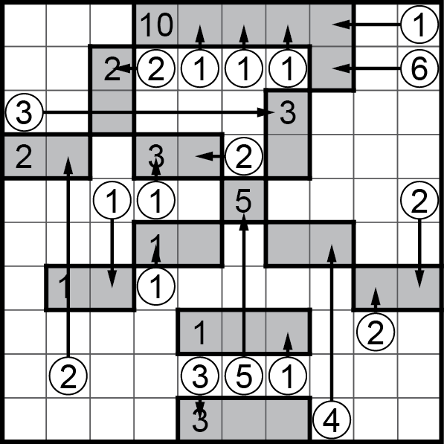 | 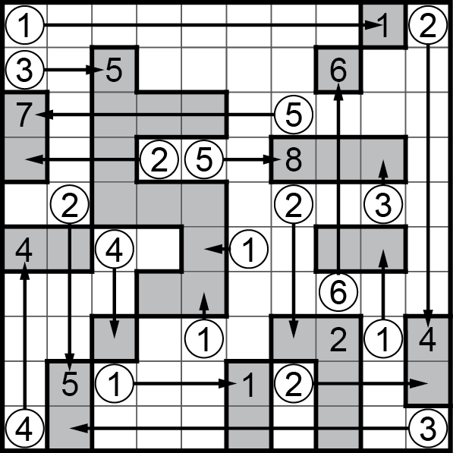
Puzzle 7 | Puzzle 8 | Puzzle 9

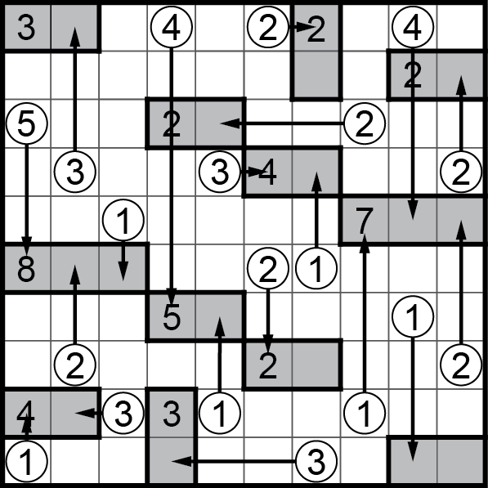 | 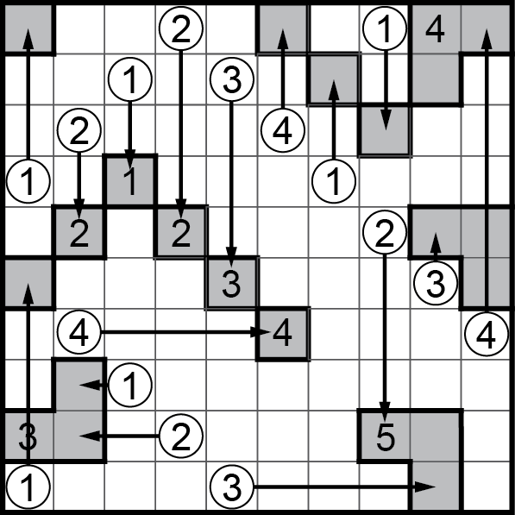 | 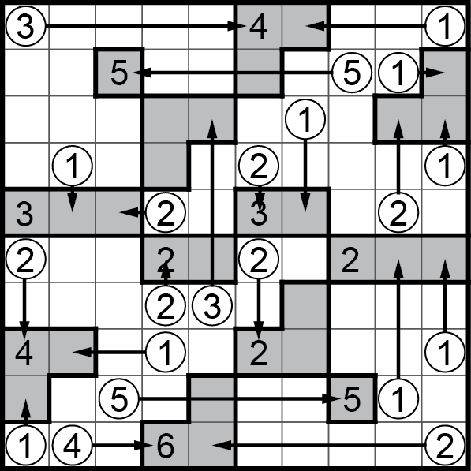
Puzzle 10 | Puzzle 11 | Puzzle 12
SOLUTIONS
Faibu Seruzu

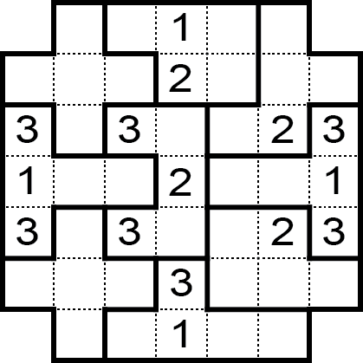 | 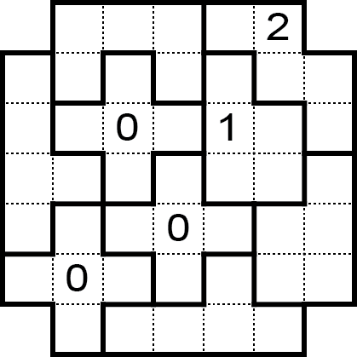 | 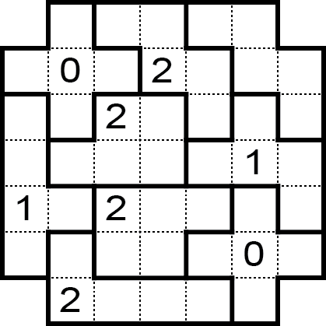
Puzzle 1 | Puzzle 2 | Puzzle 3

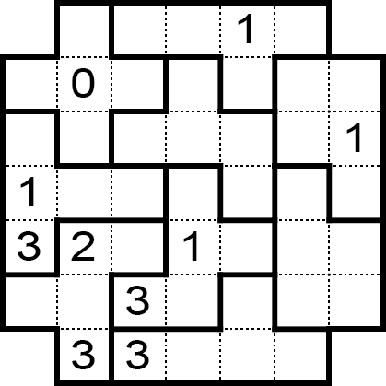 | 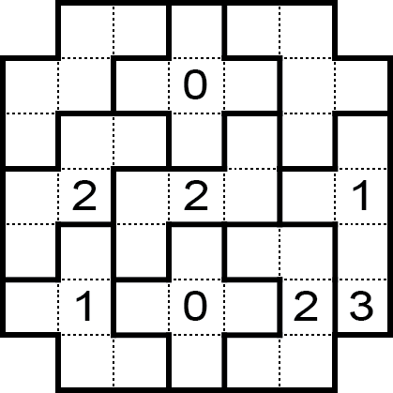 | 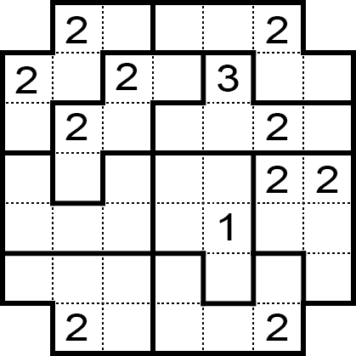
Puzzle 4 | Puzzle 5 | Puzzle 6

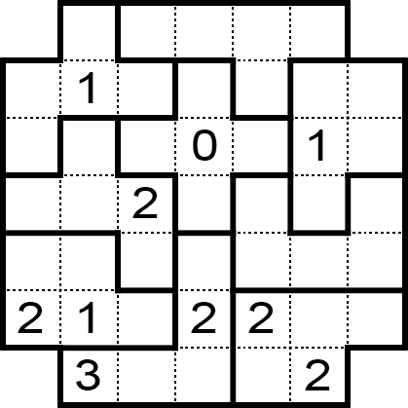 | 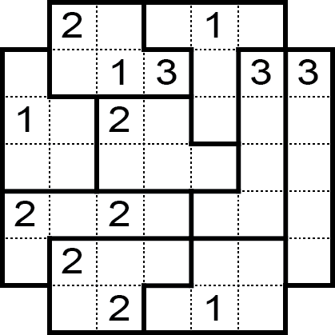 | 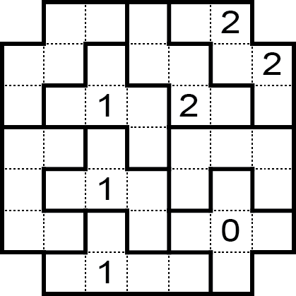
Puzzle 7 | Puzzle 8 | Puzzle 9

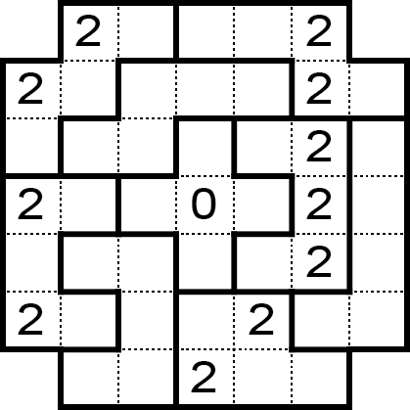 | 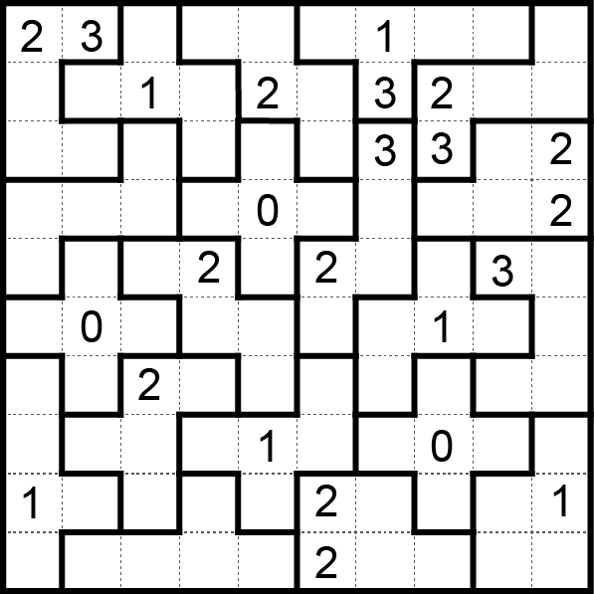 | 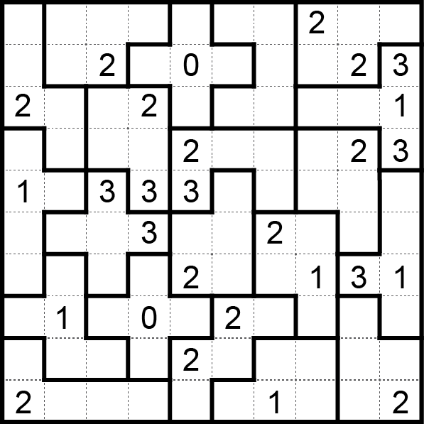
Puzzle 10 | Puzzle 11 | Puzzle 12

SOLUTIONS

Habi-Loop

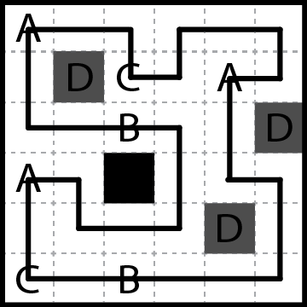 | 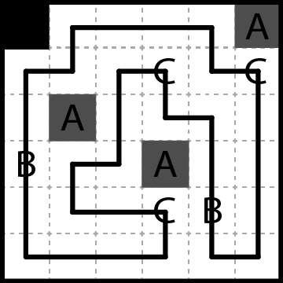 | 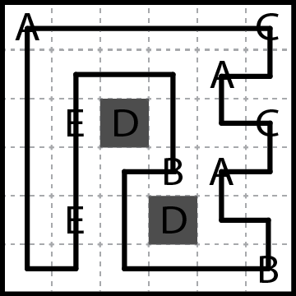
Puzzle 1 | Puzzle 2 | Puzzle 3

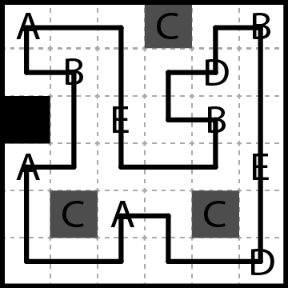 | 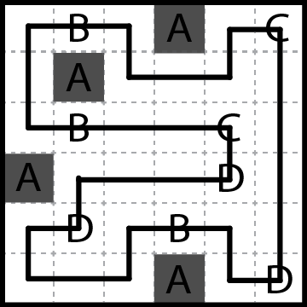 | 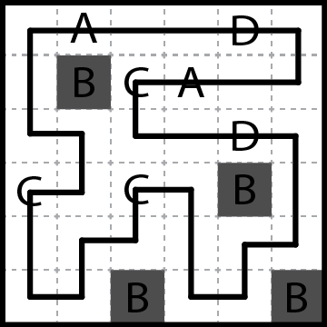
Puzzle 4 | Puzzle 5 | Puzzle 6

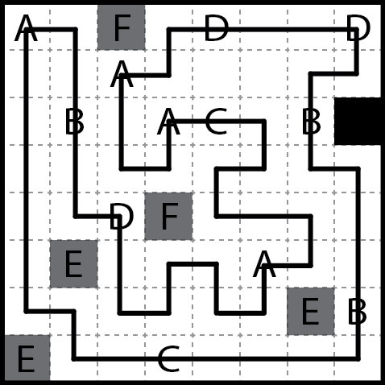 | 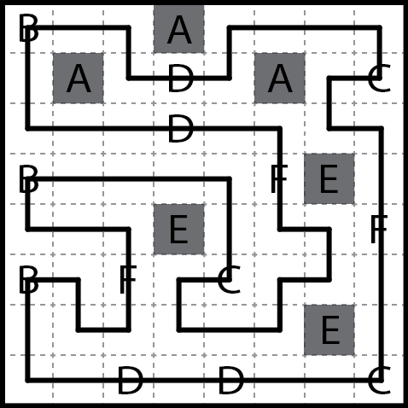 | 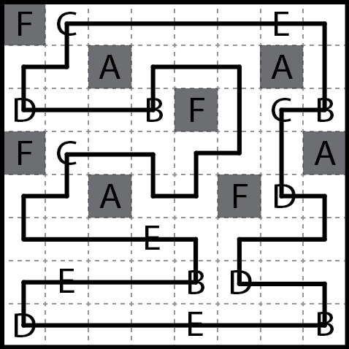
Puzzle 7 | Puzzle 8 | Puzzle 9

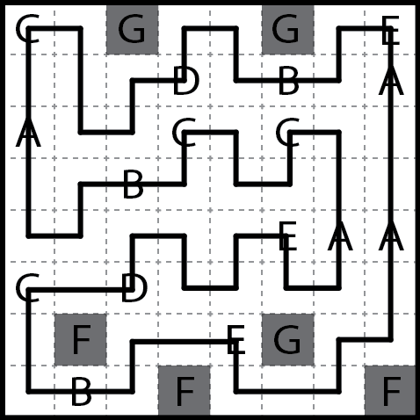 | 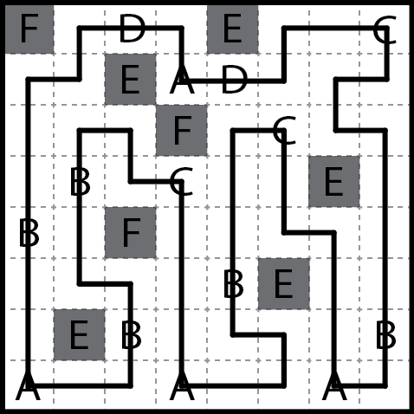 | 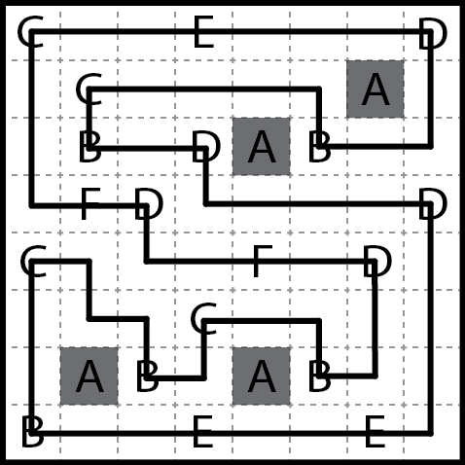
Puzzle 10 | Puzzle 11 | Puzzle 12

SOLUTIONS

Herugolf

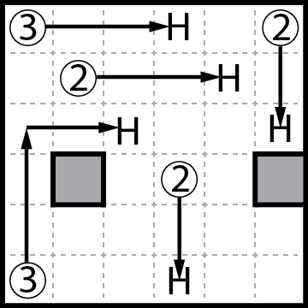 | 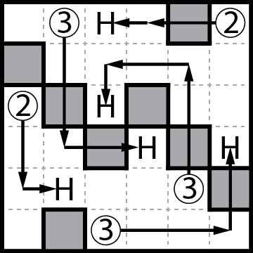 | 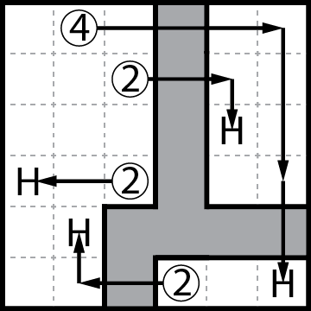
Puzzle 1 | Puzzle 2 | Puzzle 3

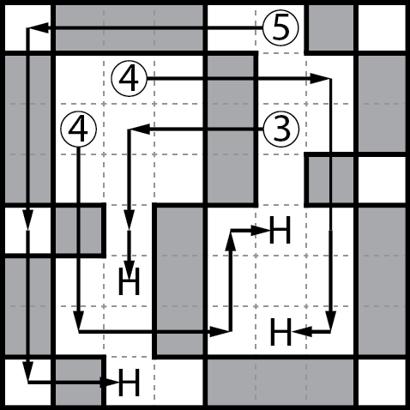 | 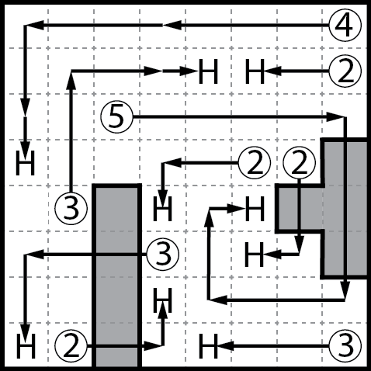 | 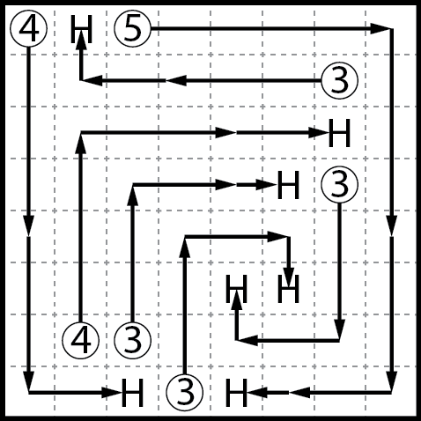
Puzzle 4 | Puzzle 5 | Puzzle 6

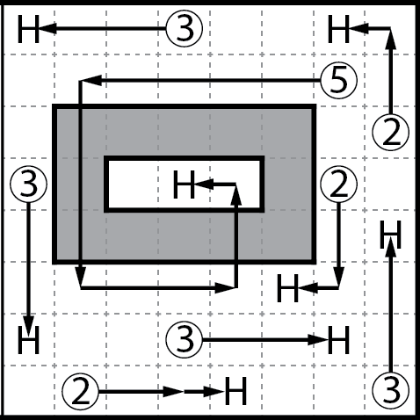 | 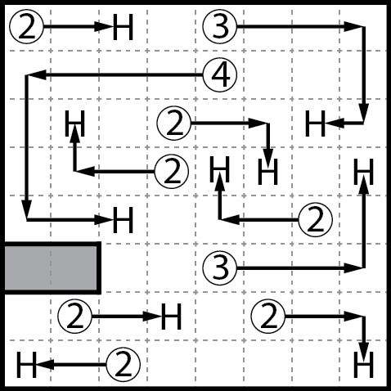 | 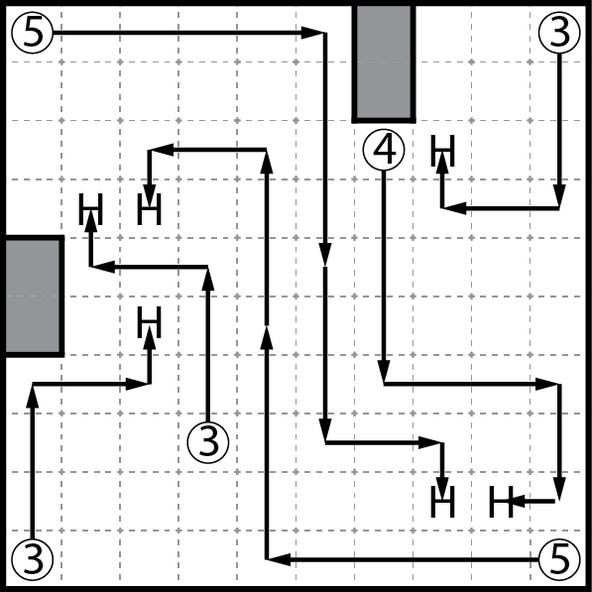
Puzzle 7 | Puzzle 8 | Puzzle 9

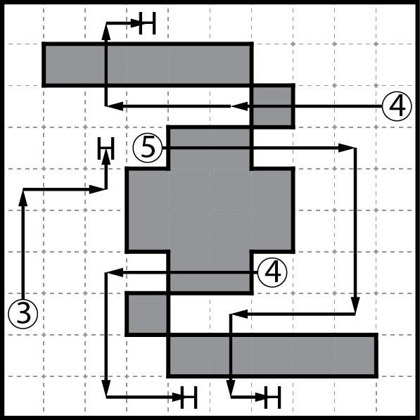 | 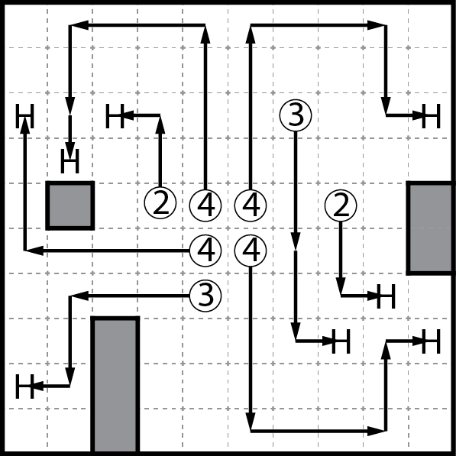 | 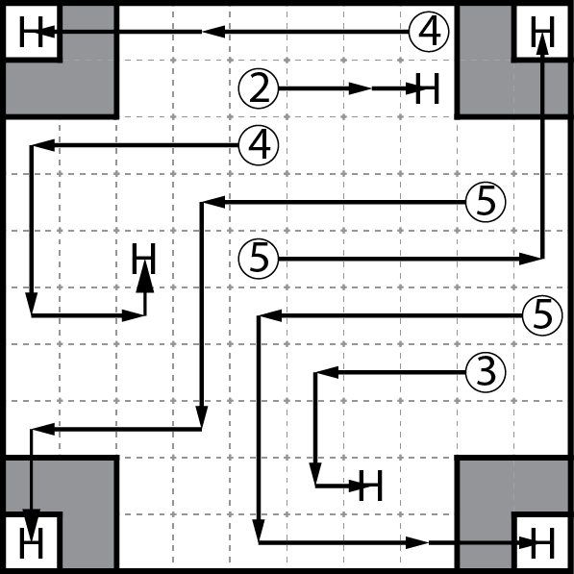
Puzzle 10 | Puzzle 11 | Puzzle 12

