BGSU CLINICAL
SUPERVISION MANUAL


DEPARTMENT OF COMMUNICATION SCIENCES AND DISORDERS
SPEECH-LANGUAGE PATHOLOGY
Bowling Green State University

August 2018
Authored by: Donna Colcord, M.S., CCC-SLP; Clinic Director
Quality speech/language pathology programs cannot exist without cooperation and partnership with external clinical sites. The supervisors who contribute their knowledge, skills and time in supervising are paramount to the successful training of our graduate clinicians. This supervision manual has been prepared as a guide for clinical supervisors and outlines responsibilities and expectations of those involved in the internship experience.

The practicum experience should be utilized to develop graduate student clinicians into entry-level professionals. Therefore, the part-time and full-time internships are extremely important facets of the student’s clinical education and growth into CF ready professionals.

The graduate clinician should be placed in a facility that:
- Shares a common mission to educate and train the graduate clinician
- Demonstrates a diversity of approaches in instructional strategies
- Encourages use of evidence based practices
- Expects and supports continuous growth through reflective practice

The clinical supervisor has a very profound impact on the development of the graduate clinician, therefore, the graduate clinician should be placed with a clinical supervisor who:
- Has had success as a practicing speech/language pathologist
- Is aware of current principles and practices in speech/language pathology
- Employs evidence based practices
- Relates well to students
- Communicates effectively
- Continues to develop professionally and personally
- Exhibits the willingness and skills to train, nurture, and mentor a graduate clinician

The on-site university supervisor has a very important job in providing the initial and ongoing training in the clinical experiences that will develop the knowledge and skills required to be a successful graduate clinician. Therefore, it is important for providing a university supervisor who:
- Has had success as a practicing speech/language pathologist
- Is knowledgeable and skilled
- Is aware of current principles and practices in speech/language pathology
- Is a reflective practitioner
- Communicates effectively
- Relates well to the needs of current clients as well as the graduate students
- Has a desire to continually develop professionally and personally
- Encourages and utilizes evidence based practices
- Exhibits the willingness and skills to train, nurture and mentor graduate clinicians

SUPERVISIOIN DEFINED:

“Supervision is a process that consists of a variety of patterns of behavior, the appropriateness of which depends upon the needs, competencies, expectations and philosophies of the supervisor and the supervisee and the specifics of the situation (task, client, setting, and other variables).”
McCrea, E. and Brasseur, J.A., The Supervisory Process in Speech-Language Pathology and Audiology, Allyn & Bacon, 2003, p. 8

FUNDAMENTALS OF SUPERVISION:

- The supervisory relationship is based on a foundation of mutual respect and effective interpersonal communication.
- Supervisors must be aware of the legal and ethical responsibilities of supervision.
- Supervision must be appropriate to the supervisee’s level of knowledge, experience, and competence.
- Recognize that supervisees will be at different stages on the continuum of supervision needs throughout their clinical training.
- Supervisory styles change based on the supervisee’s position on the continuum.
- Supervision is a dynamic process with the knowledge and skills of both the supervisor and the supervisee continually changing.

13 TASKS OF SUPERVISION:

- Developed for the ASHA Position Paper on Supervision (1985)
- Supports that supervision is a distinct area of practice
- Tasks and competencies were established by experts in the area of supervision and by peer review

1. Establishing and maintaining an effective working relationship with the supervisee.
  - Facilitate an understanding of the clinical and supervisory processes
  - Apply learning principles in the supervisory process
  - Organize and provide information on joint setting of goals and objectives, data
collection and analysis and evaluation
  - Facilitate independent thinking and problem solving
  - Maintain professional and supportive relationship that supports growth
  - Interact with supervisee objectively
  - Joint communication regarding expectations and responsibilities
  - Ongoing evaluation of effectiveness of supervisory relationship

2. Assisting the supervisee in developing clinical goals and objectives.
  - Assist in planning effective clinical goals and objectives
  - Assist in assigning priorities to clinical goals and objectives
  - Assist in developing supervisee goals and objectives for professional growth
  - Assist in assigning priorities to supervisee goals and objectives for professional
growth
3. Assisting the supervisee in developing and refining assessment skills
  - Share and facilitate integration of current research findings in client assessment
  - Assist in providing rationale for assessment procedures
  - Assist in integrating findings and observations to make appropriate
recommendations
  - Facilitate independent planning of assessment

4. Assisting the supervisee in developing and refining clinical management skills.
  - Share and integrate current research findings in client management
  - Assist in providing rationale for treatment procedures
  - Assist in identifying appropriate sequences for client goals
  - Assist in adjusting steps in the progression toward a goal
  - Assist in measurement and documentation of client and clinician change

5. Demonstrating for and participating in the clinical process.
  - Determine jointly when demonstration is appropriate
  - Demonstrate a variety of clinical techniques, materials and equipment and
participate with supervisee in the clinical management
  - Demonstrate or participate jointly in counseling of clients, family/significant
others

6. Assisting the supervise in observing and analyzing assessment and treatment sessions
  - Assist supervisee in learning, selecting and executing a variety of data collection
procedures
  - Assist in accurately recording data
  - Assist in objectively analyzing and interpreting data
  - Assist in revising plans for client management based on data obtained

7. Assisting the supervisee in development and maintenance of clinical and supervisory records.
  - Assist in applying record keeping systems to supervisory and clinical processes
  - Assist in organizing records to facilitate easy retrieval of info
  - Assist the supervisee in establishing and following policies and procedures to
protect confidentiality of records
  - Share information regarding documentation requirements of various accrediting
and regulatory agencies and third party funding sources

8. Interacting with the supervisee in planning, executing and analyzing supervisory conferences.
  - Determine with supervisee when a conference should be held
  - Assist supervisee in planning conference agenda and involve the supervisee in
joint discussion of items on agenda
  - Interact with supervisee in a manner that facilitates self-exploration and problem
solving
  - Adjust conference content based on supervisee’s level of knowledge and
experience
  - Assist supervisee in making commitments for changes/growth in clinical skills
  - Encourage and maintain supervisee motivation for self-growth

9. Assist the supervisee in developing skills of verbal reporting, writing and editing
  - Assist supervisee in use of clinical evaluation tools and development of self-
evaluation skills
  - Assist supervisee in description and measurement of his/her progress and
achievement
  - Evaluate supervisee’s clinical skills for purposes of grade assignment, completion
of CF year, professional advancement, etc.

10. Assisting the supervisee in developing skills of verbal reporting, writing and editing.
- Assist supervisee in identifying appropriate information for verbal or written
report
- Assist with use of professional terminology in a logical, concise and sequential
manner
- Assist the supervisee in adapting verbal and written reports to the work
environment and communication situation
- Ability to alter/edit report while preserving the supervisee’s writing style

11. Sharing in the formation of ethical, legal, regulatory and reimbursement aspects of the profession.
- Ability to communicate to supervisee a knowledge of professional codes of ethics (ASHA, State licensure board, etc.)
- Ability to communicate to supervisee an understanding of reimbursement policies
and procedures of the work setting
- Ability to communicate to supervisee an understanding of legal and regulatory
documents and their impact on the practice of the profession (licensure, Medicare,
Medicaid, PL 94-142, etc.)

12. Modeling and facilitating professional conduct.
- Ability to assume responsibility
- Ability to analyze, evaluate and modify own behavior
- Ability to demonstrate ethical and legal conduct
- Ability to meet and respect deadlines
- Ability to maintain professional protocols (HIPAA, etc.)
- Ability to provide current information regarding professional standards (licensure,
certification, teacher certification, etc.)
- Ability to communicate reimbursement information (billing procedures, fees,
third party, etc.)
- Ability to demonstrate familiarity with professional issues
- Ability to demonstrate continued professional growth

13. Demonstrate research skills in the clinical and supervisory processes.
- Ability to read, interpret and apply clinical and supervisory research
- Ability to formulate research questions and investigate the questions
- Ability to support and refute clinical and supervisory research findings
- Ability to report results of clinical or supervisory research and disseminate as
appropriate

American Speech-Language-Hearing Association. (1985) ASHA Practice Policy:
Clinical Supervision in Speech-Language Pathology and Audiology.

STAGES OF SUPERVISION:
(Anderson, 1988)

- Direct communication –
  - Utilize “telling, modeling, leading”
  - Supervisee needs greater structure and support
  - Concrete, frequent feedback (written and verbal)
  - Assist the supervisee in transitioning to the collaborative stage

- Collaborative stage –
  - Allows the supervisor to decrease their input in response to an increase in the involvement/knowledge/skills and independence of the supervisee
  - Supervisor/ee are actively involved in assuming responsibility for clinical and supervisor process
  - May use open ended questions, discussions, trial of new tasks/approaches with follow up evaluation
  - Encouragement of self-analysis of supervisee and client skills

- Consultative stage –
  - Final stage of supervision – the supervisee has transitioned to self-supervision and utilizes the supervisor as a consultant

The continuum of supervision allows for movement/shifts in supervisory style based on the needs/abilities of the supervisee.

Taken from: The Supervisory Process in Speech-Language Pathology
and Audiology, Jean Anderson, 1988, College Hill

ETHICAL SUPERVISION OF GRADUATE STUDENTS

Supervision of graduate students in speech/language pathology and audiology is an extremely rewarding way to contribute to the future of our professions. University programs depend upon licensed, certified speech-language pathologists and audiologists to provide supervision to graduate students at various points in their clinical training. Without adjunct supervisors (clinical educators) who work in the “real world”, university programs would have a very difficult time providing the clinical training required to meet the appropriate standards set by the Council of Academic Accreditation of Graduate Education Programs in Audiology and Speech-Language Pathology (CAA), the Ohio Board of Speech-Language-Pathology and Audiology and the American Academy of Audiology.

Many supervisors have had little formal coursework or continuing education in the supervision process. Many supervise based upon their own experiences receiving supervision. They utilize techniques that worked well for them and eliminate techniques that were ineffective. In order to provide competent supervision, we must increase our supervision knowledge and skills through continuing education, peer learning, mentoring and self-study.

It is imperative that we have knowledge and understanding of our responsibilities in supervision. Our primary role as a supervisor is to be accountable for the supervisee’s performance. In order to protect ourselves and the supervisee, and to protect the welfare of the client, we must be aware of and follow the standards established by the accrediting agencies of the CAA (2017) and the Council for Clinical Certification (CFCC, 2014) and to abide by the ASHA Code of Ethics (2016).

The CFCC standards require that supervision of graduate clinicians should be provided by a certified SLP at a minimum of 25% of the total contact with each client. However, the amount of supervision “should be adjusted upward if the student’s level of knowledge, experience, and competence warrants” (CFCC, 2014). This standard allows the supervisor to adjust their direct involvement accordingly for each individual clinician and client.

ASHA’s Code of Ethics (2016) provides additional support and guidance needed for insuring that the supervisee and supervisor are providing optimal services to the clients. Principle of Ethics I indicates that the welfare of the client must always be held paramount. The supervisor is ultimately responsible for every client and should ensure that the treatment is provided competently and that all professional responsibilities are completed in a timely and accurate manner.

Principle of Ethics II gives direction in the area of professional competence; professionals should engage only in the areas of practice that are within their scope of competence. Therefore, the supervisor should not permit or require the supervisee to provide any service that exceeds their level of competence, education, training or experience.

Principle of Ethics III provides guidance in promoting the profession and providing accurate information to the public. The supervisor and supervisee should never misrepresent their credentials, competence, education, training and experience. Clients should always be made aware that the supervisee is a graduate clinician and that the certified supervisor maintains ultimate responsibility for the client’s treatment. Further, diagnostic reports, notes, products dispensed, billing and statements to the public should never, in any way, be misrepresented.

Principle of Ethics IV describes the ethical responsibility to develop and nurture positive interprofessional and intraprofessional relationships and to accept the standards of the profession. Supervisors should not abuse their authority over students (ASHA 2016) and should be aware of potential problems that could arise in objectively evaluating the supervisee’s performance if they develop a social relationship with the supervisee. Further, the supervisor is responsible for prohibiting any practice that would violate any portion of the Code of Ethics.

Excellent supervision and adherence to the standards and ethics discussed above will support quality preparation of our future professionals. This, in turn, will provide assurance that our professions will continue to meet the needs of the communication impaired with superior quality.

REFERENCES:
American Speech-Language-Hearing Association. (2016). Code of ethics [Ethics]. Available from www.asha.org/policy/.

Council for Clinical Certification in Audiology and Speech-Language Pathology of the American Speech-Language-Hearing Association. (2013). 2014 Standards for the Certificate of Clinical Competence in Speech-Language Pathology. Retrieved [8-9-18] from http://www.asha.org/Certification/2014-Speech-Language-Pathology-Certification-Standards/.

Council on Academic Accreditation in Audiology and Speech-Language Pathology. (2017) Standards for Accreditation of Graduate Education Programs in Audiology and Speech-Language Pathology. Available from https://caa.asha.org/reporting/standards/

Submitted by:
Donna Colcord, M.S., CCC-SLP
OSLHA Ethics Committee Chair
Oct. 2008
Hearsay

Revision: Updated websites: 08/09/2018

BASIC SUPERVISION REQUIREMENTS:

- Orientation to the practicum/facility
- Prepare individuals on your caseload for the grad intern’s arrival
- Provide facility handbook, policies and procedures, regulations, etc.
- Provide the grad intern with an overview of the caseload/intervention plans
- Encourage questions

- Transfer of Responsibility
  - Establish goals, expectations, and a schedule for evaluation of skills
  - Provide opportunities for the grad intern to show initiative and creativity
  - Allow the grad intern to gradually assume responsibility of the caseload (part-time @ 100 hours +, full-time internship @200 hours +)
  - By midterm, most interns can assume full responsibility for the caseload; however, it is understood that the clinical supervisor may need to maintain certain clients for whom a new therapist would negatively impact treatment/progress

- Planning/Implementation of the therapy program
  - Encourage planning for a wide variety of learning opportunities
  - Make the intern aware of materials and resources available at the facility
  - Assist in the development of all required paperwork (plans, SOAP notes, etc.)
  - Train in use of EMR, if utilized

- Development of verbal and written communication skills
  - Offer guidance in both verbal and written communication
  - Assist in the development of all required paperwork (plans, SOAP notes, etc.)
  - Train in use of EMR, if utilized

- Evaluation of clinical skills/professionalism
  - Provide written/verbal feedback at level needed by student (more often in the beginning – daily, at least and weekly on a consistent basis)
  - Encourage self-evaluation and active discussion of skills/progress
  - Provide objective feedback
  - Formal evaluation at mid-term and end of semester
  - Model appropriate professional behavior

- Assessment of knowledge and skills via KASA forms in CALIPSO (web based application:
  - Assessment in CALIPSO at mid-term and end of semester

BGSU CLINICAL PRACTICUM/INTERNSHIP SYLLABUS

COURSE: CLINICAL PRACTICUM/INTERNSHIP

LEVEL: Graduate

CREDITS:
- 3 Credits for Part-time Internship (CDIS 6970)
- 8 Credits for Full-time Internship (CDIS 6890)

INSTRUCTOR: Donna Colcord, M.S., CCC-SLP, Clinic Director; donnaco@bgs.edu ; Phone 419-372-0189, Fax 419-372-8089

CLINICAL SUPERVISORS: Off-site supervisor(s) at facility of choice

PLACEMENT TYPE:
- 1 ADULT INTERNSHIP – Typical placement is medical facility: hospital, skilled nursing facility, outpatient rehabilitation facility, private practice or non-medical with adult developmental disability facility;
- 1 PEDIATRIC INTERNSHIP – If you are seeking school licensure/certification, you will be placed in a school setting: preschool – 12th grade options; if you are not seeking school licensure/certification, your placement can be hospital, outpatient, private practice, etc.

COURSE DESCRIPTION:
CDIS 6970 – 3 credits part-time internship and
CDIS 6890 – 8 credits full-time internship
Each internship is designed to provide graduate students/clinicians with supervised experience in assessment, diagnosis, and treatment of children and adults, across the lifespan and from culturally/linguistically diverse backgrounds, exhibiting a variety of speech/language, hearing, communication and swallowing disorders, disabilities and differences.

During the part-time internship, 100+ clock hours are recommended to be completed. These clock hours are supervised clinical experiences in the practice of speech-language pathology. A part-time placement is scheduled at 2½ to 3 days per week and typically occurs during the graduate student’s 4th semester of clinical training. This internship is considered an intermediate competency level.

During the full-time internship, 200+ clock hours are recommended to be completed in the supervised clinical practice of speech-language pathology. The full-time placement is scheduled during the final semester of clinical training in the master’s program. If the placement occurs during the fall or spring semester, it is scheduled at 5 days per week for 15 weeks. If it occurs during the summer semester, the placement is scheduled for 5 days per week for 12 weeks. In this placement, the graduate intern should be able to function with a complete caseload by midterm, at the latest. However, many interns will be able to take on the caseload more quickly. This internship is considered at the final internship competency level.
SUPERVISION REQUIREMENTS: Speech-language pathology (SLP) interns must be provided supervision by an individual who holds a current Certificate of Clinical Competence in SLP and current state licensure, if applicable. If placement is a school setting, current school licensure/certification is required in addition to the above. Direct supervision must be completed in real time and must never be less than 25% of the intern’s total contact with each client/patient and must take place periodically throughout the internship. These are minimum standards and should be adjusted upward if the intern’s level of knowledge, experience, and competence warrants.

Supervision must include direct observation, guidance and feedback to permit the intern to monitor, evaluate and improve performance and to develop clinical competence.

MEDICAL/HEALTHCARE INTERNSHIP OBJECTIVES:
- to provide the graduate intern with direct clinical experiences in the areas of evaluation and treatment;
- to provide the graduate intern with opportunities to develop professional interaction skills (inter-professional practice) with other speech-language-pathologists, audiologists, and other professionals in related disciplines;
- to provide the graduate intern the opportunities to experience the daily operations of a speech-language pathology program, which may include:
  - roles and responsibilities of each member of the rehabilitation team;
  - documentation of services (i.e. SOAP notes, reports, etc.)
  - introduction to billing and reimbursement issues
  - caseload management and productivity criteria
  - patient satisfaction, quality improvement
- to provide the graduate intern with a transitional experience between the university and professional employment

EDUCATION INTERNSHIP OBJECTIVES:
- to provide the graduate intern with direct clinical experiences in the areas of evaluation and treatment;
- to provide the graduate intern with opportunities to develop professional interaction skills (inter-professional practice) with other speech-language-pathologists, audiologists, teachers, and other professionals in related disciplines;
- to provide the graduate intern the opportunities to experience the daily operations of a speech-language pathologist in the schools, which may include the following:
  - roles and responsibilities of each member of the educational team;
  - documentation of services (i.e. daily notes, IEP reports, etc.)
  - involvement in IEP meetings
  - introduction to various types of service delivery routinely provided in the school district
  - caseload management
- to provide the graduate intern with a transitional experience between the university and professional employment

The graduate intern will demonstrate growth in the knowledge, skills, attitudes, and values of professional behaviors that will lead to CF (clinical fellowship) readiness in speech-language pathology by the end of their master’s program.

The American Speech-Language-Hearing Association (ASHA) Knowledge and Skills Acquisition (KASA) is a document that specifies the Standards for the Certificate of Clinical Competence (CCC). The KASA is used to track and confirm compliance with accreditation standards related to preparing students to meet ASHA certification standards. Please refer to the following website:

http://www.asha.org/certification/2014-speech-language-pathology-certification-standards

This document guides clinical practicum experiences. The following standards will be addressed during practicum experiences:

Standard V-A: The applicant must have demonstrated skills in oral and written or other forms of communication sufficient for entry into professional practice.

Standard V-B: The applicant for certification must have completed a program of study that includes experiences sufficient in breadth and depth to achieve the following skills outcomes:
- Evaluation
  - Conduct screening and prevention procedures (including prevention activities).
  - Collect case history information and integrate information from clients/patients, family, caregivers, teachers, and relevant others, including other professionals
  - Select and administer appropriate evaluation procedures, such as behavioral observations, non-standardized and standardized tests, and instrumental procedures.
  - Adapt evaluation procedures to meet client/patient needs.
  - Interpret, integrate, and synthesize all information to develop diagnoses and make appropriate recommendations for intervention.
  - Complete administrative and reporting functions necessary to support evaluation.
  - Refer clients/patients for appropriate services.

- Intervention
  - Develop setting-appropriate intervention plans with measurable and achievable goals that meet clients’/patients’ needs. Collaborate with clients/patients and relevant others in the planning process.
  - Implement intervention plans (involve clients/patients/ and relevant others in the intervention process).
  - Select or develop and use appropriate materials and instrumentation for prevention and intervention.
  - Measure and evaluate clients’/patients’ performance and progress.
  - Modify intervention plans, strategies, materials, or instrumentation as appropriate to meet the needs of clients/patients.
  - Complete administrative and reporting functions necessary to support intervention.
  - Identify and refer clients/patients for services, as appropriate.

- Interaction and Personal Qualities
  - Communicate effectively, recognizing the needs, values, preferred mode of communication, and cultural/linguistic background of the client/patient, family, caregivers, and relevant others.
  - Collaborate with other professionals in case management.
  - Provide counselling regarding communication and swallowing disorders to clients/patients, family, caregivers and relevant others.
  - Adhere to the ASHA Code of Ethics and behave professionally.
Standard V-F: Supervised practicum must include experience with client/patient populations across the life span and from culturally/linguistically diverse backgrounds. Practicum must include experience with client/patient populations with various types and severities of communication and/or related disorders, differences and disabilities.

Supervised clinical experiences will allow the student to meet skills outcomes in Evaluation V:B-1, Intervention V:B-2 and Interaction/Personal Qualities V:B-3 in the following disorder areas: Speech Sound Disorders (articulation/phonology), Fluency, Voice and Resonance, Receptive and Expressive Language, Hearing, Swallowing, Cognition, Social Aspects and Communication Modalities (oral, alternative/augmentative communication).

Additional Standards that will be assessed:

IV-E: The Applicant must have demonstrated knowledge of standards of ethical conduct (principles and rules of the current ASHA Code of Ethics).

IV-F: The applicant must have demonstrated knowledge of processes used in research and of the integration of research principles into evidence-based clinical practice.

IV-G: The applicant must have demonstrated knowledge of contemporary professional issues.

EVALUATION OF PRACTICUM/GRADING:
Clinical supervisors assess a student’s knowledge and skills based on their clinical experiences. Within CALIPSO, each supervisor completes one ASHA Knowledge and Skills Acquisition Form (KASA) for the clinical internship experience, indicating student performance according to the Rating Scale below.

BGSU Rating Scale

1 Not Evident/Inadequate: skill not evident most of the time. Student requires direct instruction to modify behavior and is unaware of need to change. Supervisor must model behavior and implement the skill required for client to receive optimal care. Supervisor provides numerous instructions and frequent modeling.

2 Minimally Evident: Skill is emerging, but is inconsistent or inadequate. Student shows awareness of need to change behavior with supervisor input. Supervisor frequently provides instructions and support for all aspects of case management and services.

3 Developing: Skill is present and needs further development, refinement or consistency. Student is aware of need to modify behavior, but does not do this independently. Supervisor provides on-going monitoring and feedback; focuses on increasing student’s critical thinking on how/when to improve skill.

4 Good: Skill is developed/implemented most of the time and needs continued refinement or consistency. Student is aware and can modify behavior in-session, and can self-evaluate. Problem-solving is independent. Supervisor acts as a collaborator to plan and suggest possible alternatives.

5 Very Good/Excellent: Skill is consistent and well developed. Student can modify own behavior as needed and is an independent problem-solver. Student can maintain skills with other clients, and in other settings, when appropriate. Supervisor serves as consultant in areas where student has less experience; provides guidance on ideas initiated by student.

Within CALIPSO, the KASA form is completed by the supervisor during an evaluation conference at midterm and again at the end of the semester. Clinicians must receive a mean score of 3 or higher on the 5-point scale to successfully complete the practicum/internship. These scores will be reviewed by the Clinic Director and assigned a grade of S (Satisfactory) or U (Unsatisfactory). The Clinic Director has the ultimate decision regarding the final grade.

MEDICARE RULES FOR SUPERVISION

Part A inpatient hospital therapy services: students will be considered to be under the direct supervision of a qualified speech-language pathologist if the clinician is present on the same unit or same floor while the patient is treated. The SLP must be "immediately available according to the circumstances appropriate to the service rendered," sign all documentation, and actively participate in treatment. This change in policy helps speech-language pathology students better learn how to practice on their own, and also allows qualified SLPs to treat other patients while the student is performing treatment activities.

Part B outpatient services: the supervising SLP must be present and directly overseeing the evaluation or treatment session. The therapist may bill and be paid for the services when
“the qualified practitioner is present and in the room for the entire session”. The student may participate “in the delivery of services when the qualified practitioner is directing service, making the skilled judgment, and is responsible for the assessment and treatment”. The SLP must be present in the room, guiding the student in services delivery while the student is participating in the provision of services and the SLP is not engaged in treating another patient or doing other tasks at the same time.

EXPECTATIONS FOR INTERNSHIP STUDENTS
- Observe the policies, hours, and regulations of the cooperating facility
- Recognize that the internship is his/her primary responsibility and understand that outside activities must not interfere with carrying out this obligation (students will be allowed to leave early if they have a class on an assigned internship day; thesis students will complete 4 full days instead of 5 during their final internship to allow for completion of the thesis)
- Gradually assume responsibility for the caseload (plan on obtaining clinical hours at part-time internship of 100+ hours, at full-time internship of 200+ hours)
  - By midterm, most interns can assume full responsibility for the caseload; however, it is understood that the clinical supervisor may need to maintain certain clients for whom a new therapist would negatively impact treatment/progress.
- Dress, act, talk and conduct him/herself as a professional
- Observe the standards of conduct set forth by the ASHA Code of Ethics and the facility standards
- Maintain confidentiality with respect to information given by or about clients/patients; this includes information derived from client performance, client records, personnel records, department meetings, or any other source
- Maintain regular attendance
- Participate in professional activities of the cooperating facility
- Remember that the clinical supervisor is legally responsible for the caseload and that the intern should not assume authority that has not been delegated to him/her by the clinical supervisor.
- Understand that the internship students are guests in the host facility and act accordingly.

THE BOWLING GREEN STATE UNIVERSITY (BGSU) CLINIC DIRECTOR:

The BGSU Clinic Director will assist with the supervision process by:
- Encouraging development of knowledge and skills and communicating with the graduate intern throughout the internship via phone, e-mail and meetings
- Communicating with the clinical supervisor via phone, e-mail, and face to face meetings to discuss the progress of the intern
- Answering any questions or concerns that the clinical supervisor may have regarding the intern, evaluation forms utilized, etc.
- Providing support in the development of supervisory skills
- Providing appropriate paperwork required by the hosting facility (liability insurance, medical records, fingerprints, etc.)
- Assuming responsibility for submitting the final grade, based on the clinical supervisor’s recommendation

Please feel free to contact me with any comments, questions or concerns:

Donna Colcord, M.S., CCC-SLP
Clinic Director
Phone: 419-372-0189
Fax: 419-372-8089
Email: donnaco@bgsu.edu

Your dedication, time and effort to help train
the future speech-language pathologists of tomorrow
is greatly appreciated!

CALIPSO INFORMATION/INSTRUCTIONS/DOCUMENTATION

FOR EXTERNAL-SITE CLINICAL SUPERVISORS

To Register as a Supervisor on CALIPSO:
- Before registering, have available your 1) PIN provided by the Clinic Secretary, 2) ASHA card, 3) state licensure card, and 4) teacher certification information if applicable. If possible, have available scanned copies of your certification and licensure cards to upload during the registration process.
- Go to https://www.CALIPSOclient.com/bgsu
- Click on the “Supervisor” registration link located below the login button.
- Complete the requested information and click “Register.”
- On the following screen, again complete the requested information and click “Save” at the bottom of the page. A “Registration Complete” message will be displayed and you will automatically be logged into CALIPSO.

To Login to CALIPSO:
  - For subsequent logins, go to https://www.CALIPSOclient.com/bgsu/account and login to CALIPSO using your 8- digit ASHA number and password that you created for yourself during the registration process

To Select Supervisee / Student:
  - Locate “Change class to:” and select from the drop-down menu the appropriate class
  - Click “Change.”
  - Click on “Student Information”
  - Locate “Add Student of Interest” and select your student from the drop-down menu.
  - Click “Add.”

To View Student Clock Hour Records:
  - Click on “Clockhours” then “Experience Record” to view a summary of clock hours obtained and clock hours needed.
  - Students may be required to gain a minimum of (20) hours in the evaluation and treatment of children and adults for both speech and language disorders which is summarized in the table at the bottom of the page.
  - Please note the student’s Clinical Competency Level (I, II, or III) on the page header if applicable.
  - Print/save clock hour record by clicking “Print Experience Record.”
  - Click “Student Information” located within the blue stripe to return to the student list.

To View Student’s Cumulative Evaluation
  - Click on “Cumulative evaluation” to view a summary of your student’s clinical competency across the 9 disorder areas.
  - Upon completion of the clinical program, students must have an average score of 3.0 or higher for all clinical competencies listed on the form.
  - Please make note of any areas of deficiency (highlighted in orange.)
  - Click “Student Information” located within the blue stripe to return to the student list.

To Complete Site Information Form
    - From the home page, click on the “Site Information Forms” link under the Management header.
    - Click “Add new form.”
    - Complete the requested information and click “Save.”

To Approve Clock Hours
    - At the completion of the rotation or as often as directed, your student will log their clock hours into CALIPSO.
    - An automatically generated e-mail will be sent notifying you that clock hours have been submitted and are awaiting approval.
    - Login to CALIPSO (step two.)
    - Click “clockhour forms pending approval.”
    - Identify your current student’s record.
    - Click “View/Edit” in the far right column.
    - Review hours, making changes if necessary.
    - Complete the % of time the student was observed while conducting evaluations and providing treatment.
    - Approve clock hours by selecting “yes” beside “Supervisor approval” located at the bottom of the page.
    - Click “Save.”

To View Your Supervisory Summary:
      - For an official record of this supervisory experience (past or present), click on the “Supervision summary” link located under the Management header on the home page.
      - Select “Printable view (PDF)” to create a document to save and/or print.

To View Your Supervisory Feedback:
    - At the completion of the rotation, your student will complete a supervisory feedback form in CALIPSO.
    - An automatically generated e-mail will be sent stating that you have feedback available to view.
    - Login to CALIPSO (step two)
    - Select the desired “Class” and click “change.”
    - Click “Supervisor feedback forms.”
    - Click “View/Edit” in the far right column.

To Update Your Information:
  - Update e-mail address changes, name changes, certification expiration dates with corresponding scanned copies of your card by logging into CALIPSO (step two.)
  - Click “Update your information.”
  - Make changes and click “save” and/or click “Edit licenses and certification.”
Update information and upload supporting files and click “save” located at the bottom of the screen.

ASSIGNMENT OF CLINICAL GRADES

Clinical Evaluations are completed in the CALIPSO system and can be accessed via the following link: https://www.calipsoclient.com/bgsu

To Complete a Midterm Clinical Evaluation:
- Login to CALIPSO
- Select the desired “Class” and click “change.”
- Click “New evaluation”.
- Complete required fields designated with an asterisk and press save.
- Continue completing evaluation by scoring all applicable skills across the Big 9 using the provided scoring method and saving frequently to avoid loss of data
- Once the evaluation is complete, review it with the student. Type his/her name with the corresponding date as well as your name with the corresponding date located at the bottom of the page.
- Check the “final submission” box located just below the signatures.
- Click “save.”
- Receive message stating “evaluation recorded.”
- Please note: you may edit and save the evaluation as often as you wish until the final submission box is checked. Once the final submission box is checked and the evaluation saved, the status will change from “in progress” to “final”. Students will then have access to view the submitted evaluation when logged into the system.
- To view the evaluation, click “Student Information” located within the blue stripe then “evaluations” located to the right of the student’s name.

To Complete a Final Evaluation:
  - Login to CALIPSO
  - Select the desired “Class” and click “change.”
  - Click “Student Information” then “evaluations” located to the right of the student’s name.
  - Identify the evaluation completed at midterm and click on “Make a duplicate of this evaluation.”
  - The duplicated evaluation will appear in the evaluations list.
  - Identify the duplicate (noted as “in progress”) and click on the “current evaluation” link highlighted in blue.
  - Change “Evaluation type” from midterm to final.
  - Complete evaluation by changing and/or adding scores for applicable skills across the Big 9 using the provided scoring method and saving frequently to avoid loss of data.
  - Once the evaluation is complete, review it with the student. Type his/her name with the corresponding date as well as your name with the corresponding date located at the bottom of the page.
  - Check the “final submission” box located just below the signatures.
  - Click “save.”
  - Receive message stating “evaluation recorded.”

RATING SCALE

1 Not Evident/Inadequate: skill not evident most of the time. Student requires direct instruction to modify behavior and is unaware of need to change. Supervisor must model behavior and implement the skill required for client to receive optimal care. Supervisor provides numerous instructions and frequent modeling.

2 Minimally Evident: Skill is emerging, but is inconsistent or inadequate. Student shows awareness of need to change behavior with supervisor input. Supervisor frequently provides instructions and support for all aspects of case management and services.

3 Developing: Skill is present and needs further development, refinement or consistency. Student is aware of need to modify behavior, but does not do this independently. Supervisor provides on-going monitoring and feedback; focuses on increasing student’s critical thinking on how/when to improve skill.

4 Good: Skill is developed/implemented most of the time and needs continued refinement or consistency. Student is aware and can modify behavior in-session, and can self-evaluate. Problem-solving is independent. Supervisor acts as a collaborator to plan and suggest possible alternatives.

5 Very Good/Excellent: Skill is consistent and well developed. Student can modify own behavior as needed and is an independent problem-solver. Student can maintain skills with other clients, and in other settings, when appropriate. Supervisor serves as consultant in areas where student has less experience; provides guidance on ideas initiated by student.

SPEECH-LANGUAGE PATHOLOGY / AUDIOLOGY
PRACTICUM EVALUATION

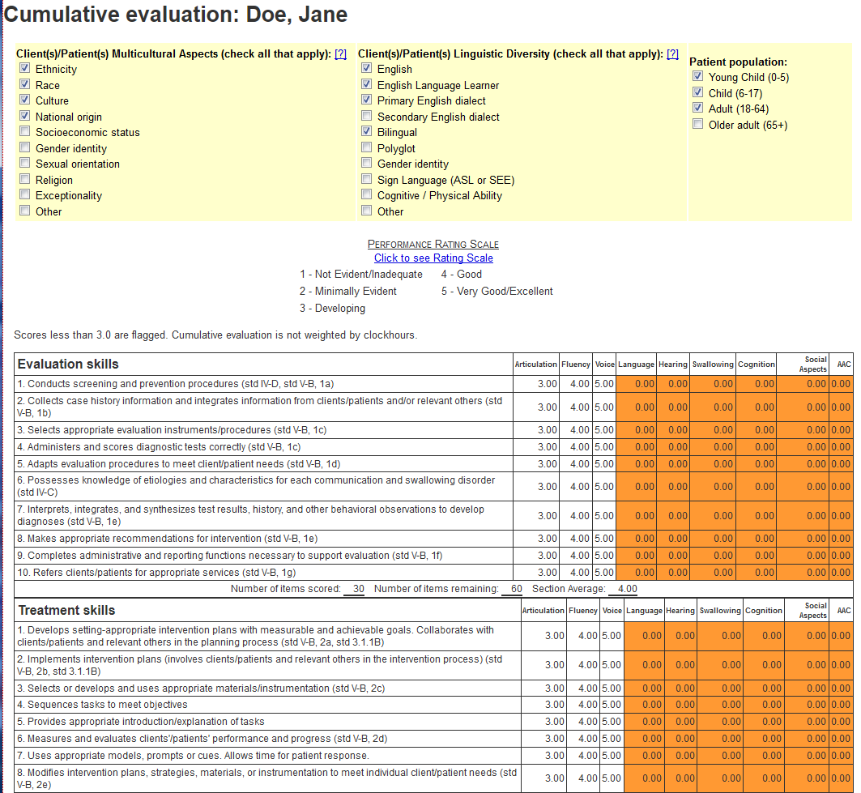
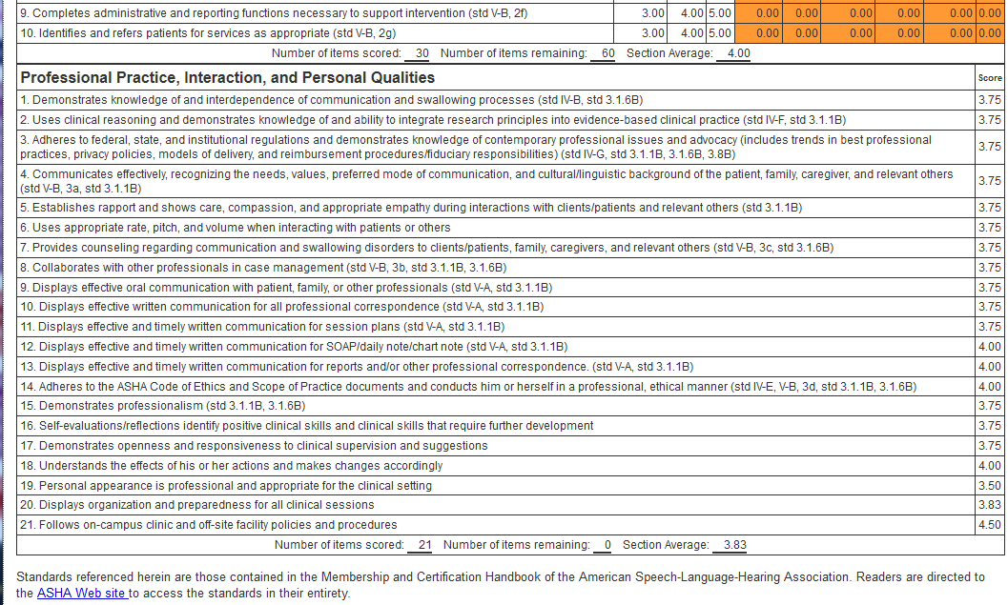

SPEECH-LANGUAGE PATHOLOGY / AUDIOLOGY PRACTICUM
SUPERVISOR FEEDBACK

- At the completion of each clinical course graduate clinicians are asked to complete feedback for each clinical supervisor.
- From the lobby page in CALIPSO, click “Supervisor feedback forms.”
- Click “New supervisor feedback.”
- Complete form and click “Submit feedback.”
- The completed feedback form will be posted for Clinic Director for approval.
- Once approved, feedback will be posted for the Clinical Supervisor to view.
- NOTE: until approved, the feedback may be edited by clicking on “View/Edit.” Once approved, no further changes/edits will be able to be made to the form.



