GRADUATE PROGRAM MODIFICATION
Instructions and Template

To complete a curriculum modification request for a modified graduate program, the author/proposer of the modification should go to the following page to find the link to complete the online form: http://www.bgsu.edu/graduate/documents-and-forms.html. See the bottom of the page for relevant links.

The online process that includes the Graduate Program Modification Proposal Form should be utilized for the internal BGSU approval process. Any program modification that equals or exceeds 50% of the current program curriculum must also go through the Chancellor’s Council on Graduate Studies (CCGS) approval process. Please see https://www.ohiohighered.org/ccgs for a link to Guidelines and Procedures for Review and Approval of Graduate Degree Programs.

BGSU Online Process:
Once in the online system, one individual must be the sole author of the proposal. The proposal may be completed in stages, with the author saving sections of it as they are complete. Note the following important points when completing the on-line proposal:

- COMPLETING THE DOCUMENT: While the author can type in the answers to each question on the form, it is suggested that most answers first by typed and saved in a Word document and then copy and pasted into the web document. This will protect the author from any unfortunate loss of material. Furthermore, the web based form can only be accessed from campus. As a result, the most substantial amount of work can be done on or off campus and later copy and pasted into the web document.
- SAVING DOCUMENT: It is best to save the proposal early in the process (within 15 minutes) so the author establishes a saved web document. After saving it for the first time (see the SAVE button on the very bottom of proposal), a “Success” page will appear. This will generate an email immediately sent to the author with a link that will take the author back to the draft proposal. To return to the saved document, click on the link sent in the email. This same email with link should be used for future re-entries into the document.
- ATTACHMENTS: There are several opportunities to attach additional documents to the proposal. At the end of section C.2, the author should attach a copy of the program checksheet and at the end of D.2., additional correspondence, such as letters of support should be attached. *PLEASE NOTE: You will need to save the form prior to adding attachments.
- SUBMITTING DOCUMENT: Do not click on “submit” at the bottom of the document until you are completely finished with it. Once submitted, you will not be able to edit the document until a later reviewer requests edits.
- PRINTING: At any time that an individual needs a copy of the proposal, it is possible to print or create a print pdf version of the proposal for records.
- EXPANDABLE FORM: Please note that this online form expands and requires additional information for each question that is answered “yes”. Otherwise, forms with “no” for the majority of answers remain short and are easily completed (replace the former “EZ” form).

REVIEW CHECKPOINT PROCEDURES
Once the proposal is completed, it will then go through the approval routing process. This approval process has been designed to route the document electronically to the levels of review required across the BGSU campus. As a result, if additional levels of review are required within particular colleges, it is up to the college to assure the extra level of review necessary is conducted according to their policies.

Once the proposal is submitted, the online process will request the BGSU username of the first level of review, the chair/director of the department/school and also the line dean. At each level, that individual’s BGSU username is connected to their “approval” and therefore represents their electronic signature. The following illustrates the review and approval process:
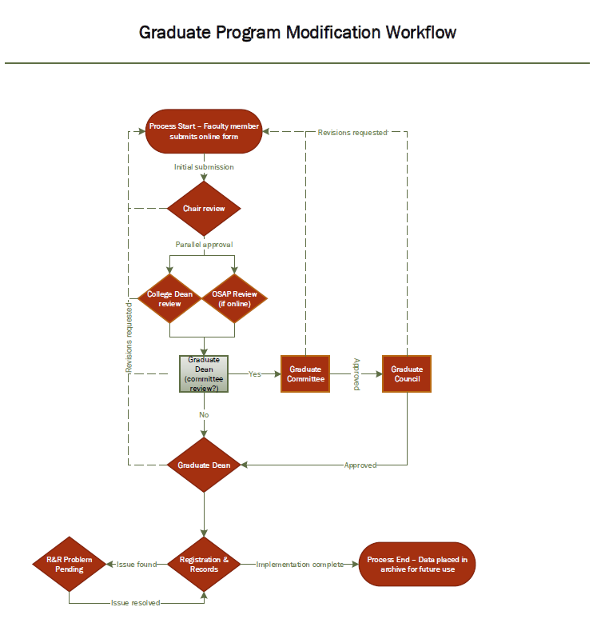

Graduate Program Modification Proposal Template
Program authors can use this template to prepare their responses and then copy and paste to the website.

- What is the current university approved degree designation and program title? (Ex. Master of Arts in History)*
- Will the name of the degree designation change? (MA, M.Ed., Ph.D. etc)*
  - Yes
  - No
*If yes: Please provide the proposed degree designation.*
- Will the title of the program change?*
  - Yes
  - No
*If yes: Please provide the proposed title of the program.*
- What additional modifications are you making to this program? (Check all that apply)
- New specialization
Name of specialization:
- Modification to specialization
Name of specialization:
- Change to program requirements
- Change catalog description
- Program to be available 100% online or blended
- Suspend admission
- Reactivate admission
- Eliminate program
- CCGS approval necessary as a result of 50% of the curriculum being modified
- ODE approval is required for teacher licensure/endorsement
*If program is to be available 100% online or blended*
4.1 Required for the Office of Online and Summer Academic Programs (OSAP): If there is a current onsite program, will the online or blended program be offered instead of or in addition to the onsite program?
4.2 Required for OSAP: If there is a current onsite program, indicate whether the online or blended program is equivalent to the onsite program (e.g., expected outcomes, number of credits, course availability, etc.). If there are differences, please explain.
4.3 Required for OSAP: Projected term the program will commence.
Year:
Term:
- Provide a brief overview of the program change. (max. 50 words)
- Program Curriculum
  - Catalog Description
  - Current catalog description (one paragraph)
  - Does the change influence prerequisites?
- Yes
- No
*If yes, explain the change below.
Current prerequisites:
Proposed prerequisites:

  - Does the change influence admissions procedures?
- Yes
- No
*If yes, explain the change below.
Current procedure:
Proposed procedure:
  - Does the change influence the general degree requirements? (e.g. total credit hours, Plan I and/or Plan II options)
- Yes
- No
*If yes, explain the change below.
Current requirements:
Proposed requirements:
  - Specific Curriculum: Is there a change in the required or elective courses?
- Yes
- No
*If yes, please give rationale for the change:
2.1 Does the change influence the current list of program required courses?
- Yes
- No
*If yes, please list the course changes below.
Current courses:
Proposed courses:
2.2 Does the change influence the list of elective courses?
- Yes
- No
*If yes, please list the course changes below.
Current elective courses:
Proposed elective courses:
2.3 Attach a copy of the program check sheet or sample TDP as Appendix A. *If appropriate, describe any restrictions regarding the choice or sequence of courses within the proposed program/certificate.
You must save this proposal before attaching supporting documentation. Details on submitting and saving are below in red.
*If program is to be available 100% online or blended*
2.4 Required for OSAP: Describe how interaction (synchronous or asynchronous) between the instructor and the students and among the students is reflected in the design of the program and its courses. For questions, contact the Office of Online and Summer Academic Programs at OSAP@bgsu.edu.
2.5 Required for OSAP: Explain how students are supported and counseled to ensure that they have the skills and competencies to successfully complete the curriculum in an online learning environment. For questions, contact the Office of Online and Summer Academics Program at OSAP@bgsu.edu.
2.6 Required for OSAP: Explain the process for academic attendance and academically related activities that show regular and substantive interaction between students and instructors. For questions, contact the Office of Online and Summer Academic Programs at OSAP@bgsu.edu.

  - Does the program change either influence the learning outcomes or the assessment methods?
    - Yes
    - No
*If yes, please list the program’s expected learning outcomes and corresponding plan for assessing the outcomes.
Current Learning Outcomes:
Current Assessment Methods:
Proposed Learning Outcomes:
Proposed Assessment Methods:
*Note: An assessment strategy can be used to assess more than one outcome.
4. Required for OSAP: Describe the evaluation systems used to measure the quality and effectiveness of the program delivered in an online or blended format. For questions, contact the Office of Online and Summer Academic Programs at OSAP@bgsu.edu.
D. Administrative Structure: Does the change affect the administrative structure?
1. Does the change influence where the program will be housed administratively (e.g. department or school)?
- Yes
- No
*If yes, please explain the change below.
Current Housing:
Proposed Housing:
Attach correspondence from the involved units.
You must save this proposal before attaching supporting documentation. Details on submitting and saving are below in red.
2. Will the proposed program change either influence or be influenced by other programs, including:
2.1 In the department/school?
- Yes
- No
*If yes, please explain what units and how they influence or are influenced:
2.2 In other BGSU departments/colleges?
- Yes
- No
*If yes, please explain what units and how they influence or are influenced:
2.3 At other universities?
- Yes
- No
*If yes, please explain what units and how they influence or are influenced:
Attach correspondence from above units (departments, colleges) that will be influenced.
You must save this proposal before attaching supporting documentation. Details on submitting and saving are below in red.
3. Do these modifications create or modify any implications regarding accreditation of this program or of associated programs in the college/university?
- Yes
- No
*If yes, please explain the implications:

E. Rationale for Program Change
1. Provide the rationale for the proposed program change:
2. Will this change modify the program demand?
- Yes
- No
*If yes, please explain:
F. Recruitment and Admissions
1. Does this change influence the recruitment plan? (Identify responsible individuals and resources for recruitment)
- Yes
- No
*If yes, please explain:
2. Does this change influence recruitment of underrepresented populations?
- Yes
- No
*If yes, please explain:
3. Would the change influence the criteria for admission?
- Yes
- No
*If yes, please explain:
Current Admission Criteria:
Proposed Admission Criteria:
G. Resource Implications
1. Does the change influence the availability of qualified faculty and staff?
- Yes
- No
*If yes, please explain:
2. Does the change influence physical resources?
- Yes
- No
*If yes, please explain:
3. If you answered yes to 1 or 2, what is the estimated financial cost?
*If program is to be available 100% online or blended*
4. Required for OSAP: Projected list of advisors for the program:
5. Required for OSAP: Development plan for faculty training and course development. For questions, contact the Office of Online and Summer Academic Programs at OSAP@bgsu.edu.
H. Is or will this change be a joint program with another institution or higher learning?
- Yes
- No
*If yes, how will the change influence any of the following?
1. What is the tuition sharing agreement and billing processing?
2. What is the plan for graduation processing (awarding of degrees, etc.)?
3. What is the plan for data sharing/communication?
I. Other pertinent information:
Provide other information that may be helpful in the review process, as appropriate:

