NEW GRADUATE PROGRAM
Submission Instructions

To complete a curriculum development request for a new graduate program, the author/proposer of the program should go to the following webpage to find the link to complete the online form: http://www.bgsu.edu/graduate/documents-and-forms.html

This online process that includes the New Graduate Program Proposal Form should be utilized for the internal BGSU approval process. All new programs (except certificate programs less than 21 credit hours) must also successfully go through a Chancellor’s Council on Graduate Studies (CCGS) approval process. A link to the full Guidelines and Procedures for Review and Approval of Graduate Degree Programs can be found on the Graduate College SharePoint site. If you wish to create a new program, you must first talk with the Graduate Dean before completing your proposal.

BGSU Online Process:
Once in the online system, one individual must be the sole author of the proposal. The proposal may be completed in stages, with the author saving sections of it as they are complete. Note the following important points when completing the online proposal:

- COMPLETING THE DOCUMENT: While the author can type in the answers to each question on the form, it is suggested that most answers first be typed and saved in a Word document and then copied and pasted into the web document. This will protect the author from any unfortunate loss of material. Furthermore, the web-based form can only be accessed from campus. As a result, the most substantial amount of work can be done on or off campus and later copied and pasted into the web document.
- SAVING DOCUMENT: It is best to save the proposal early in the process (within 15 minutes) so the author establishes a saved web document. After saving it for the first time (see the SAVE button on the very bottom of proposal), a “Success” page will appear. This will generate an email immediately sent to the author with a link that will take the author back to the draft proposal. To return to the saved document, click on the link sent in the email. This same email with link should be used for future re- entries into the document.
- ATTACHMENTS: You will need to save the form prior to adding any attachments. The CCGS Guidelines on New Program Proposal Structure, as well as templates for the New Graduate Program Proposal and the Fiscal Impact Statement, can be accessed on the Documents and Forms webpage under Curriculum Development. The New Graduate Program Proposal should be attached as a Word document.
- SUBMITTING DOCUMENT: Do not click on “submit” at the bottom of the document until you are completely finished with it. Once submitted, you will not be able to edit the document unless a later reviewer requests edits. After clicking submit, you will need to enter the BGSU usernames of the Chair/Director and the Line Dean who will be approving your proposal. For a list of your Line College’s reviewers, please see the Graduate Curriculum Development Routing Info webpage.
- PRINTING: At any time that an individual needs a copy of the proposal, it is possible to print or create a print pdf version of the proposal for records.

REVIEW CHECKPOINT PROCEDURES
Once the proposal is complete, it will then go through the approval routing process. This approval process has been designed to route the document electronically to the levels of review required across the BGSU campus. As a result, if additional levels of review are required within particular colleges, it is up to the college to assure the extra level of review necessary is conducted according to their policies.

Once the proposal is submitted, the online process will request the BGSU username of the first level of review, the chair/director of the department/school and also the line dean. At each level, that individual’s BGSU username is connected to their “approval” and therefore represents their electronic signature. The following illustrates the review and approval process:
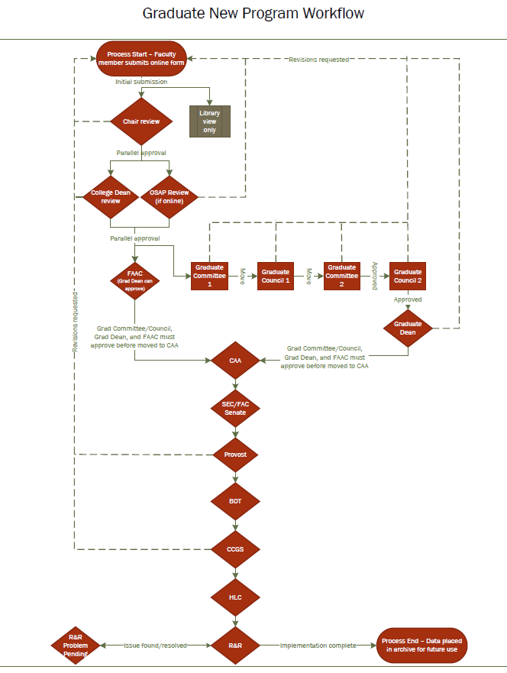

New Graduate Program Proposal OnBase Form
Program authors can use this template to prepare their responses and then copy and paste to the eform.

*Note: Questions in blue only apply to programs that are 100% Online or Web-Centric.*

A. Designation of New Degree Program.
- Degree designation (e.g., MA, MS, MFA, PhD, EdD, etc.)
- New program name (e.g., History)
- Administrative unit of program (name[s] of the participating department[s] or school[s]):
- Program delivery method (select all that apply)
☐ Face-to-Face
A.4.1. Are you requesting this program be approved as a 100% face-to-face program?
- Yes
- No
*If Yes*
A.4.1.1. Projected year the program will commence:
A.4.1.2. Projected term the program will commence:
☐ Web-centric (hybrid)
A.4.2. Are you requesting this program be approved as a web-centric (hybrid) program?
- Yes
- No
*If Yes*
A.4.2.1. Projected year the program will commence:
A.4.2.2. Projected term the program will commence:
A.4.2.3 For which campus would this program be coded?
☐ Distance/Extended
☐ Main
A.4.2.4. If there is a current onsite program, indicate whether the online or blended program is equivalent to the onsite program (e.g., expected outcomes, number of credits, course availability, etc.). If there are differences, please explain.
A.4.2.5. If there is a current onsite program, will the online or blended program be offered instead of or in addition to the onsite program?

A.4.2.6. Approximately what percentage of program content will be completed on-line?

☐ 100% Online
A.4.3. Are you requesting this program be approved as a 100% online program?
- Yes
- No
*If Yes*
A.4.3.1. Projected year the program will commence:
A.4.3.2. Projected term the program will commence:
A.4.3.3 For which campus would this program be coded?
☐ Distance/Extended
☐ eCampus
A.4.3.4. If there is a current onsite program, indicate whether the online or blended program is equivalent to the onsite program (e.g., expected outcomes, number of credits, course availability, etc.). If there are differences, please explain.
A.4.3.5. If there is a current onsite program, will the online or blended program be offered instead of or in addition to the onsite program?

B. Joint Programs
B.1. Will this be a joint program with another institution of higher learning?
- Yes
- No
*If Yes*
- What is the tuition sharing agreement and billing processing?

- What is the plan for graduation processing (awarding of degrees, etc.)?

- What is the plan for data sharing/communication?

C. Program Curriculum
- Catalog description (no more than 200 words)

- Specific curriculum:
C.2.1 List any new courses being created for this program. (Any new courses specifically for the new program must accompany the new program form when it moves to Full Graduate Council for review.)

C.2.2 Required hours in degree (certificate programs with 12-20 hours are approved by BGSU; 21 or more credit hours necessitate approval by BGSU and CCGS)

*The following only apply to programs that are 100% Online or Web-Centric. For related questions, contact the Office of Online and Summer Academic Programs at OSAP@bgsu.edu.*
C.2.3 REQUIRED FOR OSAP: Explain how students are supported and counseled to ensure that they have the skills and competencies to successfully complete the curriculum in an online learning environment.

C.2.4 REQUIRED FOR OSAP: Explain the process for academic attendance and academically related activities that show regular and substantive interaction between students and instructors.

*Note: When submitting an online or blended/hybrid program to CCGS, a State of Ohio online approval form must also be submitted. Contact the Graduate College for this form.

- Evaluation
C.3.1. Describe process to ensure the program uses Quality Matters or similar metric-driven online course design/assessment tools.

D. Resource Implications
- Faculty and staff implications:
D.1. Projected list of advisors for the program.

D.2. Describe how all instructors will be trained in offering online content and online assessments.

D.3. Will the program be offered in partnership with a third-party commercial on-line service provider?
- Yes
- No
*If Yes*
D.3.1. Please provide name of provider and their responsibilities [e.g., content creation, recruitment, admissions, advising].

E. Other Information
E.1. Provide other information that may be helpful in the review process, as appropriate.

F. Attachments
*Note: The form must be saved before attachments may be added. Please first click the Save button on the online form. You will receive an email with a link to the form, in which you will be able to add attachments.

Attach a completed New Graduate Program or Certificate Proposal (template can be found on Documents & Forms webpage)
Attach a completed Faculty Matrix (template can be found on Documents & Forms webpage)
Attach Course Descriptions
Attach a Program Check Sheet (for your check sheet, you could copy and paste the table you created in the program proposal into a new Word document and add any additional information that a student may need to know about completing the program)
Attach the completed Fiscal Impact Statement (FIS) (template can be found on Documents & Forms webpage)
Attach correspondence from any units (departments, colleges) that will be influenced
Attach any additional supporting documentation if needed (e.g., needs surveys/market analysis, consultants’ reports, etc.)

