NEW GRADUATE COURSE
Instructions and Template

To complete a curriculum modification request for a new graduate course, the author/proposer of the program should go to the following page to find the link to complete the online form: http://www.bgsu.edu/graduate/documents-and-forms.html

This online process that includes the New Graduate Course Proposal Form should be utilized for the internal BGSU approval process.

BGSU Online Process:
Once in the online system, one individual must be the sole author of the proposal. The proposal may be completed in stages, with the author saving sections of it as they are complete. Note the following important points when completing the online proposal.

- COMPLETING THE DOCUMENT: While the author can type in the answers to each question on the form, it is suggested that most answers first be typed and saved in a Word document and then copy and pasted into the web document. This will protect the author from any unfortunate loss of material. Furthermore, the web-based form can only be accessed from campus. As a result, the most substantial amount of work can be done on or off campus and later copy and pasted into the web document.
- SAVING DOCUMENT: It is best to save the proposal early in the process (within 15 minutes) so the author establishes a saved web document. After saving it for the first time (see the SAVE button on the very bottom of proposal), a “Success” page will appear. This will generate an email immediately sent to the author with a link that will take the author back to the draft proposal. To return to the saved document, click on the link sent in the email. This same email with link should be used for future re- entries into the document.
- ATTACHMENTS: There are several opportunities to attach additional documents to the proposal. At the end of section C.2, the author should attach a copy of the program check sheet and at the end of D.2., additional correspondence, such as letters of support should be attached.
*PLEASE NOTE: You will need to save the form prior to adding attachments.
- SUBMITTING DOCUMENT: Do not click on “submit” at the bottom of the document until you are completely finished with it. Once submitted, you will not be able to edit the document unless a later reviewer requests edits.
- PRINTING: At any time that an individual needs a copy of the proposal, it is possible to print or create a print pdf version of the proposal for records.

REVIEW CHECKPOINT PROCEDURES
Once the proposal is complete, it will then go through the approval routing process. This approval process has been designed to route the document electronically to the levels of review required across the BGSU campus. As a result, if additional levels of review are required within particular colleges, it is up to the college to assure the extra level of review necessary is conducted according to their policies.

Once the proposal is submitted, the online process will request the BGSU username of the first level of review, the chair/director of the department/school and also the line dean. At each level, that individual’s BGSU username is connected to their “approval” and therefore represents their electronic signature. The following illustrates the review and approval process:
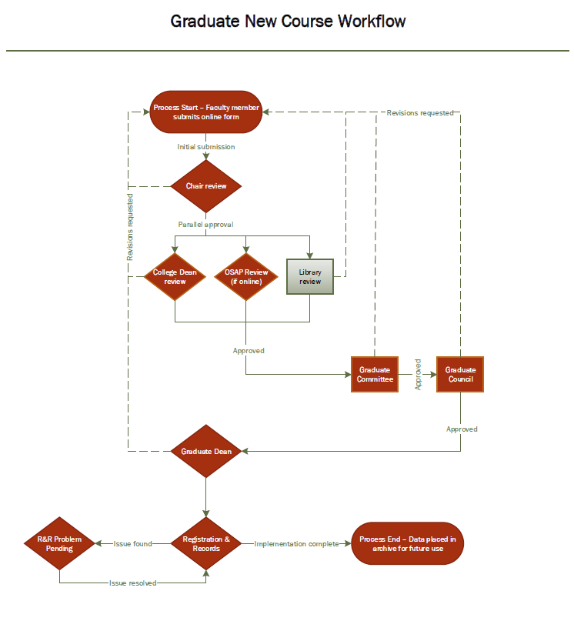

Graduate New Course Proposal Template
Program authors can use this template to prepare their responses and then copy and paste to the website.

Course Prefix:
4 Digit Course Number:
Check/input all that apply
- Face to Face
- Web-Centric
- Web-Based
*If Web-Centric or Web-Based: Required for OSAP: Please attach a copy of the syllabus. The syllabus must adhere to the guidelines for online learning found HERE. In order to attach the syllabus to this form, click the SAVE button at the bottom of this web page. Then click the link that will be sent to you via email, and upload your syllabus form there. Details on submitting and saving are also below in red.
Maximum Class Size:
Grading Method:
- S/U Only
- A/F Only
Recommended effective term:
- ASAP
- Term/Year:
New Course Description. Enter the new description of the course exactly as it should appear in the Course Catalog, including course number, title, credit hours, semesters offered, description, prerequisites, and repeatability:
*If Web-Centric or Web-Based: Please include the phrase “Approved for distance learning” at the end of your description.
- Course Details
Note: Text areas will expand, please provide the necessary information on the form.
  - Rationale (why is this new course needed?)
  - Purpose of the course (instructor’s goals)
  - Topical outline for the content to be covered and approximate percentage of time per topic:
  - List the course student learning outcomes and the corresponding assessment methods for each (Please indicate if an assessment method refers to more than one learning outcome):
*If Web-Centric: Please specify when assessment methods are specific to particular delivery methods
Learning Outcomes:
Assessment Methods:
  - Instructional Strategies. List any suggested and/or mandatory strategies and learning activities. Clearly indicate those that are mandatory:
  - Attach an example bibliography to document the existence of a body of scholarly literature requisite for a graduate course. See save button at bottom of form. *You must save this proposal before attaching supporting documentation. Details on submitting and saving are below in red.
  - Is this a 5000-level course that will be cross-listed with a 4000-level undergraduate course?
- Yes
- No
If yes:
- Undergraduate Course Prefix and Number:
- Describe the difference in graduate and undergraduate expectations:
2. Implications for Other Academic Units
a. List courses potentially impacted by this new course and the anticipated effect on enrollment:
b. What other colleges or departments/programs may be affected by this proposal?
c. Attach endorsements from related departments. When the content of a proposed course overlaps another discipline, the department proposing the new course should submit letters of endorsement from the chair(s) of the department(s) with an interest in the proposed course.
You must save this proposal before attaching supporting documentation. Details on submitting and saving are below in red.
3. Resources
a. Expected annual enrollment:
b. List the names of graduate faculty available to teach the course:
c. Indicate any unique space requirements:
d. Indicate new one-time or continuing costs for materials, equipment, supplies.
4. Administrative Course Elements
a. Course title variability: will variable titles be allowed?
- Yes
- No
b. List any other graduate courses that this course will be dual-listed with:
c. Extra fees: Do you plan to request extra fees for this course?
- Yes
- No
If yes: Amount and Rationale:
Note: A course fee request form must be processed separately: Course Fee Request Form
d. Is the course repeatable?
- Yes
- No
If yes: Enter maximum number of repeatable credits:
e. Students may enroll in multiple sections of the course per term:
- Yes
- No
f. Has the course content been offered on a trial basis under a different course number (i.e., under a topics course)?
- Yes
- No
If yes: Please provide course prefix(es), number(s), and title(s):
Other Information:
Please explain any other supporting documentation attached and/or provide other information that may be helpful in the review process, as appropriate.
You must save this proposal before attaching supporting documentation. Details on submitting and saving are below in red.

