GRADUATE COURSE MODIFICATION
Instructions and Template

To complete a curriculum modification request for a graduate course modification, the author/proposer of the modification should go to the following page to find the link to complete the online form: http://www.bgsu.edu/graduate/documents-and-forms.html. See the bottom of the page for relevant links.
The online process that includes the Graduate Course Modification Proposal Form should be utilized for the internal BGSU approval process.

BGSU Online Process:
Once in the online system, one individual must be the sole author of the proposal. The proposal may be completed in stages, with the author saving sections of it as they are complete. Note the following important points when completing the on-line proposal:

- COMPLETING THE DOCUMENT: While the author can type in the answers to each question on the form, it is suggested that most answers first by typed and saved in a Word document and then copy and pasted into the web document. This will protect the author from any unfortunate loss of material. Furthermore, the web-based form can only be accessed from campus. As a result, the most substantial amount of work can be done on or off campus and later copy and pasted into the web document.
- SAVING DOCUMENT: It is best to save the proposal early in the process (within 15 minutes) so the author establishes a saved web document. After saving it for the first time (see the SAVE button on the very bottom of proposal), a “Success” page will appear. This will generate an email immediately sent to the author with a link that will take the author back to the draft proposal. To return to the saved document, click on the link sent in the email. This same email with link should be used for future re-entries into the document.
- ATTACHMENTS: There are several opportunities to attach additional documents to the proposal. At the end of section C.2, the author should attach a copy of the program checksheet and at the end of D.2., additional correspondence, such as letters of support should be attached.
*PLEASE NOTE: You will need to save the form prior to adding attachments.
- SUBMITTING DOCUMENT: Do not click on “submit” at the bottom of the document until you are completely finished with it. Once submitted, you will not be able to edit the document until a later reviewer requests edits.
- PRINTING: At any time that an individual needs a copy of the proposal, it is possible to print or create a print pdf version of the proposal for records.
- EXPANDABLE FORM: Please note that this online form expands and requires additional information for each question that is answered “yes”. Otherwise, forms with “no” for the majority of answers remain short and are easily completed (replace the former “EZ” form).

REVIEW CHECKPOINT PROCEDURES
Once the proposal is completed, it will then go through the approval routing process. This approval process has been designed to route the document electronically to the levels of review required across the BGSU campus. As a result, if additional levels of review are required within particular colleges, it is up to the college to assure the extra level of review necessary is conducted according to their policies.

Once the proposal is submitted, the online process will request the BGSU username of the first level of review, the chair/director of the department/school and also the line dean. At each level, that individual’s BGSU username is connected to their “approval” and therefore represents their electronic signature. The following illustrates the review and approval process:

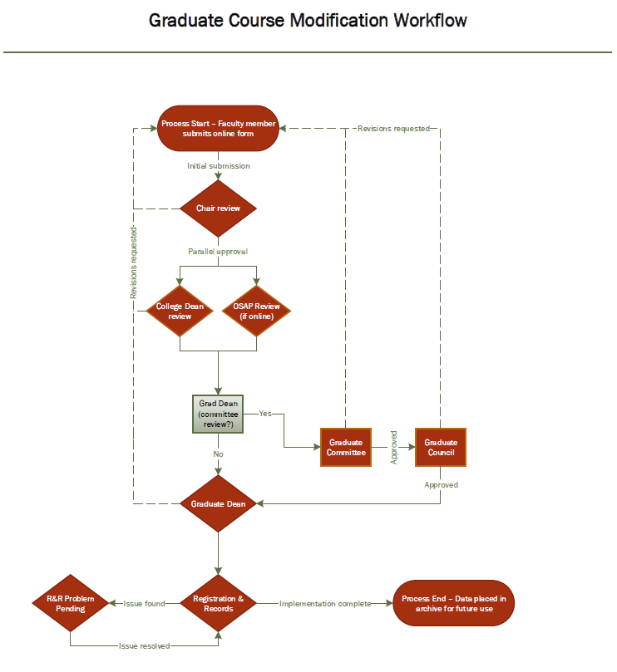

Graduate Course Modification Proposal Template
(The e-form is short but includes many conditional logic drop-down boxes. We have attempted to include all conditional logic possibilities in this form.)

Course(s) Modified
+Add a course to be modified
Course Prefix: 4 Digit Course Number

Please note that modifications to groups of courses are limited to the below options, which must apply to all courses uniformly (except for changes to prefixes/numbers). In particular, any change to credit hours must be uniform for all courses in the group, and elimination applies to all courses in the group.

Course Modifications (check/input all that apply)
☐ Eliminate Course(s)
*If checked*
Rationale/need for change (attach or enter in text area. If attached, please enter “see attachment” in the text area)
You must save this proposal before attaching supporting documentation. Details on submitting and saving are below in red.

☐ Proposed Course Prefix(es) and Number(s)
*If checked*
New Course Prefix: New 4 Digit Course Number

☐ Credit Hours
*If checked*
Current credit hours: New credit hours:

☐ Course Title
*If checked*
Current Course Title: New Course Title:

☐ Prerequisite
*If checked*
Include your modification below where it asks for “Old catalog description” and “New catalog description”

☐ Catalog Description
*If checked*
Include your modification below where it asks for “Old catalog description” and “New catalog description”

☐ Estimated Class Size
*If checked*
New Estimated Class Size (this estimation should align with the method of instruction used for the class):

☐ Grading Method
*If checked*
New Grading Method:
- S/U Only
- A/F Only

☐ Method of Instruction
*If checked*
New Method of Instruction (use the CTRL key to select multiple):
- LE Lecture
- PR Practicum
- SE Seminar
- LB Lab
- ST Studio
- TU Tutorial
- DI Discussion
- RE Recitation
- CL Clinical
- FE Field Experience
- IS Individual Studies
- SP Self Paces
- OT Other

☐ Change Repeatability
*If checked*
- Make Course Repeatable
- Remove Course Repeatability

Delivery Method
☐ Add Web-Centric
*If checked*
Required for OSAP: Please attach a copy of the syllabus. The syllabus must adhere to the guidelines for online learning found HERE. In order to attach the syllabus to this form, click the Save button at the bottom of this web page. Then click the link that will be sent to you via email, and upload your syllabus form there. Details on Submitting and Saving are also below in RED.

☐ Add Web-Based
*If checked*
Required for OSAP: Please attach a copy of the syllabus. The syllabus must adhere to the guidelines for online learning found HERE. In order to attach the syllabus to this form, click the Save button at the bottom of this web page. Then click the link that will be sent to you via email, and upload your syllabus form there. Details on Submitting and Saving are also below in RED.

☐ Add Face to Face

☐ Remove Web-Centric

☐ Remove Web-Based

☐ Remove Face to Face

☐ Addition of course fee (request form must be processed separately: Course Fee Request Form)

☐ The catalog description is being modified
*If checked*
Old catalog description:

New catalog description. Enter the modified description of the course exactly as it should appear in the Course Catalog, including course number, title, credit hours, description, prerequisites, and repeatability.

Curricular Changes
☐ Course content
*If checked*
Please explain the change in course content:

☐ Student Learning Outcomes
*If checked*
Proposed Learning Outcomes | Proposed Assessment Methods

Rationale/Need for Change
(Attach or enter in text area. If attached, please enter “see attachment in the text area):
You must save this proposal before attaching supporting documentation. Details on submitting and saving are below in red.

Recommended effective term:
- ASAP
- Term/Year:

Other Information
Please explain any other supporting documents attached and/or provide other information that may be helpful in the review process, as appropriate:

You must save this proposal before attaching supporting documentation. Details on submitting and saving are below in red.

Note: There are two options below to submit your curriculum modification. Please find the description below and select the appropriate button when they are available.

Save - This option saves your proposal to the system and sends a follow-up email to you. In order to complete your proposal, you need to click on the link in the email. This allows you to upload attachments. Please select this option if your proposal requires supporting documentation.
Submit - This option is available only after you Save the proposal for the first time. When your proposal is complete, please select the Submit option to immediately submit your proposal for processing. After submission, you will no longer have access to edit your proposal.

