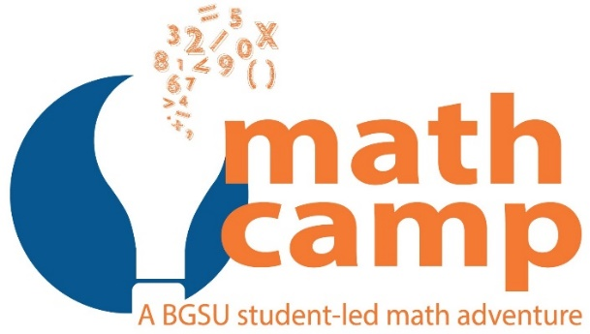

Absence Request
The Collegiate Math Camp is 6:00 PM Friday, October 19th to 5:00 PM Saturday, October 20th.
If you are missing any of the camp, this form must be submitted AND a meeting must be scheduled with Dr. Matney, gmatney@bgsu.edu by Friday October 12th.
Student Name:
BGSU Number:
Phone Number:
BGSU Email:
Students experiencing unforeseen circumstances such as contagious illness or death/severe illness in family will be handled on a case-by-case basis.
All absent individuals will receive an alternate assignment to complete.
Type of Absence Requested:
 |  |  | Illness |  | Military Commitment |  |  |  | Academic Course Required Obligation (Field Hours, Meeting, etc.)
 |  |  | Work |  | BGSU Athletic Event |  |  |  | Family Obligation or Emergency |  | Other

Dates/Times of Absence: | From: | To:

All absence requests must have supporting documentation attached (doctor’s note, signed note, etc.)
Student Signature | Date
All requests for absences must be submitted by Friday, October 12th, 2018 to Dr. Gabriel Matney office mailbox in Education 529. The office is open 8-4 pm Monday through Friday.

