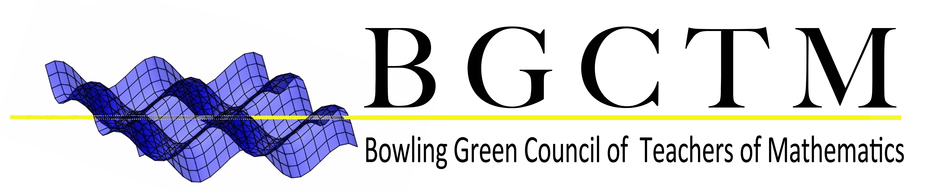

Membership Payment Form

First and Last name: _________________________ BGSU ID: ___________

Did you enter your membership registration information in our BGCTM Google form?
____ YES,
____ NO

If no, go to the Join BGCTM section of our website at www.bgsu.edu/bgctm and submit this form with $10.

Send this form with $10.00 membership fee to BGCTM, 124 Life Science Building or give to Dr. Brahier, Dr. Bostic, Dr. Matney, Dr. Gallagher, Cassy Castle or Alyssa Lustgarten. Please make checks payable to BGCTM.

Membership to BGCTM includes membership to the Ohio Council of Teachers of Mathematics (OCTM). Both memberships are valid for one year.

Need to check the status of your BGCTM membership? Go to the Membership Status link located under the Join BGCTM section of our website www.bgsu.edu/bgctm.

If you have any questions, please contact Alyssa Lustgarten via email at lalyssa@bgsu.edu.
DO NOT WRITE IN THIS SECTION Official BGCTM Advisors Only

Check Number: _________ Cash: ______ Initials: ____ Date: _____

Membership Chair Initials: ______

