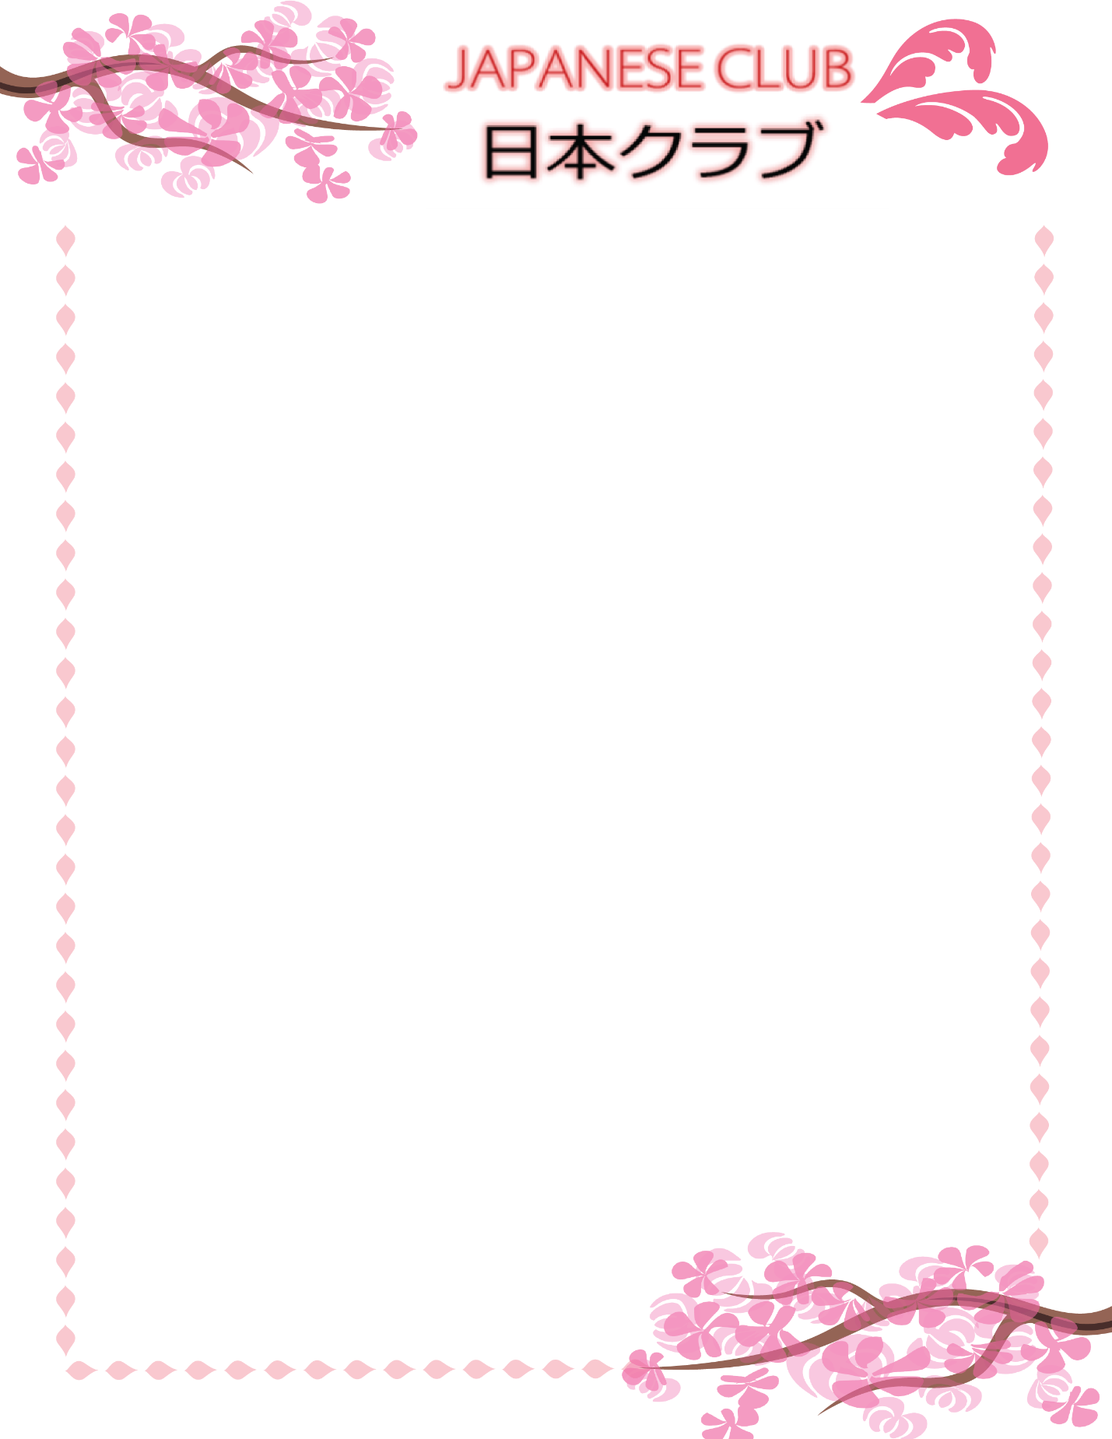

9/6 – Japanese Club Welcome

Welcome! Are you interested in Japanese culture or Asian Studies? Come meet others with a shared interest and learn about what Japanese Club is all about!

9/13 - Origami

Interested in Japanese paper folding? Join Japanese Club as we learn about and create origami together!

9/20 – Otsukimi/お月見

Come learn about Otsukimi, the full moon viewing festival, and learn about Otsukimi traditions!

9/27 – Summer Study Abroad

Join the Summer Study Abroad students as they share their experiences of a month-long summer study in Japan.

10/4 – Japanese Club Auction

Bring out your wallets because we’ll be auctioning off an array of authentic Japanese goods! Great gifts for the holidays, or why not splurge on yourself and win that rice bowl you know you’ve always wanted.

10/11 – JET Program

Interested in teaching in Japan? Come learn about how you can work and live in Japan through the Japanese Exchange and Teaching Program (JET)! We will welcome a guest speaker Ms. Rhea Young from the Consulate General of Japan in Detroit.

10/18 – Exchange Program

Join the exchange students as they share their experiences between cultures!

10/25 – Halloween

It’s Halloween! Come wearing your best costume and celebrate with us.

11/3 – Shodo Exhibit and Workshop

In this collaboration between Asian Studies and the Fine Arts, come learn about Shodo, view a demonstration, and attend a reception for the Shodo Exhibit within the School of Art building. (The details will come soon.)

11/8 – Peace Studies

Interested in global peace and learning how the world can move towards nuclear disarmament? Come learn about the Peace Studies Seminar in Hiroshima and see why it’s important.

11/10 – Half-Day Homestay

Enjoy Japanese cuisine and learn about Japanese home life in a half-day experience at Akiko Sensei’s house!

11/22 – Thanksgiving Break

11/29 – Movie Night

Come relax and have fun while learning about Japanese culture with Japanese Club movie night!

12/6 – New Year’s Eve Party/お正月
The year may be coming to an end, but that doesn’t mean the fun has to! Come enjoy our last meeting of the Fall semester and learn about how New Year’s Eve is celebrated in Japan!

All events are located in the Nakamoto Japanese Studies Room, located on the 11th Floor of Offenhauer West (Rm. 1102) from 9:00 PM to 11:00 PM unless otherwise stated. Dates are subject to change.

For more information, contact: jakiko@bgsu.edu vdelsig@bgsu.edu

