**Early Alert Instructions:**

For instructors who received the Progress Report e-mail, they can follow these instructions below:

If you log into your Navigate and select the triangle below for your “Professor Home” page, you will see the big yellow bar to fill out the Progress Reports. Once you open the Progress Report, you will see your students indicated below. At this point, you will indicate if an alert is needed or not, for each student below.

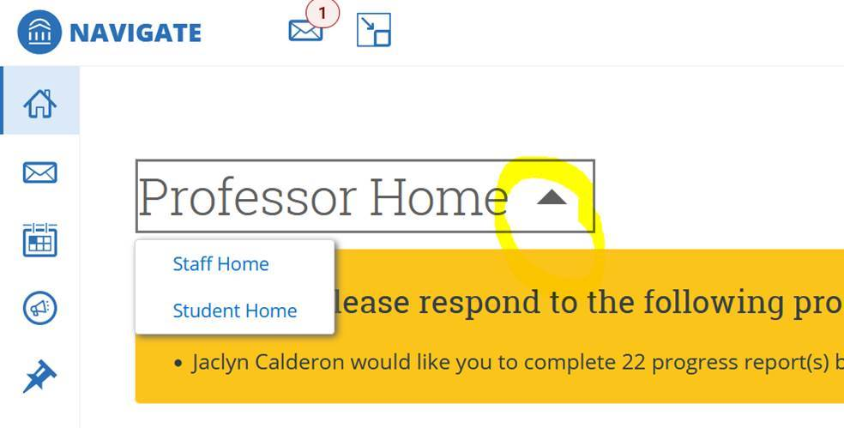

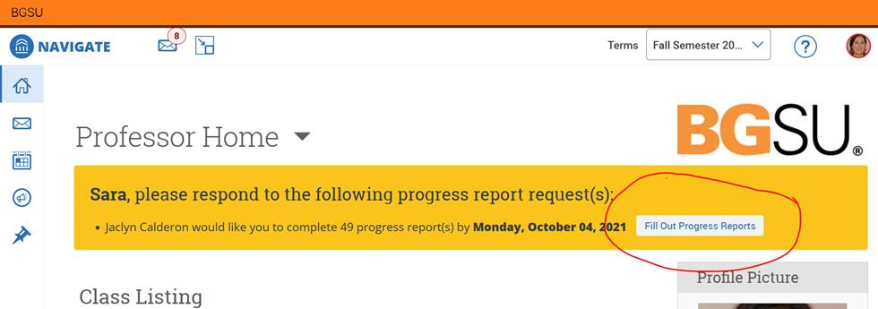

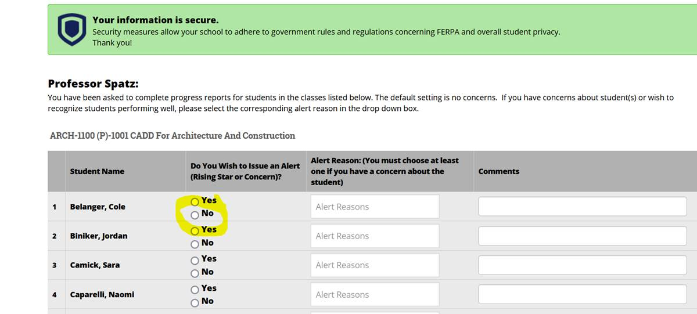

**For courses that have not been included within the Progress Reporting, please follow these instructions listed below:**

Please note, not every course has been included within the Progress Reports, but you can issue an Alert for any student regardless of their class. If you log into your Navigate and select from your list of students, as shown below. Then you can click on the “**Issue an Alert**” button and it will pull up the screen shown below. You can also select from your list of students, and click on as many students as you would like and then click on the “**Actions**” tab. From that point, you can also “**Issue an Alert**” for multiple students all at once who may have the same alert reason. There you can select what type of alert you would like to issue. This will send the student and the Outreach Coordinator the Early Alert information, and the student will get followed up with in the same manner as with the Progress Reporting.

