How to Make Your Canvas Courses Accessible

It’s important to create or add material into Canvas that is accessible. Use the Accessibility Checker located on the Rich Content Editor menu bar (Refer to image below titled “Accessibility Checker”) to check to see if the documents, tables, and other elements you create and add in Canvas are accessible.
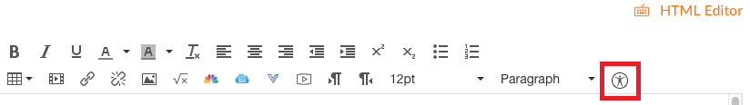
Image 1: Accessibility Checker

Headings
Headings or headers are used to create structure for content within a document, allow screen readers to quickly navigate through a document, and improve the overall appearance and readability of the content for all users.

They are divided into levels usually ranging from 1-6 with 1 being the largest. Canvas uses Headers 1-4, reserving Header 1 for page titles. Do not skip header levels. For example, do not place a Header 4 directly under a Header 2.

To use Headers in Canvas, use the “Paragraph” drop-down menu on the Rich Content Editor (Refer to image below titled “Paragraph Menu”) to add headings to pages in Canvas. Do not create headings by simply bolding and enlarging text size.
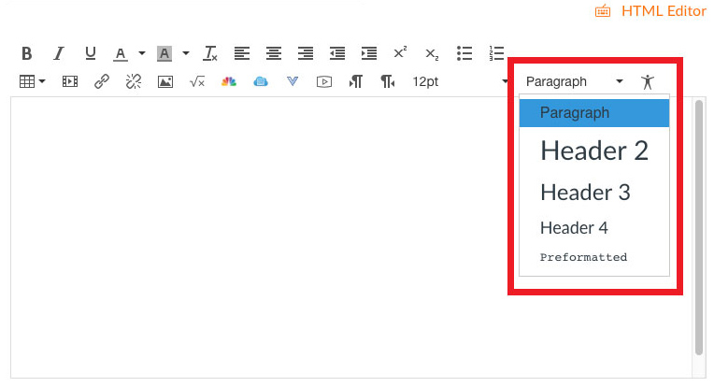
Image 2: Paragraph Menu

Text Styles
When using text styles such as bold and italic, keep in mind that most screen readers have styles turned off by default. If you do use bold and italic styles, add a special word such as “important” at the beginning of the sentence so the information will stand out for everyone. Refer to the example below.

Important: Assignment 1 Due on Wednesday, November 8 at 11:59 pm.

You can also use spacing to make a sentence that contains important information stand out from the rest of the text.

Never use all caps to make a word stand out. Screen readers will read each letter as if the word is an acronym. For example, a screen reader would read the word DUE as D-U-E.

Text styles such as underline should only be used for hyperlinks.

Color
If you use different font colors throughout your documents and/or Canvas courses, use a Color Contrast Checker to ensure there is enough contrast between the background color and font color. This will help anyone with low vision or that is color blind to read the document in the way you intended it to be read.

Lists
Lists are very helpful to structure content that is both visually appealing and easy to navigate for all users. There are three types of lists; ordered, unordered, and nested. Be sure to use the ordered list or unordered list tool in Canvas on the Rich content Editor (Refer to the image below titled “Ordered and Unordered List Tools”) when creating lists.
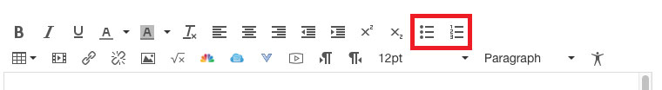
Image 3: Ordered and Unordered List Tools

Ordered Lists
Ordered lists are used to present information in a sequential way.

How to Access the Student View in Canvas
- Open your Canvas course
- Click on the "Settings" link in the course navigation on the left-hand side of the page
- Then click on the "Student View" link on the right-hand side of the screen

Unordered Lists
Unordered lists are used to provide information that doesn't need to be presented in a particular order.
Desserts
- Pies
- Cakes
- Cookies

Nested Lists
Nested lists contain sub lists within a list.
- Pies
  - Pecan
  - Pumpkin
  - Apple
- Cakes
  - Chocolate
  - Vanilla
  - Carrot
- Cookies
  - Chocolate Chip
  - Oatmeal
  - Peanut Butter

Tables
Tables are useful when presenting data. When creating tables, keep the following information in mind:
- Keep the data simple.
- Include a table caption and both row and column headers to make it easier for screen readers to navigate.
- Break the information into more than one table if using complex data.
- Avoid merging cells within a table. Screen readers have a difficult time navigating cells that have been merged.
- Do not use tables to control the page layout such as positioning of graphics or images on pages.
- Use the Color Contrast Checker from the WebAIM.org website if you use color in your tables.

How to add a table caption
- When you click on the table you created within Canvas, the “Table Context Menu” appears.
- Within this menu, select the “Table Properties” icon (the first icon on the left within the menu).
- In the Table Properties window, click the “Caption” check box then click the orange “OK” button (Refer to image below titled “Table Properties”).
- A space will appear above the table for you to enter a caption.
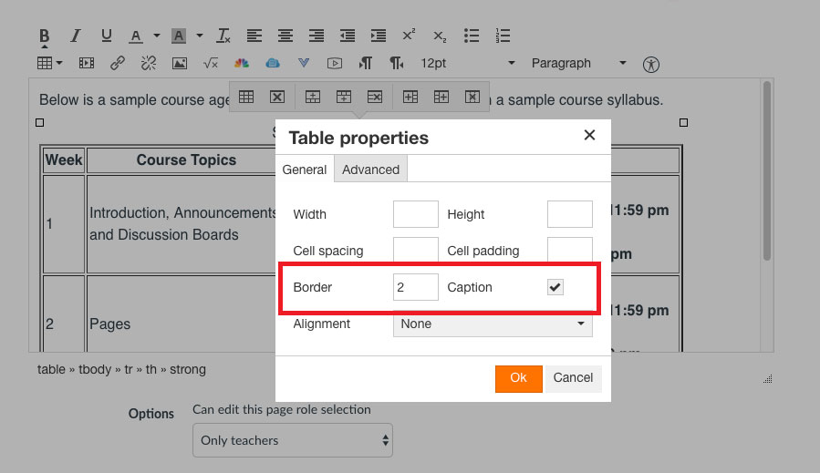
Image 4: Table Properties
To ensure your tables are accessible, click on the Accessibility Checker icon in the Rich Context Editor (Refer the image below on page 5 titled “Accessibility Checker”). This will display any errors you may have and provide information on how to fix these errors. Once you fix any errors, click on the orange “Apply” button.
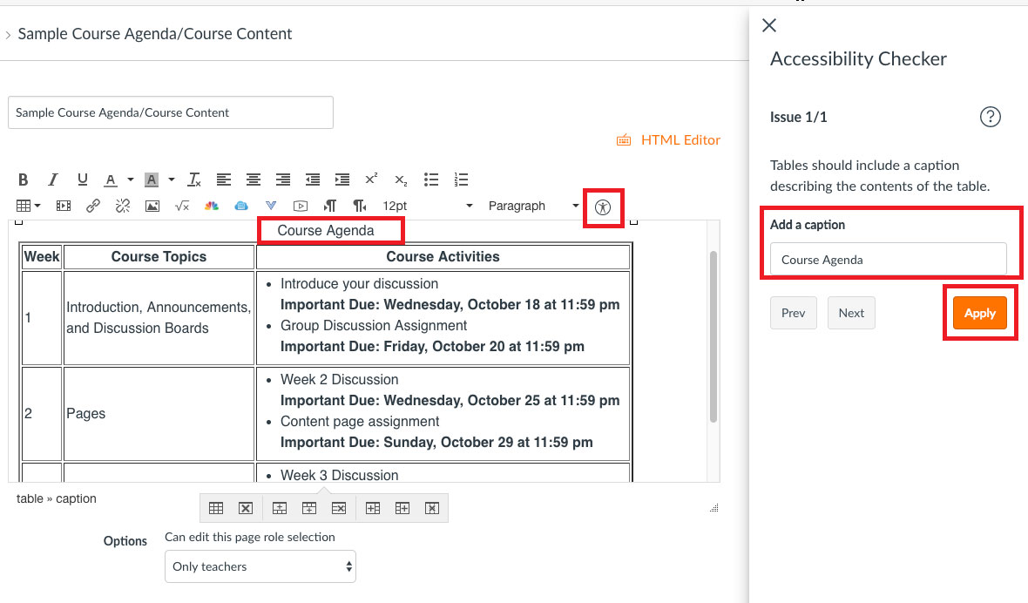
Image 5: Accessibility Checker

Hyperlinks and URLs
Use descriptive links when using hyperlinks and URLs within your courses. Descriptive links help the user determine the purpose of the link based on the text alone.

URLs are addresses of resources on the web. They can be annoying for users of screen readers since they tend to be long and contain different letters, numbers, and symbols. They are also difficult for speech recognition software users since they are hard to pronounce enough for the program to recognize them.

Examples of Descriptive Links:
- For more information on using links, visit the Links and Hypertext page on the WebAIM website.
- Be sure to refer back to the Syllabus throughout the course for important due dates.
- Be sure to complete the Canvas 101 Activity 1 before we continue through the workshop.
Use names consistently throughout your courses. For example, the link called "Modules" will always link to the same page no matter where you are within your course.
Use consistent link behaviors. A link behavior refers to how the link will be opened. This means, whether the content will open in the same window or a new window. Typically, a link should open in the same window for internal links and a new window for external links.

Images
Decorative images can be used to break up text. They convey no meaning and should be indicated as decorative so screen readers will ignore them.

Unless the image is decorative, it will need an alternative or alt text to ensure all users understand the meaning of the image. For more information on alt text, visit WebAIM’s page on Alternative Text.
- Avoid lengthy alt text by keeping it short using no more than 120 characters.
- Provide enough information to describe the image, but don’t simply repeat the information that is in the text.
- Image file names should not be used as the alt text.
- You do no need to include words such as "image of" or "picture of" in the alt text. Screen readers will announce this information.
You can enter the alt text for an embedded image using the “Embed Image” tool on the Rich Content Editor. Enter the alternative text for the image in the “Alt text” box provided (Refer to the image below on page 7 titled “Insert/Edit Image). If the image is decorative, check the “Decorative Image” check box.
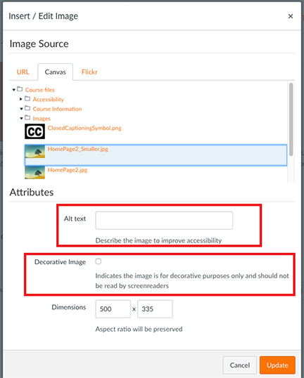
Image 6: Insert/Edit Image
Some images, such as for STEM content, require a longer description. Include the description as the caption under the image to further explain the content. The alternative text for this image should state something along the lines of “Refer to caption” to direct the person to the caption for a description of the image. (Refer to example on page 8).
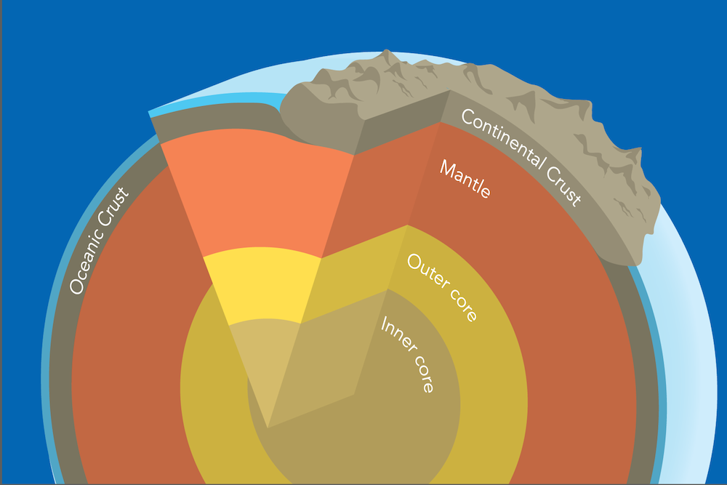
Image 7: This graphic is a representation of the earth’s layers that shows the inner core, the outer core, the mantle, and the oceanic and continental crusts. The image is not to scale. Image by Byron Inouye."

Resources

Organizations
- The National Center on Disability and Access to Education (http://ncdae.org/resources/)
- WebAIM (https://webaim.org/)
- WebAIM Color Contrast Checker (https://webaim.org/resources/contrastchecker/)
- 5 Tips for ADA-Compliant Inclusive Design from Inside Higher Ed (https://www.insidehighered.com/digital-learning/views/2017/05/03/tips-designing-ada-compliant-online-courses)

Canvas Resources
- How do I use the Accessibility Checker in the Rich Content Editor? (https://community.canvaslms.com/docs/DOC-13345-4152808104)
- How do I insert a table using the Rich Content Editor? (Includes table properties) (https://community.canvaslms.com/docs/DOC-12912-415241504)
- How do I insert course images into the Rich Content Editor using the Content Selector? (https://community.canvaslms.com/docs/DOC-13014-415265830)
- How do I embed images from Canvas into the Rich Content Editor? (https://community.canvaslms.com/docs/DOC-12904-4152115077)
- How do I create a bulleted or numbered list using the Rich Content Editor? (https://community.canvaslms.com/docs/DOC-12917-415241503)
- How do I create a hyperlink in the Rich Content Editor as an instructor? (https://community.canvaslms.com/docs/DOC-10305-4152719751)
If you require this document in an alternative format, such as large print or a different background color, please contact Rita Pool at ritap@bgsu.edu.

