How-To Set Up Faculty Office Hours/Student Drop-in Hours in Navigate
To proactively encourage students to meet with faculty during office hours, we invite all faculty to use the same system for scheduling as advisors and tutors use across campus – Navigate. Instructions are shown below on how to set your availability.

Locate and select the Navigate icon on your faculty home page in MyBGSU
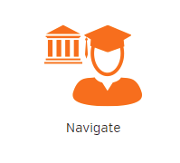

From your home page in Navigate, locate, and select the triangle next to “Professor Home” to reveal a “Staff Home” link that you can select.
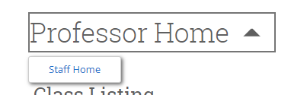

From the Staff Home Page, select the “My Availability” tab.
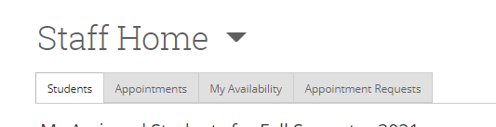

Selecting the small triangle next to “Actions” will reveal a menu where you should select “Add Time”
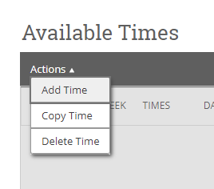
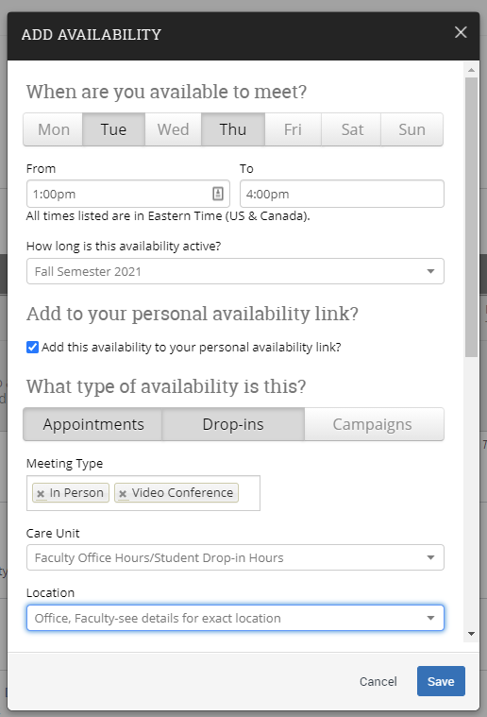
A new window will open. Select the day(s) of the week and time block you wish to be available. The days selected will turn a darker color. You can enter multiple availabilities if the times are different on different days of the week.
If you wish a personal availability link to be generated for you, click the box next to “Add this availability to your personal availability link?”(More on this later).
Click on the type of availability this is. I suggest “Appointments” and “Drop-ins.”
In the “Meeting Type” box, you can select In-person, Phone call, or Video Conference, or any combination of the three.
The Care Unit MUST be “Faculty Office Hours/Student Drop-in Hours.”
The Location MUST be “Office, Faculty-see details for exact location.”

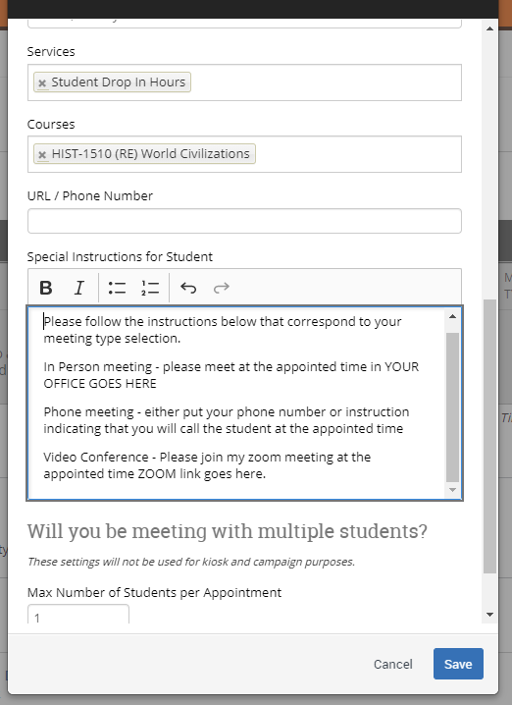
Continue scrolling in the pop-up window to reveal more requirements.
The Services MUST be “Student Drop-In Hours”
In the Courses box, start typing the courses you are teaching in the following format HIST-1510. You will see a listing of courses, select the correct course that corresponds with the modality that you are teaching. Include all courses that you wish students to use this availability to schedule with you. You can put multiple courses in the box.
In the Special Instructions for the Student, you should put instructions that align with the meeting types that you have available. Example shown below.
Make sure you hit the “Save” button at the bottom of the pop-up window.

Once you have added one availability, you can now use it as the template to add other days or times. You must first click the box next to the availability that you wish to copy, click on the arrow next to “Actions,” and select “Copy Time.” A new prepopulated window will open and you can modify your days and times to fit your schedule.
The “Office, Faculty-see details for exact location” location is set to default meeting times to 30 minutes. Only students associated with your course will be able to schedule with you.
If you have elected to have a “Personal Availability link,” your unique link can be found near the bottom of the screen on the “Availability” tab. You can share this link for students in your courses to use to schedule time with you.

If you have questions, feel free to reach out to Jaci Calderon (jbcalder@bgsu.edu, 419-372-6044) or Kim Brooks (kbrooks@bgsu.edu, 419-372-4869).

