DONATION DRIVE PREPARATION

DECIDE YOUR ORGANIZATION
You should determine what organization you would be interested in working with and how involved they would like to be in the process.

PICK UP OR DROP OFF
Once your organization has determined that they would like to be a part of your donation drive it is important to decide if you will be responsible for dropping off the items you collected or if they will pick them up for you.

MONETARY DONATIONS
Those who are coming to your donation drive may ask if they can donate money to your cause. However, some organizations are unable to accept monetary donations due to the nature of their center. This makes it important to ask if your organization is able to accept monetary donations.

DETERMINE YOUR START DATE
It is important to consider what time of year donation centers need the most donations. This can influence what time of year you start your donation drive. Communicate with your organization to determine what would be the best time for both of you.

BEGIN ADVERTISING
Once all of the details have been sorted out you should begin to advertise your donation drive to bring family and friends out for your cause. You can consider advertising food items that are most needed.
DONATION DRIVE: WHAT TO DONATE
Donation centers have made a shift towards healthier selections to help better equip the population they serve. It is important to consider the time of year, what may be needed, and if the donation center is in need than more than just food COMMONLY NEEDED ITEMS
Low sodium soups
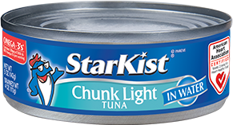
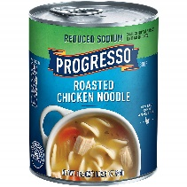
Canned proteins like tuna or chicken
Low sodium beans
Low sugar cereals
100% Fruit juices
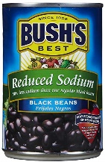
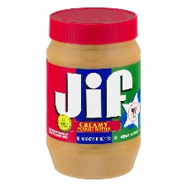
Whole Grain pasta
Unsalted nuts
No sugar added fruits
Brown Rice
Quinoa
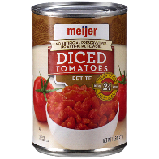
Oatmeal
Canola and Olive oil
Peanut butter
Shelf stable milks or milk substitute
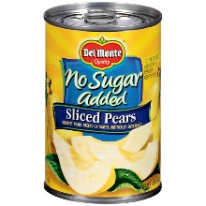
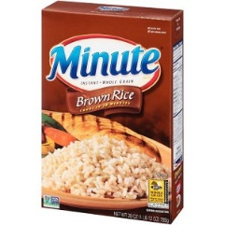
Dried fruit
Canned tomatoes
Honey
**Canned foods with pop top lids are preferred**

CANNOT ACCEPT
- Open or partially used products Alcohol Any past its expiration date
- Foods that have not been prepared by a licensed or commercially regulated kitchen
**Most importantly consider what you would want on your kitchen table to feed your own family**

