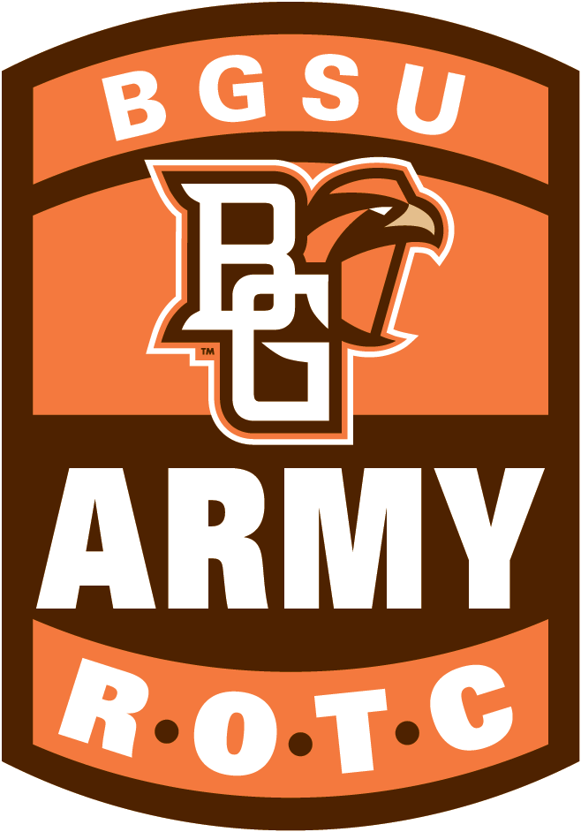

**Cadet Information**

**Personal Appearance and Uniforms**

*“When you put on a uniform, there are certain inhibitions that you can accept.”*

General Dwight D. Eisenhower

**5-1. Personal appearance**

Personal appearance is important—it demonstrates the pride and self-discipline you feel as a Cadet in the U.S. Army. Being neat and well groomed contributes to the esprit de corps in your unit. Your uniform should fit well and be clean, serviceable, and pressed as necessary. Your uniform is only part of your appearance. To look like a Cadet, you need to be physically fit, meet acceptable weight standards, and have a neat hairstyle in accordance with Army regulations.

**Note:** Reference AR 670-1 or DA PAM 670-1 for additional inquiries concerning Army uniforms and awards.

**Male Grooming Standards**

**For male personnel**,

(a) The hair on top of the head must be neatly groomed. The length and bulk of the hair may not be excessive and must present a neat and conservative appearance. The hair must present a tapered appearance. A tapered appearance is one where the outline of the Cadets’s hair conforms to the shape of the head), curving inward to the natural termination point at the base of the neck. When the hair is combed, it will not fall over the ears or eyebrows, or touch the collar, except for the closely cut hair at the back of the neck. The block-cut fullness in the back is permitted to a moderate degree, as long as the tapered look is maintained. Males are not authorized to wear braids, cornrows, twists, dreadlocks, or locks while in uniform or in civilian clothes on duty. Haircuts with a single, unta-pered patch of hair on the top of the head (not consistent with natural hair loss) are considered eccentric and are not authorized. Examples include, but are not limited to, when the head is shaved around a strip of hair down the center of the head (mohawk), around a u-shaped hair area (horseshoe), or around a patch of hair on the front top of the head (tear drop). Hair that is completely shaved or trimmed closely to the scalp is authorized.

(b) Sideburns are hair grown in front of the ear and below the point where the top portion of the ear at-taches to the head. Sideburns will not extend below the bottom of the opening of the ear. Side-burns will not be styled to taper, flair, or come to a point. The length of the individual hairs of the sideburn will not exceed 1/8 inch when fully extended.

(c) Facial hair. Males will keep their face clean-shaven when in uniform,

Mustaches are permitted. If worn, males will keep mustaches neatly trimmed, tapered, and tidy. Mustaches will not present a chopped off or bushy appearance, and no portion of the mustache will cover the upper lip line, extend sideways beyond a vertical line drawn upward from the corners of the mouth. Handlebar mustaches, goatees, and beards are not authorized. If appropriate medical authority allows beard growth, the maximum length authorized for medical treatment must be specific. For example, “The length of the beard cannot exceed ¼ inch”. Cadets will keep the growth trimmed to the level specified by the appropriate medical authority, but are not authorized to shape the hair growth (examples include, but are not limited to, goatees, “Fu Manchu,” or handlebar mustaches).

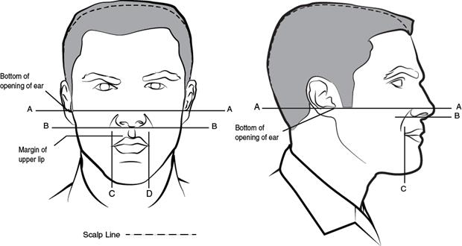



Prohibited Male Haircuts

**For female personnel** Female haircuts and hairstyles. The illustrations provided in figure 3–4 are intended only to clarify language regarding authorized hair lengths and bulks. The requirements for hair regulations are to maintain uniformity within a military population for female Soldiers while in uniform, or in civilian clothes on duty, unless otherwise specified. Female hairstyles may not be eccentric or faddish and will present a conservative, professional appearance. For the purpose of these regulations, female hairstyles are organized into three basic categories: short length, medium length, and long length hair (see fig 3–3).

***Short length.*** Short hair is defined as hair length that extends no more than 1 inch from the scalp (excluding bangs). Hair may be no shorter than 1/4 inch from the scalp (unless due to medical condition or injury), but may be evenly tapered to the scalp within 2 inches of the hair line edges. Bangs, if worn, may not fall below the eyebrows, may not interfere with the wear of all headgear, must lie neatly against the head, and not be visible underneath the front of the headgear. The width of the bangs may extend to the hairline at the temple.

***Medium length.*** Medium hair is defined as hair length that does not extend beyond the lower edge of the collar (in all uniforms), and extends more than 1 inch from the scalp. Medium hair may fall naturally in uniform, and is not required to be secured. When worn loose, graduated hair styles are acceptable, but the length, as measured from the end of the total hair length to the base of the collar, may not exceed 1 inch difference in length, from the front to the back. Layered hairstyles are also authorized, so long as each hair’s length, as measured from the scalp to the hair’s end, is generally the same length giving a tapered appearance. The regulations for the wear of bangs detailed in paragraph 3–2a(3)(a), apply. No portion of the bulk of the hair, as measured from the scalp, will exceed 2 inches.

**Long length.** Long hair is defined as hair length that extends beyond the lower edge of the collar. Long hair will be neatly and inconspicuously fastened or pinned above the lower edge of the collar (except when worn in accordance with para 3–2a(j)), except that bangs may be worn. The regulations for the wear of bangs detailed in paragraph 3–2a(3)(a) apply. No portion of the bulk of the hair, as measured from the scalp as styled, will exceed 2 inches (except a bun, which is worn on the back of the head and may extend a maximum of 3 1/2 inches from the scalp and be no wider than the width of the head).

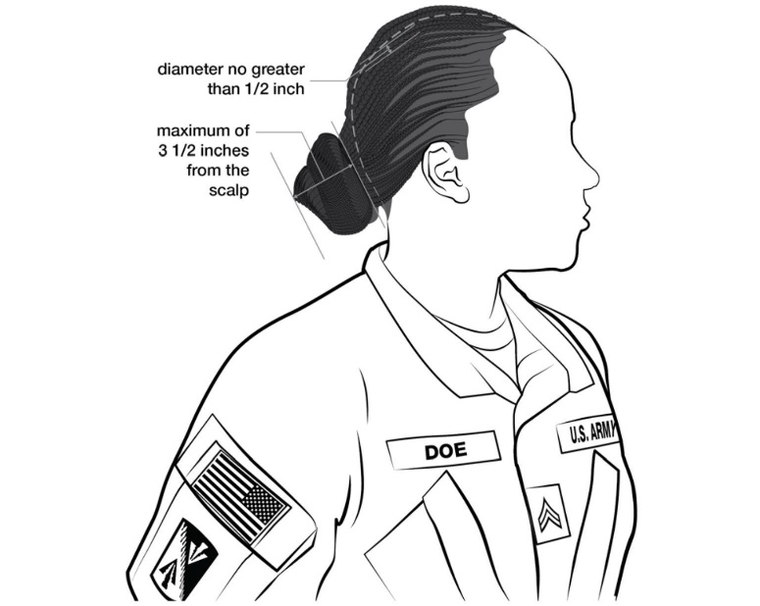

Additional hairstyle guidelines. Faddish and exaggerated styles, to include shaved portions of the scalp other than the neckline, designs cut in the hair, unsecured ponytails (except during physical training), and unbalanced or lopsided hairstyles are prohibited. Hair will be styled so as not to interfere with the proper wear of all uniform headgear. All headgear will fit snugly and comfortably around the largest part of the head without bulging or distortion from the intended shape of the headgear and without excessive gaps. When headgear is worn, hair should not protrude at distinct angles from under the edges. Hairstyles that do not allow the headgear to be worn in this manner are prohibited. Examples of hairstyles considered to be faddish or exaggerated and thus not authorized for wear while in uniform or in civilian clothes on duty include, but are not limited to hair sculpting (eccentric texture or directional flow of any hairstyle to include spiking); buns with loose hair extending at the end; hair styles with severe angles or designs; and loose unsecured hair (not to include bangs) when medium and long hair are worn up.

**Devices**. Hair holding devices are authorized only for the purpose of securing the hair. Soldiers will not place hair holding devices in the hair for decorative purposes. All hair holding devices must be plain and of a color as close to the Soldier’s hair as is possible or clear. Authorized devices include, but are not limited to, small plain scrunchies (elastic hair bands covered with material), barrettes, combs, pins, clips, rubber bands, and hair or head bands. Such devices should conform to the natural shape of the head. Devices that are conspicuous, excessive, or decorative are prohibited. Some examples of prohibited devices include, but are not limited to: large, lacy scrunchies; beads, bows, or claw or alligator clips; clips, pins, or barrettes with butterflies, flowers, sparkles, gems, or scalloped edges; and bows made from hairpieces. Foreign material (for example, beads and decorative items) will not be used in the hair. Soldiers may not wear hairnets unless they are required for health or safety reasons, or in the performance of duties (such as those in a dining facility). No other type of hair covering is authorized in lieu of the hairnet. The commander will provide the hairnet at no cost to the Soldier.

**Braids, cornrows, twists, and locks.** Medium and long hair may be styled with braids, cornrows, twists, or locks (see glossary for definitions). Each braid, cornrow, twist, or lock will be of uniform dimension, have a diameter no greater than a 1/2 inch, and present a neat, professional, and well-groomed appearance. Each must have the same approximate size of spacing between the braids, cornrows, twists, or locks. Each hairstyle may be worn against the scalp or loose (free-hanging). When worn loose, such hairstyles must be worn per medium hair length guidelines or secured to the head in the same manner as described for medium or long length hair styles. Ends must be secured inconspicuously. When multiple loose braids, twists, or locks are worn, they must encompass the whole head. When braids, cornrows, twists, or locks are not worn loosely and instead worn close to the scalp, they must stop at one consistent location of the head and must follow the natural direction of the hair when worn back, which is either in general straight lines following the shape of the head or flowing with the natural direction of the hair when worn back with one primary part in the hair (see para 3–2a(1)(c)). Hairstyles may not be styled with designs, sharply curved lines, or zigzag lines. Only one distinctive style (braided, rolled, twisted, or locked) may be worn at one time. Braids, cornrows, twists, or locks that distinctly protrude (up or out) from the head are not authorized. The bulk of the hair may not be such that it impairs the ability to wear the advanced combat helmet (ACH) or other protective equipment or impedes the ability to operate one’s assigned weapon, military equipment, or machinery. A fully serviceable ACH including all of its component parts must be worn in accordance with its technical manual to ensure a proper fit for safety.

**Physical training.** Long length hair, as defined in paragraph 3–2a(3)(c), may be worn in a ponytail during physical training. A single pony tail centered on the back of the head is authorized in physical fitness uniforms only when within the scope of physical training, except when considered a safety hazard. The pony tail is not required to be worn above the collar. When hair securing devices are worn, they will comply with the guidelines set in paragraph 3–2a(3)(e). Hairstyles otherwise authorized in this chapter (such as braids, twists, and locks) may also be worn in a ponytail during physical training.

**Physical training in utility uniforms.** Pony tails are authorized using guidelines set forth in paragraph 3–2a(3)(j), while conducting physical training in utility uniforms. However, if the helmet is worn during physical training, hair must be secured.

**Jewelry**

A wrist watch, identification bracelet, and up to two rings (a wedding set is considered to be one ring) may be worn with your uniform as long as they are conservative and tasteful. Cadets may also wear one activity tracker, pedometer, or heart rate monitor. You may wear a religious medal on a chain around your neck provided neither medal nor chain can be seen. Earrings may be screw-on, clip-on, or post-type earrings, in gold, silver, white pearl, or diamond. The earrings will not exceed 6 mm or 1∕4 inch in diameter, and they must be unadorned and spherical. When worn, the earrings will fit snugly against the ear. Females may wear earrings only as a matched pair, with only one earring per ear lobe.

**Note:** Females are not authorized to wear earrings with any class C (utility) uniform (ACU, hospital duty, food service, physical fitness, field, or organizational). The use of gold caps, platinum caps, or caps of any unnatural color or texture (permanent or removable) for purposes of dental ornamentation is prohibited. Teeth, whether natural, capped, or veneered, will not be decorated with designs, jewels, initials, or similar ornamentation. Unnatural shaping of teeth for nonmedical reasons is prohibited.

**Body Piercing**

Except for earrings worn by female Cadets when wearing the ASU, no displaying objects, articles, jewelry, or ornamentation attached or affixed to or through the skin may be worn while in uniform. Neither can such adornments be worn while wearing civilian clothes (on or off duty) when on any military installation, or other places under military control. When females are not in uniform and off duty, earring wear is not restricted as long as the earrings do not create or support ear gauging (enlarged holes in the lobe of the ear, greater than 1.6mm).

**Cosmetics**

Standards regarding cosmetics are necessary to maintain uniformity and to avoid an extreme or unprofessional appearance. Males are prohibited from wearing cosmetics, except when medically prescribed. Females are authorized to wear cosmetics with all uniforms, provided they are applied modestly and conservatively, and that they complement both the Cadet’s complexion and the uniform. Leaders at all levels must exercise good judgment when interpreting and enforcing this policy.

Eccentric, exaggerated, or faddish cosmetic styles and colors, to include makeup designed to cover tattoos, are inappropriate with the uniform and are prohibited. Permanent makeup, such as eyebrow or eyeliner, is authorized as long as the makeup conforms to the standards outlined above. Eyelash extensions are not authorized unless medically prescribed.

Females will not wear shades of lipstick that distinctly contrast with the natural color of their lips, that detract from the uniform, or that are faddish, eccentric, or exaggerated.

Females will comply with the cosmetics policy while in any military uniform or while in civilian clothes on duty.

**Fingernails**

All personnel will keep fingernails clean and neatly trimmed.

Males will keep nails trimmed so as not to extend beyond the fingertip.

Females will not exceed a nail length of 1∕4 inch, as measured from the tip of the finger. Females will also trim nails shorter if the commander determines that the longer length detracts from the military image, presents a safety concern, or interferes with the performance of duties. Females may wear clear acrylic nails, provided they have a natural appearance and conform to Army standards.

**Tattoos**

Tattoos and brands are permanent markings that are difficult to reverse (in terms of financial cost, discomfort, and effectiveness of removal techniques). Before obtaining either a tattoo or a brand, Soldiers should consider talking to unit leaders to ensure that they understand the Army tattoo and brand policy. The words tattoo and brand are interchangeable in regards to this polic The following types of tattoos or brands are prejudicial to good order and discipline and are, therefore, prohibited anywhere on a Soldier’s body:

(1) Extremist. Extremist tattoos or brands are those affiliated with, depicting, or symbolizing extremist philosophies, organizations, or activities. Extremist philosophies, organizations, and activities are those which advocate racial, gender, or ethnic hatred or intolerance; advocate, create, or engage in illegal discrimination based on race, color, gender, ethnicity, religion, or national origin; or advocate violence or other unlawful means of depriving individual rights under the U.S. Constitution, and Federal or State law (see AR 600–20).

(2) Indecent. Indecent tattoos or brands are those that are grossly offensive to modesty, decency, propriety, or professionalism.

(3) Sexist. Sexist tattoos or brands are those that advocate a philosophy that degrades or demeans a person based on gender.

(4) Racist. Racist tattoos or brands are those that advocate a philosophy that degrades or demeans a person based on race, ethnicity, or national origin.

Tattoos or brands, regardless of subject matter, are prohibited on the head, face (except for permanent makeup, neck (anything above the t-shirt neckline to include on or inside the eyelids, mouth, and ears), below the wrist bone, and hands, except Soldiers may have one ring tattoo on each hand, below the joint of the bottom segment (portion closest to the palm) of the finger. The wrist bone is defined as the joint that bridges the hand to the forearm. Previously documented tattoos on the neck or hands, for which Soldiers have a tattoo validation memorandum, continue to be grandfathered. Accessing applicants must adhere to this same policy.

**Eyeglasses, Sunglasses, and Contact Lenses**

* 1. Eyeglasses, sunglasses and contact lenses.

(1) Conservative civilian prescription eyeglasses are authorized for wear with all

uniforms.

1. Conservative prescription and nonprescription sunglasses are authorized for wear when in a garrison environment, except while indoors. Individuals who are required by medical authority to wear sunglasses for medical reasons other than refractive error may wear them, except when health or safety considerations apply. Cadets may wear sunglasses in the field environment, when required by the PMS for safety reasons or during high glare field environments. Safety glasses will be worn in all training environments as dictated by the PMS.
2. Eyeglasses or sunglasses that are trendy, or have lenses or frames with initials, designs, or other adornments are not authorized for wear. Cadets may not wear lenses with extreme or trendy colors, which include, but are not limited to, red, yellow, blue, purple, bright green, and orange. Lens colors must be traditional gray, brown or dark green shades. Personnel will not wear lenses or frames that are so large or small that they detract from the appearance of the uniform. Personnel will not attach chains, bands, or ribbons to eyeglasses. Eyeglass restraints (to include bands) are authorized only when required for safety purposes. Personnel will not hang eyeglasses or eyeglass cases on the uniform, and may not let glasses hang from eyeglass restraints down the front of the uniform. Glasses may not be worn on top of the head at any time.
3. Tinted or colored contact lenses are not authorized for wear with the uniform. The only exception is opaque lenses that are prescribed medically for eye injuries. Clear lenses that have designs on them that change the contour of the iris are not authorized for wear with the uniform. Contact lenses my restricted by the PMS for safety considerations.

**Back Packs**

Bags, handbags, purses, and backpacks are authorized, but must adhere to the following criteria:

(1) Hand carried bags will be conservative and professional in appearance. Bags (to include civilian gym bags, civilian backpacks, or other similar civilian bags) must be carried only in the hand if they do not meet the criteria outlined in paragraph 3–7f(2). DA Pam 670–1 provides additional descriptions and wear occasions for handbags.

(2) If Soldiers choose to wear a shoulder bag while in uniform, the bag must be black or match the colors of the camouflage pattern uniform being worn, and may not have any commercial logos. The contents of the bag may not be visible; therefore, see-through plastic or mesh bags are not authorized. Soldiers may carry authorized bags by hand, on one shoulder using a shoulder strap, or over both shoulders using both shoulder straps. Soldiers may not wear a shoulder bag in such a manner that the strap is draped diagonally across the body, with the bag resting on the hip opposite the shoulder holding the strap.