Mathematics task: The students in Ms. Baca’s art class were mixing yellow and blue paint. She told them that two mixtures will be the same shade of green if the blue and yellow paint are in the same ratio. The table below shows the different mixtures of paint that the students made.

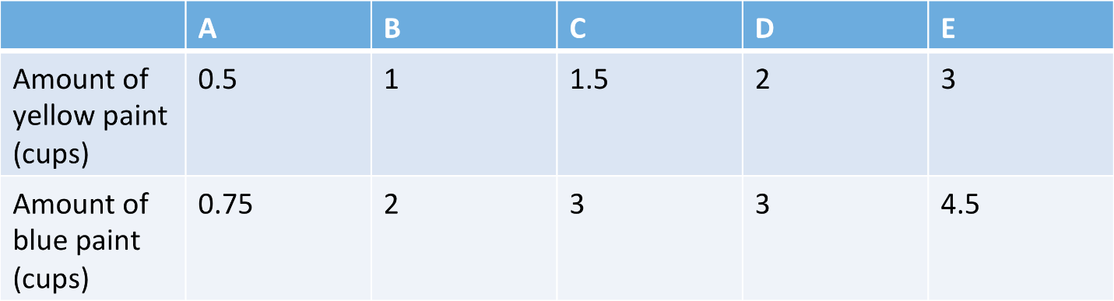
a. How many different shades of paint did the students make?

b. Which mixture(s) make the same shade as mixture A?

c. How many cups of yellow paint would a student add to one cup of blue paint to make a mixture that is the same shade as mixture A?

d. Let b represent the number of cups of blue paint and y represent the number of cups of yellow paint in a paint mixture. Write an equation that shows the relationship between the number of cups of yellow paint, y, and the number of cups of blue paint, b, in mixture E.

