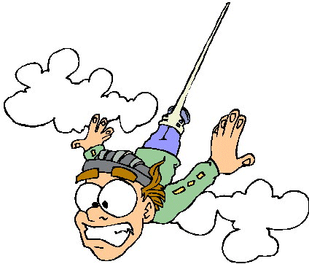
How Tall is the _______________?
Bun G. Jump wants to start his own bungee jumping business. He isn’t sure where he wants the business to be located exactly, but he is sure he wants it in Lima, OH. A group of exceptionally motivated teachers at a camp decide to help Bun find an appropriate place for his business. Bun eagerly accepts the help. The teachers are to use a clinometer to find the height of the different jump venues. In order to practice using a clinometer, teachers are going to attempt to find the height of the _____________.

Below are the tools needed to make a clinometer.
Protractor, tape, string, washer/weight, scissors, drinking straws, tape measure

++++++++++++++++++++++++++++++++++++++++++++++++++++++++++++++++++

Let’s practice:
- Your measurement: ______________________ inches
- Place an X on the line below to show how confidant you are that you measured correctly.
VERY CONFIDENT…………Confident………………not confident at all

- Would you feel comfortable giving this measurement to Bun for him to use in planning a bungee jumping site?

- Why or why not?

==================================================================

LIST the measurements from your table/group?

If you were to give one measurement to Bun to describe the height, what would it be?
- Why?

==================================================================

What are the entire groups’ measurements?

NAME | Height of Building |  | NAME | Height of Building

Find the mean, median, and mode of these measurements.

What measurement (it doesn’t have to be mean, median, more) would you give to Bun? Why?

- Is it different than the recommendation you made with the data from just your group?

==================================================================

Give a range of acceptable measurements. In other words, what is the range of numbers that are believable to you?

- Are any of the measurements outside of this range?
- Is this number considered an outlier?

