Bowling Green State University

University-wide Course Evaluation of Teaching and Learning

Instructor’s Guide
Prepared by the Office of Academic Assessment

June 2023

University-wide Course Evaluation of Teaching and Learning
Guidelines for Administrators Table of Contents

University-wide Evaluation of Teaching and Learning 3
Common Questions 3
Common Question Scoring 4
Course Evaluation Project Administration 4
Instructor Course Review 4
Evaluation Administration Dates 4
Course Evaluation Delivery 5
Certificate of Completion 5
Availability of Evaluation Results 5
Accessing the University-wide Course Evaluation System 5
Accessing Course Evaluation Results via BGSU’s Single Sign on System 5
Accessing Course Evaluations Results through Canvas 5
Canvas Account Settings Method 5
Course Evaluations Homepage 7
Response Rate Tracker 7
Course Evaluation Reports & Data 8
Report Formats 8
Detailed Report Format(s) 9
Interpreting Summary Statistics on the Detailed Report 10
Short Report Format(s) 11
Raw Data Report 11
Common Question vs. Targeted Question Reporting 12
Means of Means Calculation 12
Accessing Course Evaluation Results 12
Downloading Reports 13
Batch Reports 13
Batch Reporting (Combining Results from Multiple Courses into a Single Report) 13
Additional Information 14

University-wide Evaluation of Teaching and Learning

Bowling Green State University’s University-wide Evaluation of Teaching and Learning is administered each semester, allowing students to provide meaningful feedback about their courses. BGSU Faculty Senate and Academic Affairs collaborated to develop a set of common University questions on course expectations, feedback and assessment, support for student success, and engagement. The common course evaluation questions were developed by an ad hoc committee, inclusive of faculty, administrators, union, undergraduate and graduate student representation. The questions were piloted in AY2017-2018 and fully implemented in Fall 2018. With its focus on assessment for continuous improvement, the University-wide Evaluation of Teaching and Learning aligns with BGSU’s Strategic Plan Forward, Strategic Objective 1, Initiative 2: Intensive focus on outcomes and Strategic Objective 3, Initiative 10: Teaching and service excellence.

The University-wide Evaluation of Teaching and Learning is composed of six common course evaluation questions which are asked across all courses, followed by optional questions that specific colleges or departments/units have developed in collaboration with the Office of Academic Assessment. The six questions that are included in all course evaluations are referred to as the common questions. Questions developed by individual Colleges or academic units are referred to as targeted questions.

When completing course evaluations, the six common questions are presented to students first, followed by any additional targeted questions used by their college or academic unit (department/unit). When targeted questions have not been assigned, only the common questions are presented. In classes that are taught by two or more instructors, students are presented with drop-down lists which display their instructors’ names. Students can use these drop-down lists to evaluate each instructor separately.

Common Questions
The six common questions provide a focus on continuous improvement, and all begin with the statement, “The instructor….” The questions fall under 5 categories, as summarized below:

Category 1: Expectations
- The instructor clearly explains course objectives and requirements.
- The instructor sets high standards for learning.

Category 2: Feedback and Assessment
- The instructor offers helpful and timely feedback throughout the semester.

Category 3: Support for Student Success
- The instructor provides opportunities and/or information to help students succeed (for example, tutoring resources, office hours, mentoring, research projects, etc.).

Category 4: Engagement
- The instructor encourages student participation (for example, by inviting questions, having discussions, asking students to express their opinions, or other activities).

Category 5: Diversity, Inclusion, and Equity
- The instructor creates an environment of respect.

Common Question Scoring
Students are provided the response options presented below.

Response
Strongly Disagree
Disagree
Neither Agree nor Disagree
Agree
Strongly Agree

Course Evaluation Project Administration
A new course evaluation project is created each semester after the 15th day of the semester. Student course enrollments are refreshed daily from Canvas until the completion of the evaluation period for each course. Students are removed from course evaluation lists only after they have formally dropped or withdrawn from the course and the de-enrollment action has been recorded in the Campus Solutions System (CSS) by the Office of Registration and Records and refreshed in Canvas. Students who, for one reason or another, have discontinued attendance of a course, but who have not officially withdrawn or dropped the course, will still receive an evaluation.

Instructor Course Review
About a week prior to the start of any course evaluation period, instructors receive an automated email to their BGSU email account notifying of all courses for which they will be evaluated as instructor of record. Instructors should review this message closely to look for errors. When errors are found instructors should notify their college office or the Office of Academic Assessment immediately so that they can be corrected.

Note: Changes to courses, instructors, and targeted question assignments must be made prior to the start of the evaluation period. Once students begin submitting evaluations for a course, its settings, including the instructor of record and assignment of targeted questions, cannot be modified.

Evaluation Administration Dates
Students are permitted to complete course evaluations only during prescribed time periods that are dependent both upon the semester and the course session. Timelines for the administration of course evaluations occur as follows:

- Fall and Spring Semesters
  - 15-week sessions: 2 weeks prior to the final exam week.
Note: Only the 15-week session has a designated finals week.
  - 11-week sessions: last 2 weeks of the session.
  - 7-week sessions: last week of each session.

- Summer Semesters
  - 6, 8, or 12-week sessions: last week of each session.
  - Sessions shorter than 6 weeks long (3 or 4 weeks) have a condensed evaluation period.

Course Evaluation Delivery
The University-wide Evaluation of Teaching and Learning is administered online. Students may access their evaluations either by following links in their announcement emails or by logging in through their Canvas accounts. Students may also access their evaluations by opening http://bgsu.evaluationkit.com and logging in with their BGSU single sign on account. Students receive reminders when course evaluations are available every time they log into Canvas.

During course administration periods, instructors can review their students’ response rates by logging in to the Course Evaluations and Surveys software through their Canvas accounts or by opening http://bgsu.evaluationkit.com in their web browser.

Certificate of Completion
Students receive a certificate of completion in their BGSU email following the completion of each course evaluation.

Note: When desired, students may forward their Certificate of Completion email to their instructors as evidence that they have completed an evaluation of their course. The Certificate of Completion does not include information that would identify responses as belonging to an individual respondent.

Availability of Evaluation Results
At the end of each semester, results are available for faculty administrators, office staff with account access, and instructors to review the day after the Registrar posts final grades in CSS. Results for courses taught during the first term sessions (e.g., 6, 7, or 8-week) are not available until the end of the semester since grades for those courses can be modified until the end of the academic term.

Accessing the University-wide Course Evaluation System

Instructors can access and view course evaluation results for any course in which they are listed as an instructor of record.

The system can be accessed directly using BGSU’s single sign on or through Canvas.

Accessing Course Evaluation Results via BGSU’s Single Sign on System
Use the BGSU single sign on link: https://bgsu.evaluationkit.com/ to access Course Evaluations online.

Accessing Course Evaluations Results through Canvas
To access course evaluations using your Canvas account:

Canvas Account Settings Method
To access course evaluation results using your Canvas settings:

- Click on Account, then
- Settings, then
- Course Evaluations.
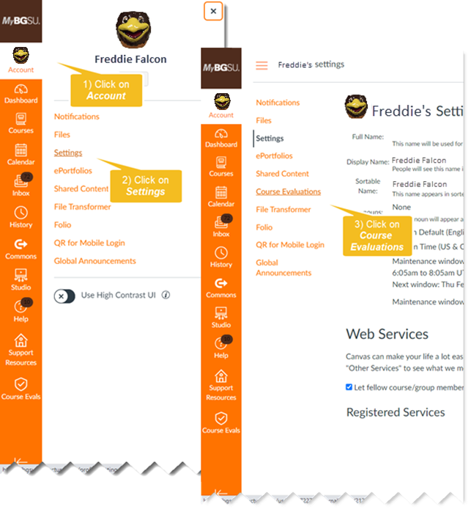

Note: Upon logging in to the system, the default role is Student. Instructors must use the dropdown in the upper-right corner of the page and change the role to Instructor to access their course evaluation data.

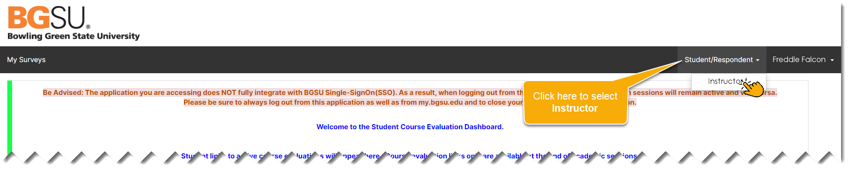

Course Evaluations Homepage

After logging into the system, users are presented with the Course Evaluations Homepage, which displays two features:

- Response Rate Tracker: displays response rate statistics for an active course evaluation project. The statistics shown in this widget display aggregated response rates for all courses in which faculty is assigned as the instructor of record. Following a link to any open project allows the instructor to drill down and view response rates at the individual course level.

- Project Results: displays all courses in which an instructor has been evaluated. Clicking on any Project name (e.g. Spring 2023) allows instructors to access results obtained for all courses in which the faculty was evaluated instructor of record from the selected project.

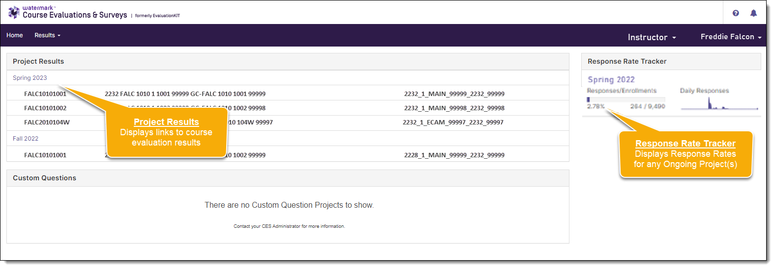

Response Rate Tracker
The Response Rate Tracker allows faculty to view response rates for any courses in which they are assigned as instructor of record while an evaluation project is in progress.

To access response rate statistics for an open course evaluation project:

- Click on any project shown under the Response Rate Tracker widget on the Home Page or select Results from the Home Page menu bar.
- Then select Response Rate Tracker from the dropdown menu.
- Select an active Project from the Response Rates page.
- Review the results for the selected hierarchy on the Course Response Rates page.

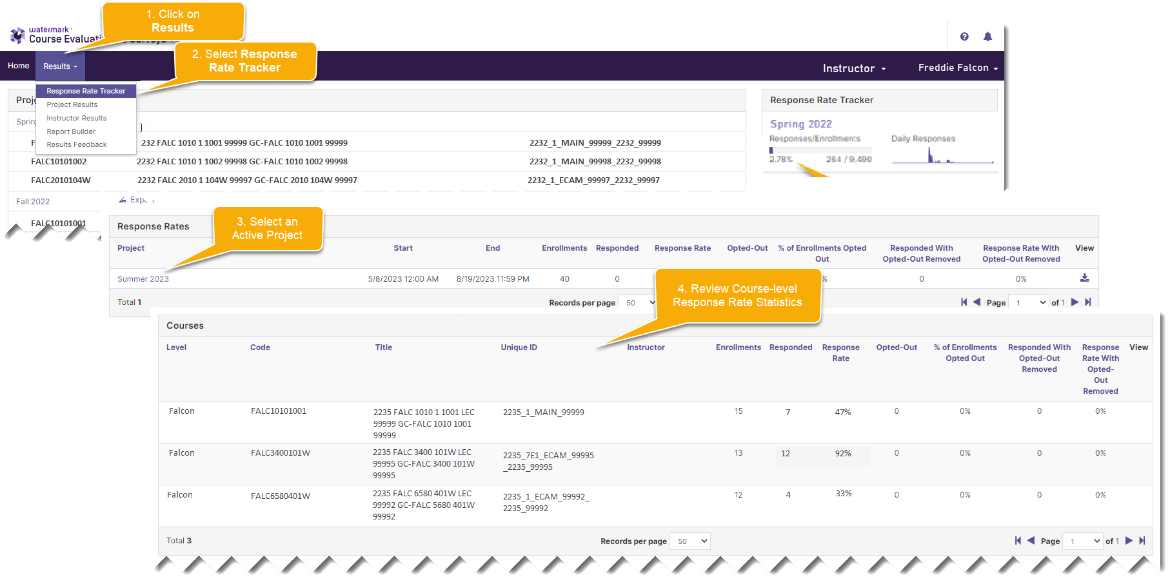

Note: We recommend that instructors log in and check the Response Rate Tracker regularly while a project is in progress to monitor response rates. Instructors can encourage greater participation from their students if they notice that response rates are low.

Course Evaluation Reports & Data

Report Formats
Five types of report format are available from the course evaluation system:

- Detailed Report - a PDF report which provides summary statistics obtained for each question in the course evaluation, including frequencies, standard deviation, median, and mean scores shown at the course, college, and university levels.

- Detailed Report + Comments – a PDF report which includes student comments in addition to the summative statistics described above.

- Short Report – a PDF report that displays summary statistics, including mean scores for each question in a condensed format at the course, college, and university levels.

- Short Report + Comments - a PDF report that includes student comments in addition to the summative statistics provided in the condensed report described above.

- Raw Data - an Excel data file which includes anonymized results at the individual response level. The raw data file can be used in Microsoft Excel or Power BI to generate reports that go beyond the four packaged reports which are outlined above.

In all reports, results for the six common questions are shown first, followed by any targeted questions the college or department might be using.

Notes:
- The Detailed Report + Comments report is recommended as the default report because it includes student comments in addition to question-level response frequencies and mean scores.

- For colleges and departments that use targeted questions that only collect qualitative data (i.e., student comments), the Detailed Report + Comments or Short Report + Comments report must be used to view results. Otherwise, no results will be shown for those questions.

Detailed Report Format(s)
There are two types of Detailed Report formats, both of which may be downloaded from the evaluation system in PDF format:

- Detailed Report: produces a PDF report with quantitative statistics for each evaluation question.

- Detailed Report + Comments: produces a PDF report which includes student comments in addition to all elements of the Detailed Report.

Each format produces a PDF report which includes a header, results, and mean of means section:

- The header section displays the name of the course, identifies the instructor of record, and shows the overall response rate (number of students who participated in the course evaluation divided by the total number of students enrolled in the course).

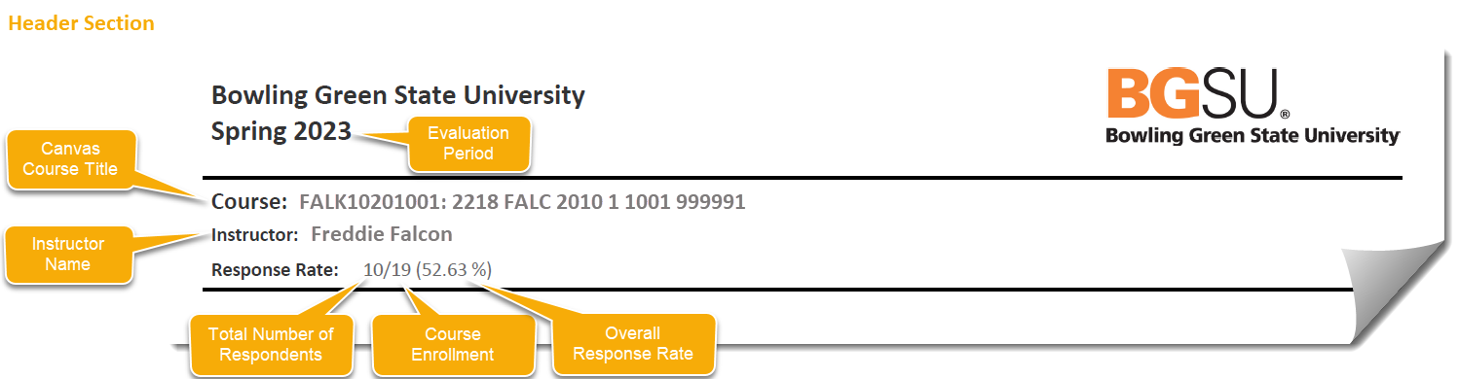

Note: When courses are co-taught, all instructor names appear in the Instructor line and the instructor for whom the report is being generated is indicated by an asterisk.

- The results section summarizes response statistics for each course evaluation question; including the question text, response options, response option frequencies (number of students selecting each response item), question response rate (number of students who completed the question divided by the total number of students in the course), mean score (average), standard deviation (measure of variability), and median (middle). Summary results for each item are displayed side-by-side at the course, university, and college levels. Student comments are included only when the Detailed Report + Comments report has been selected.

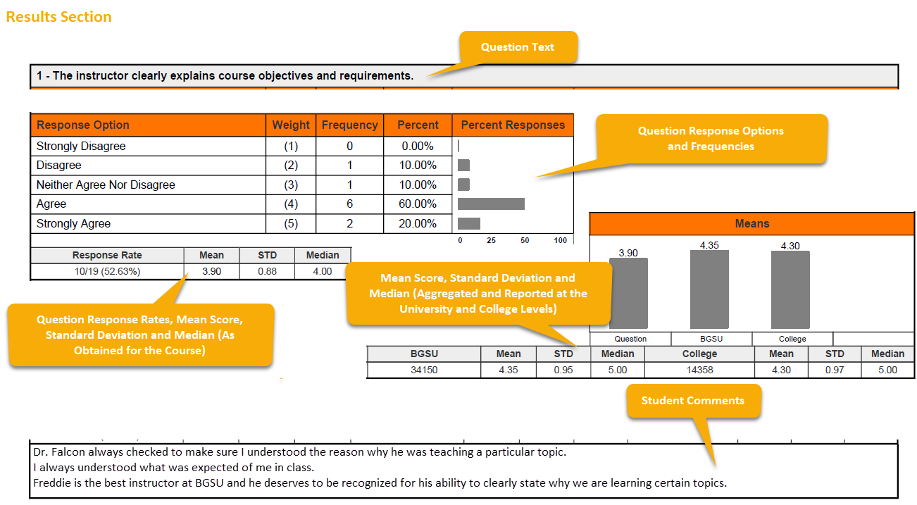

- The mean of means section, which is shown at the bottom of the Detailed Report provides a combined mean score for all six common questions.

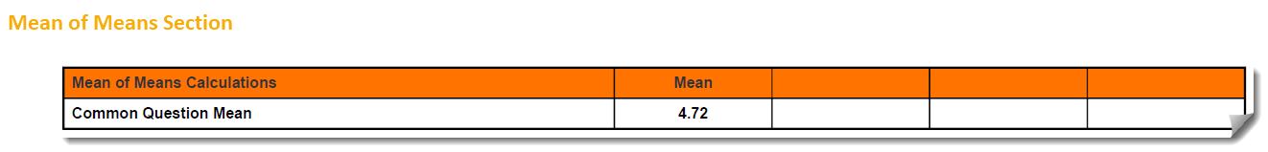

Interpreting Summary Statistics on the Detailed Report
The Detailed Report compares averages obtained by the course evaluation for each question, including any targeted questions, at the course (instructor) level, the university level, and the college level:

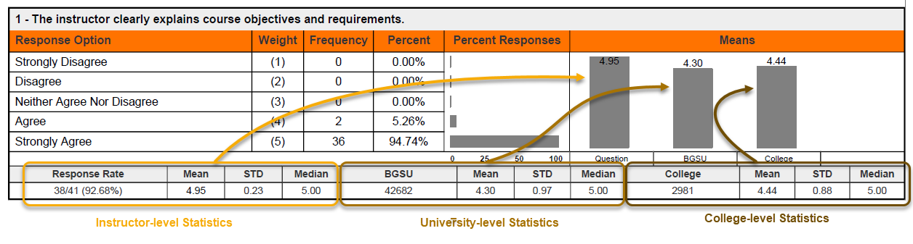

Short Report Format(s)
As with the Detailed Report, there are two types of Short Report formats:

- Short Report: produces a PDF report with condensed quantitative statistics.

- Short Report + Comments: produces a PDF report which includes student comments in addition to all elements of the Short Report.

The header section of the Short Report identifies the name of the course, instructor of record, and response rate. The results section of the report presents results for each question in a linear fashion with response frequencies first, followed by mean scores obtained at the university and college levels, and then the mean, standard deviation, and median score obtained at the course level.

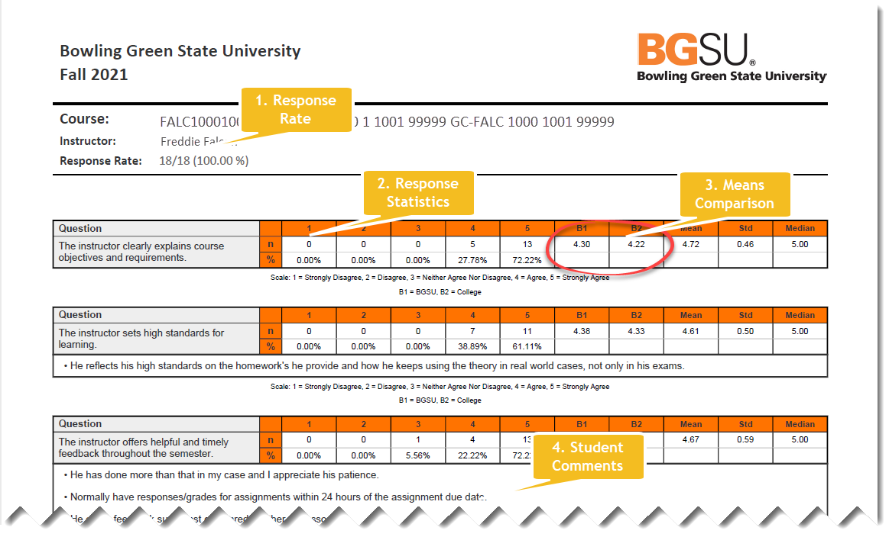

Raw Data Report
Raw data output is available for each course or selection of courses using the Raw Data Report. When this report format is selected, the course evaluation system produces an Excel file with anonymized evaluation data. Each row in the raw data file represents responses submitted by an individual student for a single course. Data elements provided in the Excel file include:

- Course information: hierarchy, course code, course title, unique course id, number of instructors, and total enrollment.

- Instructor information: instructor username, Canvas ID number, and name.

- Response data: number of respondents and response rate. In co-taught courses the response rate data is displayed as obtained for the course, as opposed to each of the individual instructors.

- Evaluation data: question-level responses including quantitative ratings and student comments.

Common Question vs. Targeted Question Reporting
In all report formats, the six university-wide common questions are presented first. Any targeted questions utilized by a college or department follow beneath the common questions.

Note about interpreting common question vs. targeted question comparisons: since the common questions are included in all course evaluations, the comparisons shown on the Detailed and Short Reports for the instructor, university, and college all differ according to the responses submitted by students. However, since targeted questions apply only to colleges or departments/units, results are repeated at the university and college levels in these reports since targeted questions are not evaluated at the university level.

Means of Means Calculation
A means of means calculation is provided at the end of the Detailed and Short Report formats which shows the combined mean obtained on the evaluation for all six common questions.

Note: While it appears at the end of the Detailed and Short Report formats, the Mean of Means calculation only averages the 6 university-wide common questions. It does not include results from any targeted questions that may be used by the college or department.

Accessing Course Evaluation Results
To view course evaluation results, after logging into the course evaluation system:

- Click on a Project Name from the Project Results display.
- Click on the Report Icon next to a course and select a report format.
- The system will download the results using the selected report type.

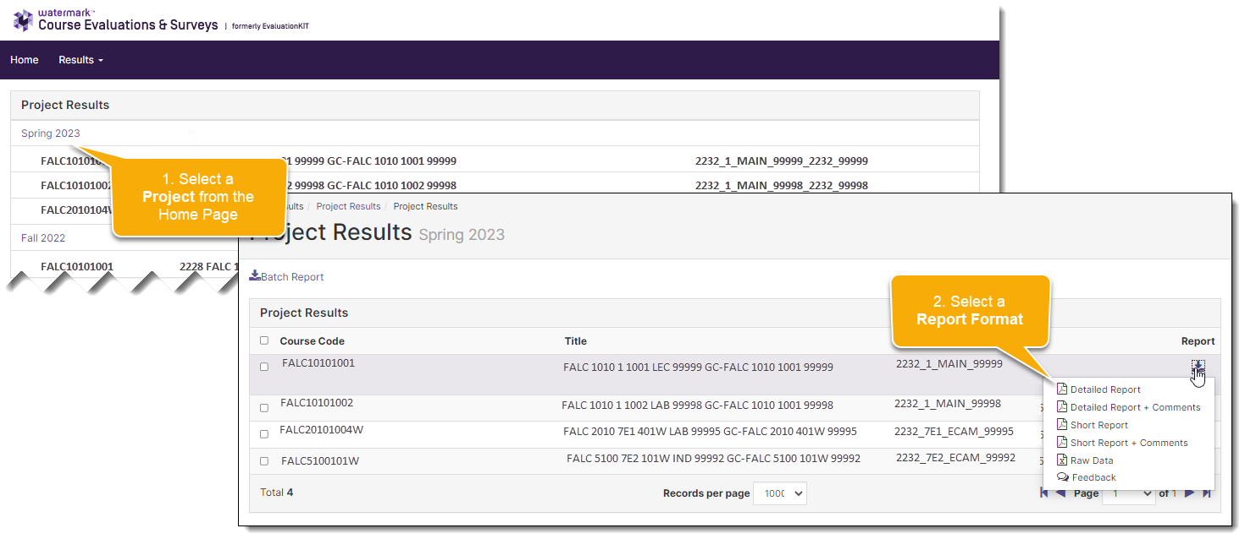

Downloading Reports
Reports are downloaded by selecting a Report Format from the Project Results page.

Note: Depending upon the size of the data file requested, the course evaluation system may display a message indicating that an email with a link to the report will be sent to your BGSU email account. When this occurs, follow the link in the email when it arrives to download the report.

Batch Reports
The Batch Reporting feature can be used to download multiple reports simultaneously or to combine data from more than one course into a single report.

Batch reporting is useful in the following scenarios:

- An instructor wants to efficiently generate results for multiple course sections all at the same time.
- An instructor wants to combine the results for all sections of a course that they taught into a single report.
- An instructor wants to combine results for all courses that they taught into a single report.

Batch Reporting (Combining Results from Multiple Courses into a Single Report)
To combine results from multiple courses into a single report, first select the courses from which data is required, and then select a batch report type. Additional information about batch files is included later in this document:

To use the batch report feature:
- Select courses to be included in the report by checking the box next to their name.
- Click the Batch Report link.
- Give the report a Report Name.
- Select a Report Type.
- Select a Delivery Type.

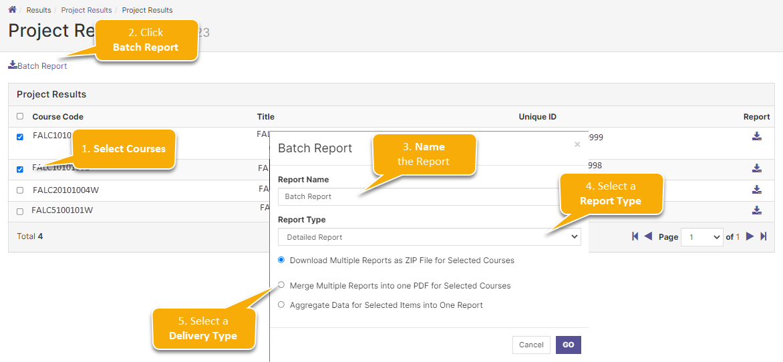

The report types available for batch reports include Detailed Report, Detailed Report + Comments, Short Report, Short Report + Comments, and Raw Data.
Three delivery types are available:

- Zip File: Separate PDF reports will be produced for each of the selected courses and saved into a .zip file.

- Merged Report: Separate reports will be created for each of the selected courses and combined one after the other to form a continuous, multi-page PDF file.

- Aggregate Report: A single summary report will be created by combining data from each of the selected courses to form a composite. This option will combine the data obtained from each of the course evaluation questions to create aggregated frequencies, percentages, means, standard deviations, and medians. This report also will provide the means, standard deviations, and medians for BGSU overall and the College for each of the six University-wide questions.

Notes:
- When batch files are requested, the course evaluation system generates an email which leads recipients to the output using an internet link.

Additional Information
Additional information may be obtained by contacting Bowling Green State University’s Office of Academic Assessment at 419-372-5530 or assessment@bgsu.edu.

