SEC/PROVOST JOINT CONFERENCE
MINUTES
September 22, 2015
2:30-4:30 pm 110 Olscamp Conference Room

Present: Rodney Rogers (VPAA), Allen Rogel (FS Chair), Rachelle Hipper (FS Vice-Chair), Robyn Miller (FS Secretary), Peter Blass (A&S), David Border (TAAE), Timothy Brackenbury (HHS), Kerry Fan (TAAE), Mariana Mitova (EDHD), Maryam Kamrn (GSS), Victor Senn (UGS)

PRESIDER: Vice-Chair, Rachelle Hippler
Meeting began at 2:30 p.m.

APPROVE MINUTES:
MOTION (Mariana Mitova) Move to approve minutes from September 8, 2015 (Second: Victor Senn). Minutes approved unanimously.

PROVOST ROGERS: Provost Rogers explained that we are off to a good start. The freshman class academic preparedness is up for the third year in a row. There is also an increase of 12% in masters program especially in the professional masters areas. The retention rate is 77.53% one of the highest in University history and there is an overall increase in enrollment for the first time in 5 years.
Provost Rogers also discussed three themes that he would like to see worked on this academic year.
- Revitalizing Our Academic Portfolio: This will include rolling out new programs and reviewing of under performing and under enrolled programs.
- Fully Leveraging Facilities: Using technology, we have upgraded about 98 classrooms in the last three years. We have 40 more classrooms this summer and about 40 more next summer.
- Hiring: We will be doing some hiring over the next three years. We hired 69 new faculty this fall, 34 were tenure track the rest were non-tenure track. We will be hiring in some key areas that will invigorate our research agenda, in order to increase funding from external sources.

OLD BUSINESS:
Sick Leave Bank: Chair Allen Rogel- there is a sick leave bank, which provides an opportunity for employees to donate sick leave in order to help other employees who are dealing with a major illness. Bess Wood is on the Sick Leave Bank Committee, which is not a University standing committee. She will be retiring in December and would like for there to be a replacement for her. We are referring this to Com/Com.
SEC Appointments:
- Appointment to CPA: Ann Darke was selected to serve. Chair Rogel contacted Com/Com for suggestions concerning names of other possible appointees. He has not heard back from Com/Com yet. This matter is tabled until Com/Com responds.
- Foundation Liaison: Vice-Chair of Faculty Senate is usually the liaison. Rachelle Hippler has accepted the appointment.
MOTION (Tim Brackenbury) Motion to appoint Rachelle Hippler as liaison to the Foundation. (Second: Mariana Mitova). Motion approved unanimously.
Enrollment Advisory Update: Situation where the Director for E Campus and Center for Faculty Excellence position was split over the summer into two positions. Suggestion to Com/Com to have the Director of E Campus serve on the committee instead of Director for Faculty Excellence, the matter has been forwarded to Com/Com, still have not heard back with the language to act on this. Tabled until we hear back from Com/Com.
Academic Honesty: Moved to Student Affairs. There were two separate Ad Hoc committees circulated. Chair Rogel will be picking out two to four specific items on which to bring to Senate this year in order to keep the process moving. Provost Rogers felt this was a good strategy since there are certain proposals that we cannot do until Academic Honesty is settled in Student Affairs. We will discuss this some more in SEC next week.
MOTION TO CHANGE ORDER: Motion to change and review Faculty Senate agenda items before moving on to new business. Motion (Rachelle Hippler) Second (Victor Senn). Unanimously approved to discuss agenda items before moving on to new business.
[October 6, 2015] SENATE AGENDA ITEMS:
- David J Levey, Chair board of Trustees- Bulk of time will be given to Mr. Levey
- Marie Huff & Vivia McCarver, United Way Campaign- Decided to allow this presentation to go first, since the Clean Air campaign has been met with some resistance.
- Monica Longmore, Clean Air Committee- Will be giving us an update on the review on the Clean Air Campaign.
NEW BUSINESS:
Charter Editorial Changes: There are two proposed editorial changes to the charter:
- The Charter states that the Fiscal Affairs Advisory Committee has 11 members yet only states 10. Chair Rogel and Provost Rogers would like to make an editorial change to the charter to state the FAAC has 10 members instead of 11 to remove this inconsistency.
Motion (Allen Rogel) to make an editorial change to the charter in order that the inconsistency with the number of members on the FAAC versus the number listed will be removed. (Second, Peter Blass). Motion carried.

- FAAC in function five select one of the faculty members on FAAC to serve as a non-
voting liaison to the CAA, however, in the CAA section there is no mention of this representative in their membership. The editorial change proposed is to add a reference to that liaison in the CAA description. This will have to go to Amendments and Bylaws for actual charter language
Motion (AllenRogel) to send editorial change to Amendments and Bylaws for charter language to add liaison to description of CAA. (Second, Victor Senn). Motion carried.
New OFCCP Requirements: Office of Federal Contract Compliance requires the University to report in aggregate the number of self-identified disabled employees that the University has. Allen received an invitation to a meeting that will be held Friday, September 25 from 10:30-11:30. He is unable to attend due to a class requirement. Tim Brackenbury has volunteered to attend the meeting in place of Allen. There will also be weekly meetings concerning this matter every Tuesday from 12:00-1:00 through the month of January. We will defer this matter until the committee obtains more information on the subject.
Athletics Advisory Council: This is a committee that President Mazey requested. It is separate from the University standing committee. It has been put together to advise the President in response to some of the scandals that have occurred in college athletics. There will be three Faculty Senate representatives on this committee: Faculty Senate Chair, Chair of Intercollegiate Athletic Advisory Committee, and Robyn Miller Faculty Senate Secretary has volunteered to be the third representative. Chair Rogel will forward the representative list to Com/Com for approval.
Discussion: There was a discussion that there are no student athletes on this committee. Provost Rogers and Chair Rogel both agreed that student athletes should be represented.
House Bill 64: This is a bill that was passed requiring the University to review all programs and submit a report by January 1, 2016 concerning courses and programs that are under performing and under enrolled. The point of bringing this item up was to request as much faculty involvement and input as possible in cases where there are under enrolled or underperforming courses that faculty may be able to bring some insight into what is really going on in these courses or programs. The report has to be approved by the BOT and has to be posted for 15 regular days before the BOT meeting. Provost Rogers clarified that there does not have to be an action plan set in place; just the review completed and turn into the Ohio Department of Higher Education by January 1, 2016. Further action such as working with other institutions will be based on the findings in the revealed in the report.
Curriculum Review Clarification: The Administration expressed interest in a speedy overall process of curriculum approval. Some courses are taking more than year to get approved. Provost Rogers discussed that there has to be clarity in the approval process and that the Charter has to be followed. Allen developed a flowchart spreadsheet to clarify the approval process. The process was decided upon as follows:

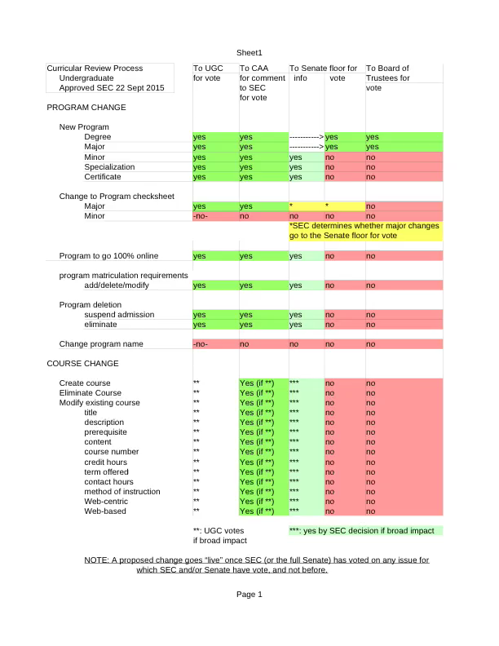

ISSUES/CONCERNS:

ADJOURNMENT:
The meeting adjourned at 4:50 pm.

Respectfully submitted by Robyn Miller, secretary: Sept. 25, 2015

