SENATE EXECUTIVE COMMITTEE
March 29, 2016 Cedar Point Conference Room
2:30-4:30 pm Firelands Campus

Present: Allen Rogel (FS Chair), Rachelle Hipper (FS Vice-Chair), Robyn Miller (FS Secretary), Peter Blass (A&S), Tim Brackenbury (HHS), Mariana Mitova (EDHD), Stephanie Walls (Firelands), Chris Rump (CBA), Victor Senn (USG),

INVITEE:

PRESIDER: Chair Allen Rogel
APPROVE MINUTES:
MOTION: Mariana Mitova) Move to approve minutes from March 29, 2016. (Second:Chris Rump). Minutes approved unanimously.

OLD BUSINESS
None
NEW BUSINESS
- Adjunct Issues- The Charter interpretation that was written concerning adjunct faculty and their ability to serve on various committees was forwarded to A&B for clarification of the interpretation. Rob Obey the chair of AFC was going to come to SEC to discuss the interpretation, but after consulting with his constituents on AFC, they decided that AFC should discuss the interpretation with SEC as a group.
Discussion: When will this meeting be between AFC and SEC be determined? Possibly next week when Allen Rogel attends the AFC meeting. Hopefully, some clarification of the Charter interpretation can be established with AFC next week. The concern is, what will the agenda be for this meeting? One issue may be to discuss the adjunct survey that was distributed to SEC a few months ago. There was a hope to get the survey out this academic year, however, the Charter interpretation has overshadowed the survey. Setting up the AFC took longer than expected due to the elections to AFC being delayed. There has been no word from Joel O’Dorsio concerning the Charter interpretation.
- University Policy on Policy Development- Bill Balzer reached out to Allen Rogel concerning the new policy from the Ohio Attorney General determining where the Charter and other policies are to be housed. They are to be housed on the General Counsel’s website at BGSU. There could be a potential issue with this, if a policy needs to be changed. The policy change may have to go through full Senate or the BOT my act. Bill Balzer reached out to Senate in order that the BOT does not just start taking items out of the Charter. This would cause the Senate and other various groups to not have proper representation.
Discussion: There has been proposed an establishment of a Policy Review committee that will consist of the various chairs and vice chairs of the entities represented throughout the University. The committee will decide whether an issue is editorial or substantive. An example of editorial would be changes such as bringing the Charter in compliance with the CBA. When a change occurs the committee would decide if it is editorial or substantive. If it is editorial the committee would vote to accept the changes or reject the changes and then send to the President’s Panel, it would not have to go to Senate or other representative bodies. The reason for the Panel is to make sure things are being voted on and not just changes without the knowledge of the various constituencies. If the changes are substantive, it will go to Faculty Senate, however the BOT can override anything. There will be correspondence between the representatives and their constituencies on the new Panel, and substantive changes will go through the same channels as they currently do at this point. This suggested modifications to the Policy on Policies are as follows: (See page below)
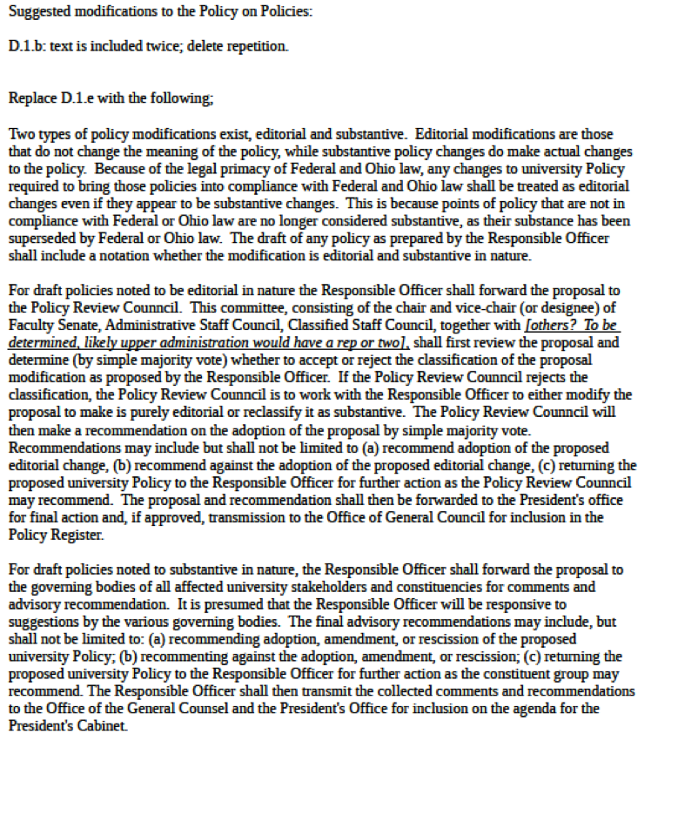

- Academic Charter Amendments- There were several Charter amendments that needed approved by SEC that were sent from A&B
- Antiquated Reference: The Antiquated Reference amendment is as follows:
There are two places under B-I.E: Ethical Responsibilities that reference inappropriate Charter policies or sections of the Charter that no longer exist. In both instances Amendments and Bylaws recommends replacing the reference with a reference to Article 12 of the Collective Bargaining Agreement. The committee believes both these changes to be editorial in nature.

B-I.E Ethical Responsibilities on Page 6 of 7

OLD Version:
- Policy on Violence
It is the policy of Bowling Green State University that acts of violence, threats of violence, or intimidation will not be tolerated. Bowling Green State University recognizes the importance of providing a safe environment for all its members. In this community, victims/survivors will be treated with dignity and respect. Any persons found in violation of this policy may be subject to disciplinary action (B-II.F.3 and B-I.E). Violators may also be subject to criminal prosecution.

NEW Version:
3. Policy on Violence
It is the policy of Bowling Green State University that acts of violence, threats of violence, or intimidation will not be tolerated. Bowling Green State University recognizes the importance of providing a safe environment for all its members. In this community, victims/survivors will be treated with dignity and respect. Any persons found in violation of this policy may be subject to disciplinary action (Article 12 of the CBA). Violators may also be subject to criminal prosecution.

OLD Version
4. Drug-Free Workplace Policy
In order to ensure the University's commitment to a quality educational and work environment, every faculty member, employee and student has a right to work and learn in an environment free from the effects of abuse of alcohol and other drugs. Therefore, it is the policy of Bowling Green State University to prohibit the unlawful use, sale, dispensing, transfer, or possession of controlled substances, alcoholic beverages, drugs not medically authorized, or any other substance that may impair an individual's academic or work performance or pose a hazard to the individual, public, students, or employees of the University on its property or at any of its activities. It is the responsibility of each faculty member, employee and student to adhere to this policy. If a violation of this policy occurs, support programs will be made available where appropriate. Disciplinary action may be taken up to and including dismissal or expulsion from the University and possible criminal prosecution. The University will make appropriate effort to provide rehabilitative support before giving consideration to termination of employment for cause as stipulated in B-I.C.3.c) of the Academic Charter and Sect. 3345.22- 25 of the Ohio Revised Code.
NEW Version
4. Drug-Free Workplace Policy
In order to ensure the University's commitment to a quality educational and work environment, every faculty member, employee and student has a right to work and learn in an environment free from the effects of abuse of alcohol and other drugs. Therefore, it is the policy of Bowling Green State University to prohibit the unlawful use, sale, dispensing, transfer, or possession of controlled substances, alcoholic beverages, drugs not medically authorized, or any other substance that may impair an individual's academic or work performance or pose a hazard to the individual, public, students, or employees of the University on its property or at any of its activities. It is the responsibility of each faculty member, employee and student to adhere to this policy. If a violation of this policy occurs, support programs will be made available where appropriate. Disciplinary action may be taken up to and including dismissal or expulsion from the University and possible criminal prosecution. The University will make appropriate effort to provide rehabilitative support before giving consideration to termination of employment for cause as stipulated in Article 12 of the CBA and Sect. 3345.22- 25 of the Ohio Revised Code.
Motion: To approve antiquated reference Charter amendment. (Motion: Peter Blass) (Second:Tim Brakenbury). Approved
- Academic Honesty: The Academic Honesty amendment is as follows:
Members of Amendments and Bylaws met with the president of Undergraduate Student Government and are confident the following changes address the student-driven request to allow students to waive their appeals in cases of academic honesty. Students want the ability to keep the process moving forward when they are not making an appeal or do not intend to make an appeal.

The committee recommends additions in TWO sections.
CHANGE 1: The following as highlighted is to be added in B-I.G Academic Honesty Policy on pages 4 and 5 under section 2 “Violations Discovered Before Graduation,” (a) Jurisdiction, subsections (1) Instructor and (2) Academic Dean. The black type is original language and remains the same.

2. Violations Discovered Before Graduation
This section shall apply to violations of the Academic Honesty Policy that are discovered before the student has graduated and that are within the statute of limitations. B-I.G.1.f)
a) Jurisdiction
(1) Instructor
(a) In any case in which the sanction to be imposed for the alleged offense is less than suspension, the instructor in the course shall have original jurisdiction. The instructor shall determine and impose the sanction. B-I.G.2.b)(5)
(b) If necessary, the instructor may delegate responsibility for conducting a conference and determining and imposing the sanction, in writing, to the Chair of the department in which the course is taught.
ADD: (c) Upon written notice of the application of sanction, students must file an appeal or give written notice of wavier of an appeal within seven days to the appropriate authority.
Absent extenuating circumstances, no action on the part of the student shall be interrupted as acceptance of the sanction.
(2) Academic Dean
(a) In any case in which the sanction to be imposed for the alleged academic honesty violation is suspension, dismissal or expulsion, or in which the alleged academic honesty violation is a second offense, the academic Dean shall have original jurisdiction. The academic Dean shall determine and impose the sanction. B- I.G.2.b)(6)
(b) The academic Dean may delegate to an individual or committee the responsibility for providing notices, arranging and conducting conferences/hearings, determining whether or not a violation has occurred, and recommending a course of action to the academic Dean. B-I.G.2.b)(g)
(c) Conferences/hearings shall be conducted under procedures established by the academic Dean.
ADD: (d) Upon written notice of the application of sanction, students must file an appeal or give written notice of wavier of an appeal within seven days to the appropriate authority.
Absent extenuating circumstances, no action on the part of the student shall be interrupted as acceptance of the sanction.
CHANGE 2: This change is to be added in B-I.G Academic Honesty Policy on the section beginning on page 7 labeled (b) Procedures. The following as highlighted should be added on page 9 under section 5 “Cases with Instructor Jurisdiction,” letter (f) subsection (i) and (ii) section. The black type is original language and remains the same.

(f) If the instructor determines that a violation of the Academic Honesty Policy has occurred, the instructor is required in all cases to inform the Division of Student Affairs, in writing, of the facts (including whether or not a conference between the instructor and student took place) and the decision in the case.
  - i) If the sanction is partial or no credit, and the student has waived the appeal or the appeal deadline has passed with no appeal, or if the instructor’s decision in the case has been upheld on final appeal, the instructor shall calculate the sanction into the course grade and report the grade on the class grade sheet. Otherwise, the instructor shall report an “NGR” (no grade).
  - ii) If the sanction is withdrawal from the course and assignment of a grade of “WF”, and the student has waived the appeal or the appeal deadline has passed with no appeal, or if the instructor’s decision in the case has been upheld on final appeal, the instructor shall report the sanction on the class grade sheet. Otherwise the instructor shall report an “NGR” (no grade).
  - iii) The registrar shall not convert an “NGR” to a “WF” while an appeal is pending.
Motion: motion to approve Academic Honesty Amendment (Motion: Chris Rump) (Second: Mariana Mitova). Motion carried.
- Standing Invitations to SEC: The amendment for Standing Invitations to SEC are as follows:
As per the request from an email dated March 22, 2016, we are submitting the following for consideration by SEC.

Amendments and Bylaws recommends the addition of the BGSU‐FA liaison and the chair of ComCom as highlighted below in Article IV “Faculty Senate,” Section F: “Committees of the Senate,” Subsection 1: “Senate Executive Committee (SEC).

1. Senate Executive Committee (SEC)
a) Membership
The SEC shall be composed of twelve members:
(1) The Chair, the Vice-Chair, and the Secretary of the Faculty Senate;
(2) Seven Faculty Senators elected by and from the Faculty Senators for two-year terms, provided that each of the degree-granting undergraduate colleges and the graduate college are represented by at least one elected member and that three terms expire each year;
(3) An Undergraduate student appointed by the USG; and
(4) A Graduate student appointed by the GSS.
The SEC extends a standing invitation to the chair or designee of the Amendments and Bylaws Committee, the Committee on Academic Affairs, the Committee on Committees, the Committee on Professional Affairs, and the Fiscal Affairs Advisory Committee, and the BGSU-FA. Attendance is not a mandatory requirement and those representatives will not have voting privileges on the SEC.
Motion: motion to approve substantive changes to Standing Invitations on SEC. (Motion: Chris Rump) (Second: Tim Brakenbury). Motion carried.

All substantive changes will go to the floor of Senate.

Motion: (Motion: Chris Rump) (Second: Peter Blass). Motion carried.

.

ISSUES AND CONCERNS
- Consensual Amorous Relationship- The approved amendment was vacated by General Council. A&B is trying to update it, but has an issue with one section. This section reads: (i) allows a consensual amorous relationship to occur or continue. When discussing the role of a supervisor.
Discussion: There will be more information once Allen Rogel speaks with Kelly Taylor and Barbara Waddell. A&B has not signed off on the section in question, it was added by General Counsel. We have been striking out in a new direction of being more tolerant, however, this sentence puts us back to no fraternizing policies. Allen will try to talk with General Counsel because this affects everyone and faculty senate is weighing in.
- AFC Committee Open Invite to SEC- AFC is the only committee not that was not included in the new amendment which was approved concerning open invites to SEC. This is not fair and should be changed.
Motion: motion to table sending new amendment of Standing Invitations to SEC to A&B until we can open the invitation to all committees (Motion: Stephanie Walls) (Second: Chris Rump). Motion carried.

Motion: motion to invite all chairs of senate standing committees to have a standing invitation to attend SEC. (Motion: Peter Blass) (Second: Tim Brakenbury). Motion carried.
- Clean Air Policy- Some constituents voted against accepting the new Clean Air Policy. President Mazey reached out to Allen Rogel to have all representatives from the various constituencies come together to discuss this policy. One problem is, the old policy is not being enforced, and therefore, it will be difficult to enforce the new policy.
- New University Course Evaluations- Rachelle Hippler gave an update on the new University course evaluations. There are eight common themes and the committee wants to narrow the questions down, so there will not be too many in order that students will fill out the reviews. This should probably not go to Senate, but use a Listserv that upper administration uses to send out to all faculty. The committee would like to do a trial in fall 2016 and roll it out in spring 2017. Finding a way to get students to fill out the surveys can be difficult.

ADJOURNMENT:

Motion: To adjourn (Kerry Fan) (Second: Chirs Rump).

Meeting adjourned 4:30 pm.

Respectfully submitted by Robyn Miller, Secretary: April 4, 2016

