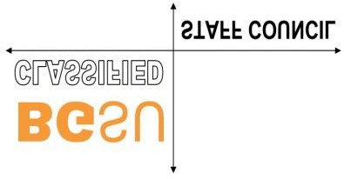
March Meeting Minutes

Call to order 10:15
Present: Chris Snyder, Deb Lucio, Lisa Molnar, Gretchen Avery, Linda Hammond, Deb Lowery, Marisa Cline, Debra Huff
Absent: Danielle (Dean’s meeting), Dana (off), Andrea (?), Deb Carden/Nestor Rave (meeting/scheduling)
*no Retiree rep, no Admin Staff rep

Secretary Report – move to next month
Treasurer Report – no report, no spending
Admin Staff Report – no rep
Retirees Report – no rep
Fireland’s Report – no rep
Chair’s report –
*President yesterday – Current issues
-President worried about stress and well-being for employees and students
-issues with flex policy?
-Donuts & Coffee – trying to find times for 3plus shifts
*HR Report – pay increases from evaluations
- not a step increase
-yes, eligible for raise increase
-raises % based, then based on market
-no one’s salary will decrease (after evals)
-will be looking at pay ranges
-timeline=2 years, market analysis to be done

Old Business
*Diversity & Belonging committee – no one stepped up
-Anyone willing on council to serve?
-advertise in campus update
-people seem overworked/over stretched
-email Gretchen with suggestions/individuals
*Coffee and Donuts (in Pres report)
*Spring Banquet – Committee met. Will be June 8 @ The Oaks
*Elections & Committee Positions – Keep putting in FFF (Deb) add to Campus Update (Gretchen)
-self nomination forms – in May? (check with Deb Lowery)
*Food Pantry – Collection ends Friday
-include in FFF – “everyone welcome to shop the food store @ Central Hall
*Flex policy – Feedback on Flex policy?
-Supervisor must give written response for tracking

New Business
*Salary Comp – Christopher
-Sent to group, changes made, editing
-Will meet again and then send to Exec, after Exec it will be sent to council to approve (via email possibly)
*Plaques – Christopher fixed the Union plaque issues
-plates need to be sent for engraving (Gretchen)

*One Day – waiting to hear from One-Day committee
-info will be sent out to council members (Deb)

Committee Notes:
Public Safety (Gretchen)
*police have a new radio system
*ITS – cyber security training
*Professional training
*hired 3 new officers, still not back to full staff levels
*Updating campus emergency plans
*AED locations to be added to interactive BGSU map
*Severe weather training April 19
*preparing for Solar Eclipse, April 2024

Parking (Gretchen)
*gateway lots – construction
*may change some spots to commuter
*resurfacing
*tunnel issue, near library
*Lot 12, airport expanding
*shovel use is up
*fleet upgrades 2023

Good of order – nothing

Next CSC meeting, Thursday, April 21, 2022

